Fe-K/ Al₂O₃-MgO 촉매의 제조, 성질 규명 및 이산화탄소의 탄화수소 전환연구

남 상성, 키 산, 이 명우, 최 명재, 이 규완
한국화학연구소, 화학기술연구단 1팀

Synthesis, Characterization and CO₂ Hydrocarbons studies over Fe-K Supported on Al₂O₃-MgO Mixed oxides

Sang-Sung Nam, Gurram Kishan, Myung-Woo Lee, Myoung-Jae Choi and Kyu-Wan Lee

Chemical Technology Division-I, Korea Research Institute of Chemical Technology

Introduction:
The environmental impact of high concentrations of CO₂ in the atmosphere has been of acute concern to the global community (1-3). One of the ways to mitigate this problem is to convert CO₂ to valuable industrial feed stocks (1-3). Iron based catalysts have shown great promise in reverse water gas shift (RWGS) reaction as well as F-T synthesis, which are the two major steps involved in the hydrogenation of CO₂ (2). Potassium was found to be an effective promoter for iron based catalysts in the F-T synthesis (2). On the other hand, several authors (4) emphasized the importance of support in iron catalysts for F-T synthesis, as it is expected to influence the iron particle size, reducibility, degree of interaction with the support.

Experimental procedure:
The mixed oxides (Al₂O₃-MgO) supports were prepared by varying Al₂O₃/MgO ratio by coprecipitation method. 10 wt% Fe-K catalyst supported on above mixed oxides were prepared by impregnating supports with nitrate precursors. The atomic ratio of Fe:K was maintained as 2:1. The catalysts were dried and calcined at 773 K for 24 hrs. The catalysts were characterized by TPR, CO₂ chemisorption and BET surface area methods. The catalysts were tested for CO₂ hydrogenation under fixed reaction conditions.
Results and Discussion:
The BET surface areas and CO₂ uptake values of the catalysts are listed in Table 1. The results indicate that the surface areas are decreasing gradually with increasing MgO content. In fact, the surface areas of supports have been also observed to follow a similar trend. However, the decrease was more profound after impregnation of iron and potassium, which may be attributed to pore blockage. The CO₂ uptake values increased with increasing MgO content upto 20 wt% in the catalysts, while further increase in MgO content led to decrease. A good correlation was found between the CO₂ hydrogenation activity results and chemisorption uptakes.
The results of CO₂ hydrogenation to hydrocarbons are summarized in Table 2. It is clear from Table 2, that CO₂ conversion, selectivity to CO and total hydrocarbons vary based on support composition. The conversion of CO₂ and the total hydrocarbon content in products increased with increasing MgO content, peaking at 20 wt%, while further increase in MgO content of support has an opposite effect. The selectivity towards C₂-C₄ olefins and C₅₊ hydrocarbons also show a similar trend. According to Gallegos et al (4) who studied the F-T synthesis over Fe/SiO₂-MgO catalysts, an optimal concentration of about 4 wt% of MgO offers the highest selectivity to olefins. As has been observed, the increase in MgO content beyond 20 wt% results in the decrease of total hydrocarbon content. This behavior may be attributed to poor dispersion due to aggregation of iron particles on these supports. From these observations, it is clear, that bacisity of a catalyst alone may not be useful in the production of hydrocarbons from CO₂. Hence, the strong acid sites in conjunction with basic sites may be the real active sites responsible for the formation of hydrocarbons.

Table 1. BET surface area and CO₂ chemisorption values of Fe-K catalysts
supported on Al₂O₃-MgO.
Catalyst (Fe –K)  Al₂O₃ : MgO | 100:0 | 90:10 | 80:20 | 70:30 | 50:50 | 25:75 | 0:100
BET surface area (m²/g) | 172.11 | 173.90 | 162.13 | 129.39 | 92.34 | 88.29 | 25.67
CO₂ uptake  (μ moles/g) | 337.37 | 373.05 | 402.34 | 328.10 | 241.11 | 203.32 | 50.14
Table 2. CO₂ hydrogenationª over Fe-K catalysts supported on mixed metal oxide (Al₂O₃-MgO)
Catalyst (Fe –K)  Al₂O₃ : MgO | 100:0 | 90:10 | 80:20 | 70:30 | 50:50 | 25:75 | 0:100
CO₂ conv.(%) | 21.34 | 24.05 | 27.53 | 23.08 | 18.79 | 16.83 | 13.75
Selectivity(C mol%)
CO | 38.65 | 26.20 | 18.57 | 37.98 | 53.39 | 59.33 | 79.80
-HC- | 61.35 | 73.80 | 81.43 | 62.02 | 46.61 | 40.67 | 20.20
C₁ | 30.42 | 28.34 | 22.92 | 26.08 | 27.76 | 33.27 | 51.58
C₂⁼ | 2.47 | 2.77 | 4.89 | 8.80 | 8.75 | 7.27 | 1.96
C₂ | 16.44 | 15.76 | 10.52 | 9.51 | 8.79 | 12.85 | 23.97
C₃⁼ | 10.33 | 12.16 | 15.93 | 18.21 | 14.24 | 11.37 | 6.04
C₃ | 9.59 | 9.21 | 5.92 | 4.60 | 7.13 | 8.47 | 9.49
C₄⁼ | 7.50 | 10.92 | 14.65 | 5.01 | 10.20 | 6.99 | 3.20
C₄ | 7.10 | 4.70 | 4.47 | 11.84 | 5.31 | 6.93 | 1.11
C₅ > | 16.15 | 16.14 | 20.70 | 15.95 | 17.83 | 12.86 | 2.65
Ol./(Ol.+Para.) | 38.00 | 46.56 | 62.91 | 55.24 | 61.00 | 47.58 | 24.47
ªCO₂ hydrogenation at 1900 ml/g/h, 573 K, and 10 atm
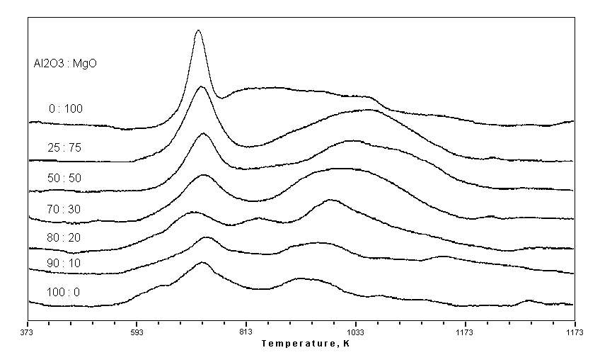Figure 1: The TPR profiles of Fe-K/Al₂O₃-MgO catalysts with different Al₂O₃-MgO proportions.

The TPR profiles of Fe-K catalysts supported on Al₂O₃-MgO mixed oxides have been shown in Figure 1. They indicate a two or three stage reduction mechanism depending on the support composition. Usually the first peak is attributed to reduction of Fe₂O₃ to Fe₃O₄ , whereas the second peak is attributed to reduction of Fe₃O₄ to Fe metal. We did not observe any peak corresponding to the formation of metastable FeO. However, for Fe-K/Al₂O₃(80)-MgO(20) catalyst, three stage reduction profile has been observed. The middle peak may be attributed to Fe₃O₄ to FeO transformation. Bulk-phase FeO is thermodynamically metastable compared to either magnetite or α-Fe at temperatures below 840K (5). However, in the presence of certain oxide supports, FeO may be stabilized and the stability of FeO on different oxide supports can be used to estimate the extent of the iron oxide-support interaction. In this catalyst, there exists a strong interaction between surface iron oxide with mixed Al₂O₃(80)-MgO(20) oxide support. The height of the first reduction peak has increased with increasing MgO content in the catalyst. This behavior may be due to the influence of MgO, which is a good electron donor, hence it may have influenced the iron oxide making them more easy to reduce.

Conclusions:
TPR of the catalysts show that, reduction of Fe₂O₃ to Fe⁰ follows two step mechanism through Fe₃O₄. However, 20wt% of MgO content in the catalyst imported the stability of metastable FeO peak, which shows a strong metal (oxide) support interaction. The CO₂ conversion and total hydrocarbon selectivity increases with increase in MgO content in the catalysts upto 20 wt%, decreases beyond this loading. The C₂-C₄ olefin selectivity and C₅₊ hydrocarbon selectivity are found to increase in the same way as CO₂ chemisorption values.

References:
- 1. B. Delmon, Appl. Catal. B 1(1992)139.
2. M.D. Lee, J.F. Lee and C.S. Chang, Bull. Chem. Soc. Jpn., 62(1989)2756.
3. N.G. Gallegos, A.M. Alvarez, M.V. Cagnoli, J.F. Bengoa, S.G. Marchetti, R.C. Mercader and A.A. Yeramian., J. Catal., 161(1996)132.
4. A.J.H.M. Koch, H.M. Fortuin and J.W. Geos., J. Catal., 96(1985)261.

