상분리 현상을 이용한 분자크기 광 다이오드의 제작

조 경상, 최 정우*, 이 원홍*, 송 남웅, 김 동호
한국 표준과학연구원 분광그룹, 서강대학교 화학공학과

Fabrication of Molecular Scale Photodiode using Phase Separation Technique

Kyung Sang Cho, Jeong-Woo Choi*, Won Hong Lee*, Nam Woong Song and Dongho Kim
Spectroscopy Laboratory, Korea Research Institute of Standards and Science
*Department of Chemical Engineering, Sogang University

INTRODUCTION

Currently, miniaturization of device and highly integrated circuit design is major interest for the development of electronic device. Various investigations have been done to develop new materials and new processing techniques [1]. For instance, more than 10¹⁶ number of devices per unit area is needed to produce an artificial intelligent machine like a human brain. The size of this unit is a molecular level. By using organic (bio) materials, molecular size device (molecular electronic device (MED)) can be realized because organic (bio) materials show the functional characteristics in the molecular level.
To realize the artificial photodiode as a molecular device, molecular patterning using phase separation technique was performed. In the molecular patterning, two kinds of methods are mainly used. The one is direct patterning or lithography using AFM tip and the other is phase separation technique [2]. In direct patterning, two step processes are needed. First step is annealing process and second step is lithography process. In annealing process, typical areas are annealed by inducing forces with AFM tip. In lithography process, molecular layers are removed by solvent except typical areas which are annealed by AFM tip, so patterned layers can be formed. Molecular patterning using phase separation technique is one step process. When mixed solvent of hydrocarbon and fluorocarbon are spread on the surface of water, hydrocarbon domains are formed. Since the attraction forces between hydrocarbons are stronger than that between fluorocarbons, hydrocarbon layers form island like domain and fluorocarbon domain layers form sea like domain. The size and distribution of domains can be controlled by changing subphase pH, molar ratio of hydrocarbon and fluorocarbon, waiting time of evaporation of solvent and incorporation of metal ions into the subphase. In this study, the molecular patterning was performed using phase separation technique for the fabrication of molecular-scale photodiode.

EXPERIMENTAL DETAILS

1. Materials
For the molecular patterning, octadecyltrichlorosilane (ODTCS) and nonadecafluorodecanoic acid (PFCA) were used. Ferrocene (1-1'-ferrocene-N-dioctadecyl carboxamide), flavin (7,8-dimethyl-10-dodecyl isoalloxazine), viologen (N-allyl-N'-[3-propylamido-N",N"-di (n-octadecyl)]-4,4'-bipyridinium dibromide) and TCNQ (N-docosylquinolinium tetracyanodimethan) are used as an electron donor (D), sensitizer (S), relay (R) and acceptor (A) unit, respectively. The deposition of LB film was carried out using a circular Langmuir trough (type 2022, Nima Tech., England).

2. Method
To observe AFM (PSI AutoProbe CP, USA) images of LB films, mica was used as a substrate. The cantilever spring constant was 0.07~0.31 N/m, the servo gain was 1 and the set-point value was 20~50 nN. For the STM image of the hetero LB film, silicon wafer was used as a substrate. STM chips were made by etching tungsten wire before experiment since they are easily oxidized and corroded. Tungsten wires were electrically etched in 1 M KOH solution with inducing voltage and rinsed with ethanol. AFM images were obtained with constant force mode and STM images were obtained with constant height mode.

RESULTS AND DISCUSSION

1. Phase Separation of ODTCS and PFCA
The 2:1 mixed solvent of ODTCS and PFCA in the chloroform was spread on the subphase. After drying chloroform (30 min), monolayer of mixed LB film was fabricated on the mica substrate using horizontal dipping method. LB film was annealed in the oven for 12 hours at 70 ºC to harden the hydrocarbon layer. Annealed LB film was sonicated in the ethanol solution for 5 minutes, so the PFCA layer was removed and the patterned structure of ODTCS was constructed.
Domains of ODTCS were clearly formed and each domain has about 0.25 μm radius. The height of domain is about 150 ~ 200 Å so it is thought that the domain is not a monolayer of ODTCS but stacked layers of ODTCS. Based on the result, phase separation using electron transport organic material was performed.
2. Patterning of D/S-ODTCS Hetero LB film
To form a patterned layer of S LB film, following procedure were used. First, monolayer of ferrocene LB film was deposited on the silicon wafer substrate. Onto this layer the mixed LB film of flavin:ODTCS:PFCA = 0.2:1:2 was fabricated using horizontal dipping method. LB film was annealed in the oven at 45 ºC for 4 hours for hardening the hydrocarbons and sonication was performed using ethanol for 5 minutes.
AFM image of D/S-ODTCS patterned structure shows that the Hydrocarbon domains are clearly formed. The average radius of domain is about 0.15 μm. The smaller radius than 2:1 mixture of ODTCS and PFCA system is due to the reduced amount of the molar ratio of the sum of S and ODTCS. The average height from valley to top is ca.150 Å.
3. Patterning of D/S/R/A Hetero LB film
On the patterned layer of D/S-ODTCS, R and A LB layers were fabricated. First, viologen monolayer is deposited during upstroke and TCNQ monolayer was deposited during downstroke sequentially. Fig. 1 shows the expected structure of D/S/R/A LB films. The weak head-tail interaction will reduce the amount of the viologen which are directly deposited on the ferrocene layer. Fig. 2 shows the AFM image of D/S/R/A hetero LB film. The average height from valley to top is ca. 180 Å. The height of domain in the D/S/R/A structure increased by 30 Å than in D/S structure. No adhesion of the viologen molecules to the ferrocene layer might lead the increase of average height of domain.
Fig. 1. Structure of Molecular Photodiode
TCNQ
viologen
flavin/ODTCS
Si Wafwe

4. Molecular Photodiode of D/S/R/A Hetero LB film
To obtain the photodiode effect in the D/S/R/A hetero LB films that are molecularly patterned STM images were investigated. Fig. 3 and 4 show the STM image of D/S/R/A hetero LB film in the dark (without light) state and photo (irradiation of light) state when sample bias was 0 V and tip bias was 0.8 V. In the STM, the difference of the current density can be represented by the difference of height. In the STM image in the photo state LB film, the domain structure could be observed. The height of domain was about 400 Å in the photo state LB film which is extremely higher (about 10 times) than that in the dark state. When we applied the tip bias as a negative voltage, the observed signals were very unstable, so images cannot be obtained. Based on the results it could be concluded that the photoinduced electron transport and directional flow of electron from D to A was successfully occurred in the molecularly patterned domain and molecular photodiode and photoswitch was realized.

REFERENCES
[1] K. S. Cho, J.-W. Choi, W. H. Lee, N. W. Song and D. Kim, Thin Solid Films, 1998, in Press.
[2] R. M. Overney, E. Meyer, J. Fromer, H.-J. Guntherodt, M. Fujihira, H. Takano and Y. Gotoh, Langmuir, 10, 1994, 1281

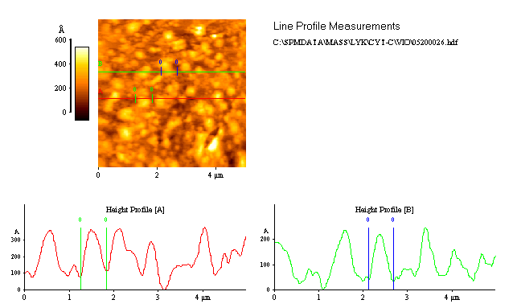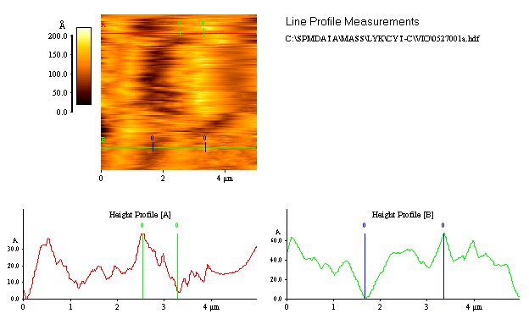Fig. 2. AFM Image of D/ODTCS-S/R/A Hetero LB Film

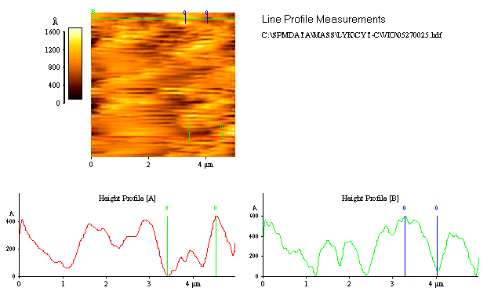Fig. 3. STM Image of D/S/R/A in the Dark Condition
Fig. 4. STM Image of D/S/R/A with Irradiating Light

