근시야 원자간력 현미경을 이용한 Merocyanine LB막의 구조특성 연구

김 종민, 장 상목, 村松宏*
동아대학교 화학공학과,세이코 첨단기술연구소*

Structure Studies on the Merocyanine LB films using Scanning Near-field Optical/ Atomic-force Microscope (SNOM/AFM)

Jong-min Kim, Sang-Mok Chang, Muramatsu. H*
Dept. of Chem. Eng., Dong-A Univ., Pusan, Korea
Advanced Technology Center, Seiko Inst Inc., Chiba 271, Japan*

Introduction
The field of scanning probe microscopy (SPM) has become firmly established over the past ten years in a broad range of fundamental science and real application. In its many forms, atomic force microscopy (AFM) allows the quantitative study of topography, adhesion, compliance, and friction, all correlated on the nanometer length scale¹. Recent approaches in SPMs have advanced on the simultaneous imaging methods of topography and physical properties or chemical properties such as pulsed forced microscopy (PFM) for mapping the electrical double layer force², chemical force microscopy (CFM) for imaging functional group distinction³, magnetic force microscopy for mapping magnetic dissipation⁴, and scanning near-field optical microscopy (SNOM) for imaging localized optical property ^{5,6}.
In these days, We have developed a rather new imaging system called scanning near-field optical/atomic-force microscope, SNOM/AFM)^{7,8}. In this system, optical fiber is used as a cantilever and the distance control between tip and sample is based on the AFM method. Therefore, SNOM/AFM system can be operated both contact mode (constant force mode,AFM mode) and non-contact mode (dynamic force mode, DFM mode). SNOM/AFM can provide high-resolution topographical and optical images simultaneously. In a shear-force feedback microscope, the spatial resolution is defined not only by the radius of the tip of the probe but also the amplitude of vibration. Therefore, the resolution of SNOM/AFM image is better in principle than that of the shear-force feedback microscope. The applicability of SNOM/AFM ranges from the imaging of living specimens, to the spectroscopic analysis and the characterization of materials in the nanometric region on the scientific side. On the technological side, its potential applications involve photo-fabrication processes and optical high-density data storage devices.
Merocyanine dyes⁹⁻¹¹, originally developed as a photosensitizer for silver halide photography, have renewed interest as a class of organic photoconductor, which may be useful for high efficiency photovoltalic device. Various reports on the optical photoelectric characteristics of merocyanine have been investigated in systems fabricated using vacuum evaporations, casting or Langmuir-blodgett films. Even though, various reports were faced on the optical properties of merocyanines, there were no reports on the optical structures of these dyes.
In this report, We will present the optical properties of merocyanine LB film in the far and near-field based on various film deposition conditions such as different kinds of merocyanine and mutual mixing ratios of the two kinds of merocyanine.

Experiment
Figure 1 shows the schematic diagram of the SNOM/AFM in the transmission mode. A SNOM/AFM instrument is based on a conventional AFM unit (SPI 3700, Seiko Instruments Inc) which contains a dynamic-mode AFM function. A sharpened and bent optical fiber probe is mounted on a bimorph.
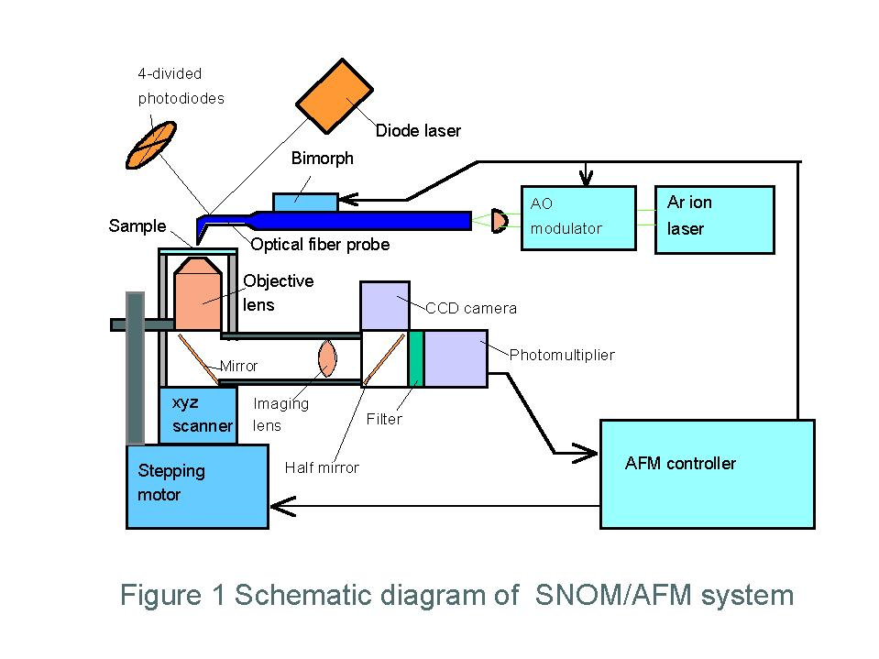
The distance between the tip of the probe and sample surface is controlled by a laser-beam-deflecting AFM technique, in which the cantilever vibrates vertically at the resonant frequency. The distance controlled with a piezo-electric device module. The amplitude of the cantilever vibration decreases with a decrease in the distance. This AFM function allows that the light is to be easily illuminated from the optical fiber probe in an optically near-field region. Light of 488 nm from a Ar ion laser with the output power of ~50 mW is coupled the end of probe and illuminated from the tip of the probe to the sample surface. The light of argon ion laser is modulated by an acousto-optic (AO) modulator for improving S/N ratio of optical signal and controlling irradiation rage in the probe vibration. After transimission through both the aperature of optical fiber probe and the sample, the remaining light is detected with a photomultiplier through a collimation lens, a mirror and anoptical fiber. The signal from the photodetector is demodulated and amplified by a lock-in amplifier and noise in the optical signal is reduced. With this configuration, the SNOM/AFM can provide topographical and optical images simultaneously with high resolution. The near-field probe was made of a single-mode optical fiber, whose core and clading is 3.2 μm and 125 μm in diameter, respectively. In other to taper the prober and sharpen the tip to less than 100 nm in diameter, the optical fiber was pulled and bent by a ${\text{CO}}_{2}$laser beam. The ridge of the probe was ground and polished into a mirror for an optical lever of AFM function. The aperture at apex of the probe was formed by a 100 nm thick aluminum film.
The sample for the optical adsorption spectra, the optical and topographical measurements were prepared by the standard procedure of LB film deposition with 10 layers using glass substrates. SNOM/AFM measurement was performed applying approximately 3 mW of 488 nm line of Ar ion laser in coupled with the untapped end of the fiber probe with dynamic and transmission mode operation.

Results and Discussions
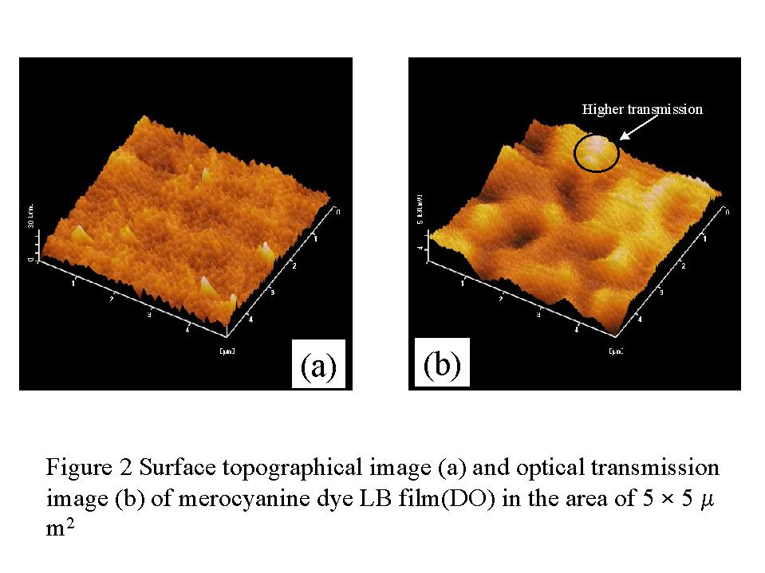
Figure 2 shows the dynamic mode AFM image (a) and near-field optical transmission (b) of merocyanine dye LB film (this chemical is called DO)¹¹. The distance between cantilever and sample maintained about 50 nm during the experiment, and scan speed held 0.127 Hz with 256 scan lines.
In Fig. 2(a), the topographical image indicate that this LB film has more rough surface morphology than that of normal expectations, and LB film id grained with average grainsize about 50 nm. In Fig. 2(b), the near-field transmission image shows highly separated structure of transmission and independent image on the surface topography. In the continuous measurement on these dyes, the appearance of near-field optical transmission images showed a certain dependence on the kinds of dyes and the mutual mixing ratios of different dues. These experimental results suggest that there is a certain kind of interaction between these different dyes.

References
- Scanning Probe Microscopy, edited by R. Wiesendanger (Cambridge University Press, 1994)
- T. Miyatani, M. Horii, A. Rosa, M. Fujihira, and O. Marti, Appl.Phys.Lett. 71(18), 2632 (1997)
- C. D. Frisbie, L. F. Rozsnyai, A. Noy, M. S. Wrighton, and C. M. Lieber, Science 265, 2071 (1994)
- P. Grütter, Y. Liu, P. LeBlanc, and U. Dürig, Appl.Phys.Lett. 71(2), 279 (1997)
- E. Betzig and J. K. Trautman, Science 257, 189 (1992)
6. H. Muramatsu, N. Chiba, K. Homma, K. Nakajima, T. Ataka, S. Ohta, A. Kusumi, and M. Hujihira, Appl.Phys.Lett. 66, 3245 (1995)
7. K. Nakajima, H. Muramatsu, N. Chiba, T. Ataka and M. Fujihira, Thin Solid Films 273, p. 327 (1995)
8. T. Ataka, H. Muramatsu, K. Nakajima, N. Chiba, K. Homma, and M. Hujihira, Thin Solid Films 273, p. 154 (1996)
9. Y. Yonezawa, D. Möbius and H. Kuhn, J.Appl.Phys. 62, p.2016 (1987)
10. K. Saito, K. Ikegami, S. Kuroda, M. Saito and M. Sugi, Thin Solid Films 179, p. 369 (1989)
11. K. Murata, H. K. Shin, S. Kuroda and K. Saito, Mol.Cryst.Liq.Cryst. 294, p.113 (1997)

