Hydrogenation of Ethanol-Solubilized Coals over a Ru/Al₂O₃ Catalyst and Their Pyrolysis Reactivities

Hideyuki TAKAGI, Hideharu SAIKI, Takaaki ISODA,
Katsuki KUSAKABE and Shigeharu MOROOKA

Department of Materials Physics and Chemistry,
Graduate School of Engineering, Kyushu University,
Fukuoka 812-8581, Japan

Introduction

Coals were subjected to mild oxidation in an aqueous solution of H₂O₂ in the presence of n-propanol. The ethanol-soluble fractions were hydrogenated over a Ru/Al₂O₃ catalyst, yellowish white solids (hereafter, referred to as hydrogenated white coals [1]) were obtained after solvent removal. Aromatic rings and side chains were hydrogenated, and some of the sp² carbon bondings were changed into the sp³ structure. Pyrolysis reactivity was improved by oxidation and hydrogenation and correlated well with the H/C and O/C atomic ratios in the raw, oxidized and hydrogenated coals.

Coal is a macromolecular solid which contains a variety of covalent and non-covalent linkages. Miura et al.[2] oxidized a low rank coal in aqueous H₂O₂ at 60C for 2 h and reported that more than 90% and 84% of the oxidized coal became soluble in dimethyl sulfoxide and a mixture of methanol and methylnaphtalene, respectively. We recently reported that Yallourn coal, which was oxidized under mild conditions with aqueous H₂O₂ in the presence of n-propanol, was solubilized in methanol at a yield of 80wt% of the raw coal [3]. The coals were both partially depolymerized and alkylated as a result of the treatment, thus increasing the solubility of the coal in methanol.
In the present study, coals are oxidized, and the ethanol-soluble fractions were hydrogenated over a Ru/Al₂O₃ catalyst. The pyrolytic reactivity of the hydrogenated coals is evaluated using a Curie-point pyrolyzer, and the relationship between pyrolytic reactivity and changes in the coal structure by oxidation and hydrogenation is discussed.

Experimental
Yallourn, South Banko, Taiheiyo, Miike, and Hunter Valley coals were used as the coal samples. 1-4 g of each coal was mildly oxidized in a solution composed of 2-8 ml of aqueous H₂O₂ (30wt%) and 5-20 ml of n-propanol at 70C for 6 h under atmospheric pressure. Each product was stirred in ethanol under ultrasonic irradiation at room temperature, and the ethanol-soluble (ES) and ethanol-insoluble (EI) fractions were obtained. The ES fraction was evaporated and was subjected to hydrogenation. The EI fraction was dried at 70C for 12 h in vacuo and then weighed. The ES fraction was hydrogenated in a batch-autoclave at 120C for 12-72 h in a H₂ atmosphere of 10 MPa, using 0.5-1.5 g of an alumina-supported ruthenium (Ru/Al₂O₃) catalyst in the presence of 0-8 ml of acetic acid. The product was recovered by solubilization in a mixture of methanol and tetrahydrofuran, and the catalyst was separated by centrifugation. After removal of the solvent, the products were extracted with water to give a water soluble fraction (WSO) and a residue (hydrogenated ethanol soluble; H-ES).
H/C and O/C atomic ratios of the ES, H-ES, WSO and EI fractions were determined by elemental analysis. The samples were characterized before and after hydrogenation by GPC, FT-IR and Raman spectroscopy. For Raman spectra, the ratio of the peak intensity at 1380 cm⁻¹ to that at 1600 cm⁻¹ was taken as an indicator of the ratio of sp³ to sp² carbons. Spectra were determined in 20 separate runs by changing the locations of each sample, and the distribution of the data was obtained.
Oxidized coal (defined as ES + EI) and hydrogenated coal (defined as H-ES + EI + WSO) were pyrolyzed at 764C at a heating rate of 3000C/s using a Curie-point pyrolyzer, and product gases were analyzed by gas chromatography.

Results and Discussion
The color of Yallourn coal became brown after H₂O₂ oxidization in the presence of n-propanol and yellowish white after catalytic hydrogenation. The color changes of the other coals were similar to Yallourn coal. Figure 1 shows the nitrogen content of the hydrogenated white Yallourn coal as a function of the H/C atomic ratio. The H/C ratio increased to 1.07 as a result of the oxidation, from 0.96 of the raw coal. The H/C ratio was further increased to

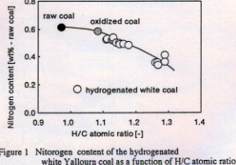

1.28 after hydrogenation for 72 h. The extent of denitrogenation was slight by the H₂O₂ oxidation, and the nitrogen content was decreased to 0.52wt%. Denitrogenation was further promoted by the hydrogenation, and the nitrogen content was decreased to 0.37wt% for the hydrogenated Yallourn coal, which had an H/C ratio of 1.28.
Figure 2 shows sp³/sp² ratios for raw Yallourn coal as well as oxidized and hydrogenated samples. The sp² carbon bondings were partially converted to the sp³ structure. The molecular weight of oxidized coal, determined by GPC, was decreased by the hydrogenation. The FT-IR peak assigned to methylene bonds increased as a result of the hydrogenation. These results suggest that aromatic rings and side chains were hydrogenated and slightly cracked.
Table 1 shows product distribution of hydrogenation of coals. Figure 3 shows the relationship between H/C ratio and char yield by the flash pyrolysis. The char yield decreased with increasing H/C ratio except the cases of Miike (M) and Hunter Valley (H) coals. The pyrolysis reactivity of these two coals was decreased by the hydrogenation. The yield of ethanol solubilization, H-ES and WSO, was 5.3 and 6.4wt% for Miike and Hunter Valley coals, respectively. This suggests that the structure of these coals was changed by thermal hysteresis during hydrogenation. Figure 4 shows the relationship between H/C ratio and tar yield. The tar yield increased with increasing H/C ratio and approached a maximum value. Figure 5 shows that the IOG yield (CO + CO₂+ H₂O + H₂) increased in a linear fashion with increasing O/C atomic ratio, reflecting the amount of oxygen-containing groups, such as carboxy and hydroxy groups in the coal samples.
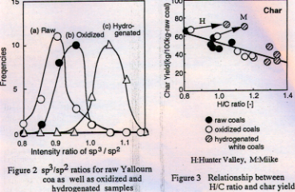
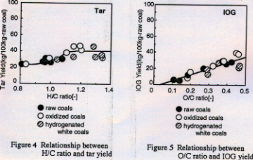
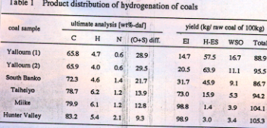

In conclusion, the pyrolysis reactivity of coal is improved by catalytic hydrogenation and can be described as functions of the H/C and O/C atomic ratios, provided thermal hysteresis during hydrogenation is negligible.

References
[1] Isoda, T.; Takagi, H.; Kusakabe, K.; Morooka, S. Energy Fuels, in press.
[2] Mae, K.; Maki, T.; Araki, J.; Miura, K. Energy Fuels, 11 (1997) 825.
[3] Isoda, T.; Tomita, H.; Kusakabe, K.; Morooka, S. Proc. of Intern. Conf. on Coal
Science, (1997) 583.

