1,2,4-Trimethylbenzene의 불균등화 반응을 위한 제올라이트 NU-87 촉매의 특성

이종형, 박세호, 이현구
서울대학교 응용화학부 ·화학공정 신기술 연구소

Characteristics of Zeolite NU-87 Catalyst for the Disproportionation of 1,2,4-Trimethylbenzene

Jong-Hyung Lee, Se-Ho Park and Hyun-Ku Rhee
School of Chemical Engineering and Institute of Chemical Processes
Seoul National University

Introduction
Recently, much attention has been focused on zeolites with intersecting medium (10-MR) and large (12-MR) pores, e.g. NU-87 and MCM-22, owing to their interesting structural features. The synthesis of zeolite NU-87 was first reported by Casci and Stewart in 1990 [1]. NU-87 has parallel 10-MR channels with a diameter of 4.7Å×6.0Å linked together by 12-MR cavities which are accessible only via the 10-MR windows of the channels. Due to this peculiar pore system, NU-87 may offer a unique reaction activity, selectivity and stability not found in other zeolites and serve as favorable catalysts for the disproportionation of aromatic compounds with somewhat bulky diphenylalkane intermediate. Although this zeolite does not show linear combination of the advantageous catalytic behaviors of medium and large pore zeolites, high diffusion rates (12-MR), high shape selectivity and low deactivation (10-MR) are expected to some extent. For instance, NU-87 was found to possess interesting shape selective properties in the conversion of methylnaphthalenes [2].
Disproportionation is a practical process for the interconversion of aromatics, especially for the production of dialkylbenzenes. Several newly developed processes producing dialkylbenzenes which are particularly rich in p-isomers compared to their thermodynamic equilibrium compositions, for example, MSTPD (Mobil Selective Toluene Disproportionation Process) for p-xylene production and Taiwan Styrene Monomer Company’s selective PDEB (p-Diethylbenzene) process for p-DEB production were presented in a recent review paper [3]. Disproportionation of 1,2,4-Trimethylbenzene (TMB) to yield xylene and tetramethylbenzene (TeMB) is also an important process in the petrochemical industry because of the continuous demand for high-valued p-xylene and 1,2,4,5-TeMB. Xylenes are the key raw materials for polyesters, plasticizer and engineering plastics. 1,2,4,5-TeMB is also used for obtaining pyromellitic anhydride for heat resistant polyimide resin.
In this study, zeolite NU-87 was prepared by hydrothermal method and applied to the disproportionation of 1,2,4-TMB. Catalytic properties of NU-87 were investigated on the basis of product distributions and time-on-stream behavior of catalytic experiments. For comparison, the results obtained with zeolite MCM-22 that has a pore geometry similar to NU-87 and large pore zeolites such as mordenite and beta, were also included. In addition, ethylbenzene disproportionation was adopted as diagnostic catalytic test for analyzing acidity and pore structure of zeolites.

Experimental
NU-87 and MCM-22 were synthesized as previously described [1,2,4]. Decamethonium bromide and hexamethyleneimine were used as templating agents. To remove the template, as-synthesized zeolite was calcined. It was then transformed into H-form via a threefold ion exchange with 1M aqueous solution of NH₄NO₃ at 343K for 8 h followed by washing and calcination in air at 773K for 5 h. H-mordenite (Engelhard, Si/Al=22.5) and H-beta (PQ Corp., Si/Al=11) were taken from commercial samples.
Crystal structure and phase purity were confirmed by X-ray powder diffraction (XRD) patterns and IR spectra in the framework region of zeolites synthesized. Morphology and particle size were estimated from scanning electron microscopy (SEM). NH₃-TPD and pyridine chemisorbed FTIR were employed to examine acid properties of zeolites. For in situ IR measurements, thin self-supporting samples with a weight of 20 mg were prepared and pretreated in vacuum cell at 773K for 3 h. After treatment, pyridine was admitted into the cell at 423K and saturated. The samples were then outgassed at 423K, 473K, 573K, 623K and 673K, respectively, for 30 min under vacuum, and the spectra were recorded.
The disproportionation of 1,2,4-TMB were carried out in a fixed-bed flow reactor under atmospheric pressure with WHSV=2.8 h⁻¹ and He/feed molar ratio of 12. Catalysts were activated in a He flow at 773K for 30 min and then cooled down to the reaction temperature. The products were analyzed with HP 5890 gas chromatography equipped with FID and the capillary column HP-INNOWAX (60 m, 0.32 mm, 0.50 µm ID).

Results and discussion
The XRD pattern of as-synthesized form of zeolite NU-87 agreed well with that in the published literature. In case of calcined form, reduced intensity was observed at 20~21 2θ degree. This suggests that loss of crystallinity and structural change in specific region have occurred. In combination with IR study in framework spectral region (based on band shift at wavenumbers of the asymmetric stretching T-O vibration), it is supposed that Al is partially removed from the framework although the data were not presented here. Dealumination during calcination has been reported in an earlier study using ²⁷Al MAS NMR spectroscopy [2]. NU-87 appeared under the SEM as rectangular rods with a length of 0.2~1.0 µm. XRD and SEM analyses of MCM-22 verified that the zeolite was successfully synthesized.
FT-IR spectra of zeolite NU-87 and others in the 1700~1400 cm⁻¹ region are given in Figs. 1 and 2. In general, the band at ca. 1540 cm⁻¹ and 1450 cm⁻¹ are assigned as Brønsted-bound pyridine and Lewis-bound pyridine, respectively. In our experiment, these bands were observed at ca. 1543 cm⁻¹ and 1453 cm⁻¹, respectively. The integrated absorbances of the bands at ca. 1543 cm⁻¹ and 1453 cm⁻¹ (integration regions approximately 1515~1565 cm⁻¹ and 1435~1470 cm⁻¹, respectively) were determined to measure the amount of pyridine adsorbed on Brønsted and Lewis acid sites, respectively. Absorption coefficients of the pyridine IR bands were taken from Ref. [5]. Quantitative results are presented in Table 1. The amount of pyridine adsorbed on Brønsted acid sites at 423K is decreased in the order
Table 1. Acidity of various zeolites measured in mol of adsorbed pyridine per g of the zeolite at various temperatures

Zeolite | Brønsted |  |  |  |  |  | Lewis
Zeolite | 423  K | 473  K | 573  K | 623  K | 673  K |  | 423  K | 473  K | 573  K | 623  K | 673  K
NU-87 | 156 | 138 | 98 | 65 | 30 |  | 52 | 41 | 26 | 23 | 16
MCM-22 | 156 | 135 | 83 | 45 | 9 |  | 44 | 36 | 19 | 16 | 13
MOR | 188 | 145 | 62 | 24 | - |  | 48 | 44 | 33 | 29 | 24
BEA | 90 | 59 | 18 | 4 | - |  | 100 | 79 | 48 | 37 | 22
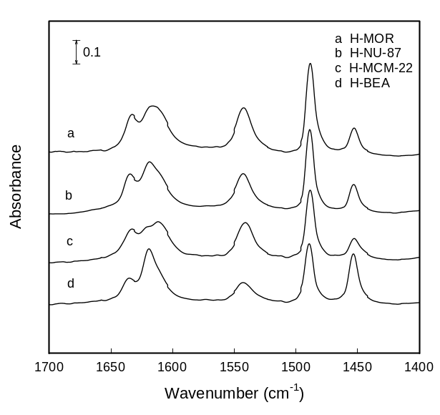
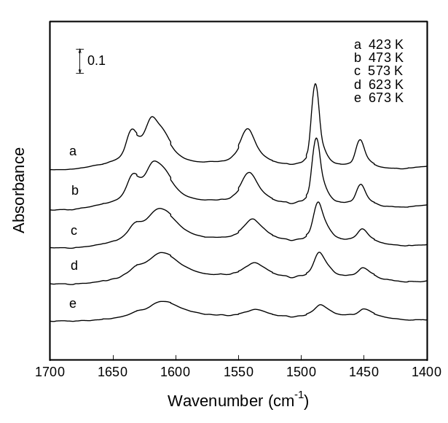
Fig. 2. IR spectra of various zeolites after adsorption and desorption of pyridine at 423K.
Fig. 1. IR spectra of H-NU-87 after adsorption and desorption of pyridine at various temperatures.

H-mordenite > NU-87 MCM-22 > H-beta. It is considered that mordenite has a high density of Brønsted acid. However, Brønsted acidity of mordenite rapidly decreases compared to that of NU-87 and MCM-22 with increasing temperature. In case of NU-87 and MCM-22, some amount of protonated pyridine is still remained after desorption at 673K, indicating the presence of strong acid sites. Acid properties of NU-87 are similar to MCM-22. This is in accordance with our previous results using NH₃-TPD. The zeolites investigated in this study show little differences in the Lewis acidity, except for the case of H-beta. H-beta has a large amount of Lewis acid sites instead of Brønsted acid sites.
The results obtained in the disproportionation of 1,2,4-TMB over NU-87 and other zeolites are shown in Figs. 3 and 4. NU-87 is found to have considerable catalytic potential for this reaction in terms of xylene yield and stability. Although the total conversion of 1,2,4-TMB over NU-87 is lower than that over H-mordenite and H-beta in the beginning of the reaction, the yield of xylene is found higher. The selectivity to xylene over NU-87 is also very high compared with H-mordenite and H-beta. These results are elucidated in view of the peculiar pore structure of zeolite NU-87. Bulky intermediate species can be trapped in the 12-MR cavities of NU-87 and these species may be further catalyzed to products of smaller sizes such as xylene during diffusion out through 10-MR channels. In addition, NU-87 shows a better catalytic stability than other zeolites owing to the characteristics of NU-87
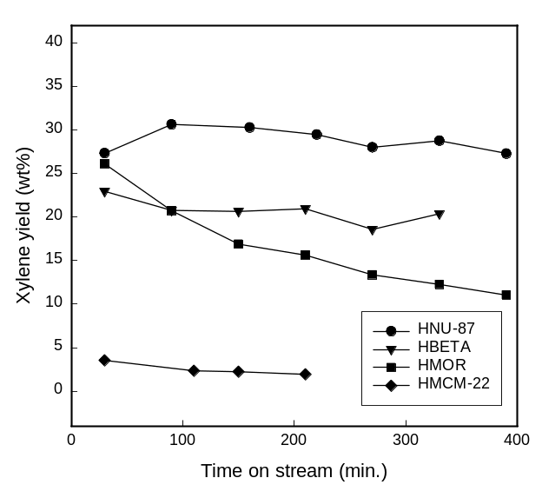
Fig. 4. Xylene yield as a function of the time on stream over various catalysts from the disproportionation of 1,2,4-TMB.
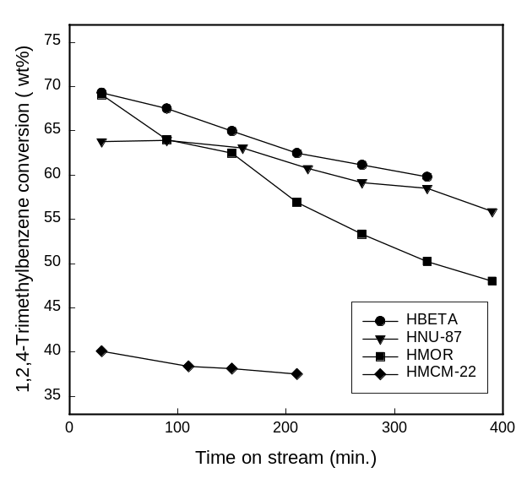
with 10-MR channel.
Fig. 3. Conversion as a function of the time on stream over various catalysts for the disproportionation of 1,2,4-TMB.
In case of MCM-22, catalytic stability is also higher compared with large pore zeolites but the conversion of 1,2,4-TMB is found much lower. Especially, the yield of xylene is very low although the conversion is about 40 %. It is observed that isomerization to 1,2,3- and 1,3,5-TMBs prevails against disproportionation in the conversion of 1,2,4-TMB over MCM-22. Despite similar acid properties between NU-87 and MCM-22, these two zeolites show different catalytic behavior in the disproportionation of 1,2,4-TMB. These features are attributed to delicate difference of structure between NU-87 and MCM-22. Results of ethylbenzene disproportionation (in our earlier study) support this estimation. It was reported that ethylbenzene can be catalyzed to benzene and diethylbenzene on Brønsted acid sites located in 10-MR pores or on the outer surface of the zeolite particles [6]. MCM-22 has independent 10-MR channels and surface pockets not present in NU-87. This is the reason why MCM-22 exhibited a very high activity for the disproportionation of ethylbenzene. On the contrary, distinctive features from large pore zeolites were not observed in case of NU-87.
Putting all results described above together, it is concluded that NU-87 has more free space and higher accessibility to 12-MR cavities than MCM-22. To elucidate the novel catalytic features, a kinetics study of 1,2,4-TMB transformation over zeolite NU-87 is in progress now through investigation of the effect of space time.

References
- Casci, J. L. and Stewart, A.: Eur. Patent Appl., 377,291(1990).
- Gläser, R., Li, R., Hunger, M., Ernst, S. and Weitkamp, J.: Catal. Lett., 50, 141(1998).
- Tsai, T. C., Liu, S. B., Wang, I.: Appl. Catal. A, 181, 355(1999).
- Corma, A., Corell, C. and Pérez-Pariente, J.: Zeolites, 15, 2(1995).
- Emeis, C. A.: J. Catal., 141, 347(1993).
- Weitkamp, J., Breuninger, M., Karge, H. G. and Hunger, M.: Proc. 12th IZC, Vol. 4, 2697(1999).

