MFI 형 ferrisilicate를 이용한 벤젠의 하이드록시 촉매반응

전환섭, 이명우, 남상성, 김성보, 이규완
한국화학연구소 화학기술연구단

Catalytic hydroxylation of benzene with nitrous oxide
over MFI type ferrisilicate zeolites

Chun Hwan-Sup, Lee Myung-Woo, Nam Sang-Sung, Kim Seong-Bo, and Lee Kyu-Wan
Chemical Technology Division I, Korea Research Institute of Chemical Technology

Introduction
Many attempts have recently been made to find a one step synthesis of phenol from benzene. Conventional partial oxidation methods with molecular oxygen mainly led to destruction of the aromatic ring and hence gave low selectivity towards phenol. Although there was a new proposal to hydroxylation of benzene with an oxygen/hydrogen mixture, the use of alternative oxidants promises the best results. While hydrogen peroxide is the favorite oxidant in liquid phase benzene hydroxylation on Ti-silicate-1, nitrous oxide is more preferred in the gas phase reaction.
It is reported that Fe-containing ZSM-5 zeolites and their ferrisilicate analogs are shown to be the most efficient catalysts among wide range of catalysts for the benzene hydroxylation with nitrous oxide as an oxidant. In particular, as shown by Kharitonov et al. [1], ferrisilicate analogs of ZSM-5 zeolite are able to perform one-step oxidation of benzene to phenol by using nitrous oxide. Panov and coworkers [2-3] have investigated the role of iron in the hydroxylation using nitrous oxide decomposition on Fe-ZSM-5.
In this work, the MFI type ferrisilicates were hydrothermally synthesized under the content of the framework iron. NH₃-Temperature programmed desorption(TPD) was performed to measure the acidic property of prepared zeolites. We have systematically studied the catalytic activity of MFI type ferrisilicate for benzene oxidation to phenol with nitrous oxide.

Experimental
Ferrisilicates of MFI type were synthesized by the hydrothermal method.[4] Various different concentration of iron was introduced from 0.1 to 2 wt.%. Designation of samples reflects wt.% of Fe₂O₃. The prepared samples were 2 wt.% (Si/Fe = 50), 1.5 wt.% (Si/Fe = 75), 1.0 wt.%(Si/Fe = 100), 0.75 wt.% (Si/Fe = 150), 0.5 wt.% (Si/Fe = 200), 0.3 wt.% (Si/Fe = 300) and 0.1 wt.% (Si/Fe = 1000). In a typical preparation, required amount of Fe(NO₃)₃·9H₂O (98% Aldrich) was dissolved in a solution containing H₂O(50 g) and H₂SO₄ (97%, 1.04 g). Tetraethylorthosilicate (TEOS) (43.5 g, 98% Aldrich) was added slowly to this fresh solution under vigorous stirring. The resulting yellowish solution was stirred at 298 K for 3 hrs and then tetrapropylammonium bromide (TPABr) (6.52 g) in H₂O (30 g) as a template was added. NaOH (1.6 g) dissolved in H₂O (20 g) was added to the above mixture under vigorous stirring. Finally, the required amount of NaOH dissolved in 100 g of H₂O was added to the resulting white gel and stirred for 1 h. The final gel mixture was transferred to a Teflon lined stainless-steel autoclave and heated at 443 K for 6 days. The product was washed several times with distilled water and calcined at 773 K for 5 h under nitrogen flow first for 8 h and air flow for 4 h. After calcination, the zeolites were transformed into the acid form via ion exchange with NH₄⁺ and subsequent calcination at 773 K for 5 h in air.
These prepared samples were analyzed with XRD, SEM, BET and TPD technique. X-ray diffraction (XRD) analysis was carried out using a Rigaku D/max-ⅢB diffractometer with CuKα radiation (λ = 1.5406 Å). The morphology of the crystalline phase was done on a JEOL JSM-840A scanning electron microscope(SEM). Specific surface areas, pore volumes and pore size distributions of prepared catalysts were determined from nitrogen adsorption isotherms at 77k obtained by using a Micrometrics ASAP 2400. Acidity measurements were determined by ammonia-TPD by using a conventional flow system with a thermal conductivity detector. About 0.5g of sample was loaded in a quartz reactor and heated at 873 K for 4 h under helium atmosphere. After cooling the sample to 373 K, pure ammonia was adsorbed for 1h. Then the sample was swept with helium for 30min at 373 K to remove physisorbed ammonia and finally TPD measurement was performed from 373 K to 873 K at a heating rate of 10 K/min.
The hydroxylation experiments were carried out using a fixed-bed flow reactor equipped with an on-line chromatography. The stainless steel reactor was filled with 0.5g catalysts. Nitrous oxide and the other gases were directly supplied with mass flow controllers. Benzene was fed into the reactor with a high-pressure liquid pump and heated at 150 ºC. Total flow was kept at 3 ml/min with nitrogen as balance. Analysis of the product stream was performed by on-line gas chromatography (Hewlett Packard 5890 Series II Plus) equipped with a TCD and FID.

Results and discussion

Three peaks of NH₃ desorption are observed in the TPD-spectra, as shown in figure 1. The low-temperature peak was assigned to ammonia weakly held or physically adsorbed on the ferrisilicates, whereas the middle-temperature peak was due to NH₃ desorption from defect sites, cations and weak Brönsted and Lewis acid sites. The high-temperature peak is desorption peak of ammonia which was adsorbed on the Brönsted acid sites.[5] The middle
acid sites are considered to main parameter of hydroxylation reaction. It was increased with increasing iron content of the framework up to 0.75 wt.% and then decreases.
The presence of iron on T sites in the zeolite framework gives rise to bridging hydroxyl
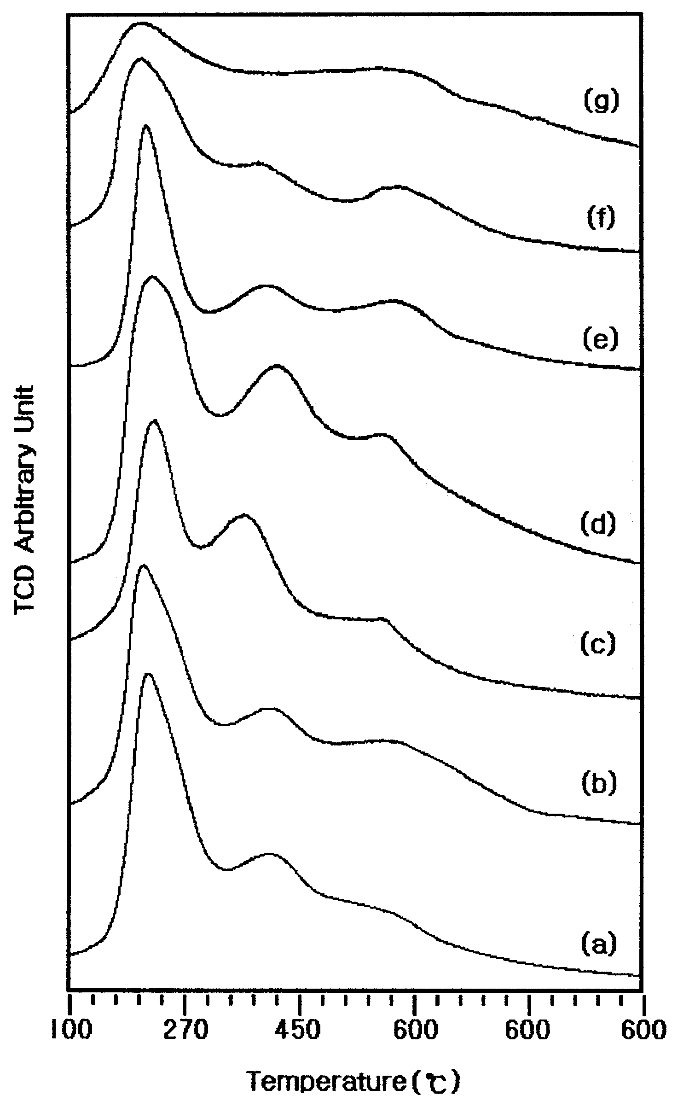
Figure 1. Comparison of NH₃-TPD profiles of various iron contents on Fe-silicate
Zeolites (a) Fe-2.0, (b) Fe-1.5, (c) Fe-1.0 , (d) Fe-0.75
(e) Fe-0.5, (f) Fe-0.3, (g) Fe-0.1
group which act as Brönsted aicd sites. Therefore, the acidity of the zeolite is related to its iron content, and one can expect a linear increase of acidity with increasing iron content of the zeolite. Consequently, the catalytic activity of acid-catalyzed reaction is often directly related to the iron content of the zeolite, as has been shown previously for hydrocarbon conversions.[6] However, more detailed studies have subsequently revealed that other parameters have to be taken into account. It is now commonly accepted that intrinsic acid strength, dependent on the structure and composition of the zeolite, is of major importance. Furthermore, catalysis by zeolites may also originate from the presence of Lewis acid sites, Lewis-Brönsted acid site interactions, and extraframework iron species.[7]
Table 1 shows the conversion of benzene as a function of iron content. In fact, the sample Fe-0.1 containing an extremely small amount of iron in MFI type ferrisilicate zeolite exhibits a very low activity of conversion (0.55%) at 673K. The maximum conversion of benzene to phenol was obtained at Fe-0.75 sample. The conversion of benzene increases rapidly with the increase in iron concentration, peaking at 0.75 wt.% of Fe₂O₃ , Above this concentration has opposite effect. A slight decrease in selectivity takes place and this becomes more profound for the samples. This can be explained by the fact that the successive oxidation of phenol was increased. The Fe-Si samples with optimal iron content exceed essentially in their catalytic efficiency for all known catalysts including ZSM-5 zeolites prepared without intentional introduction of iron.[8] It can be seen that the catalytic activity of ferrisilicate samples in the oxidation of benzene increased with increase

Table 1. Effect of iron content on Fe- silicate zeolites in oxidation of benzene
Catalysts | Conversion(%) | Selectivity(%)
Fe-2.0 | 5.79 | 97.0
Fe-1.5 | 5.56 | 98.1
Fe-1.0 | 12.47 | 99.0
Fe-0.75 | 16.12 | 99.4
Fe-0.5 | 3.32 | 99.5
Fe-0.3 | 2.70 | 99.6
Fe-0.1 | 0.55 | 100
Temperature: 673K
of relative content of incorporated framework iron in the unit cell, but samples with excessive iron content were prohibited from oxidation of benzene. This indicates that the highly dispersed iron species incorporated in the framework sites are mainly responsible for the active species in the benzene oxidation.

Conclusions
The middle acid site in the result of TPD is considered to main parameter of hydroxylation reaction. It increased with increasing iron content of the framework up to 0.75 wt.% and then decreases. MFI type ferrisilicates were shown high conversion of phenol in the hydroxylation of benzene. The conversion of benzene to phenol increased with increasing iron content up to 0.75 wt.% and then rapidly decreases. As a result of the TPD, the high activity is due to highly dispersed iron species of the weak acid strength in the framework sites of MFI type ferrisilicates.

References
- Kharitonov, A.S., Sheveleva, G.I., Sobolev, V.I., Paukshtis, Y. A., Romannikov, V.N., Applied Catalysis A : General, 98, 33 (1993)
- Burch, R., Howitt, C., Appl. Catal. A, 86, 139 (1992)
- Panov, G. I., Shevelera, G. A., Kharitonov, A. S., Romannikov, V. N., Vostrikova, L. A., Appl. Catal. A, 82, 31 (1992)
- Szostak, R., Thomas, T. L., J. Catal. 100, 555 (1986)
- Sasidharan, M., Hedge, S. G., Kumar, R., Microporous and Mesoporous Materials, 24, 59 (1998)
- Sohn, J. R., Decanio, S. J., Fritz, P. O., Lunsford, J. H., J. Phys. Chem. 90, 4847 (1986)
- Zholobenko, V. L., Kustov, L. M., Kazansky, V. B., Loeffler, E., Lohse, U., Oehlmann, G., Zeolites, 11, 132 (1991)
- Suzuki, E., Nakashiro, K., Ono, Y., Chem. Soc. Jpn., Chem. Lett. 953 (1988)

