Magadiite로 부터 Co-Silicalite-1과 Mn-Silicalite-1의 합성 및 특성규명

김명훈,김영희,김선진,안성환,어용선
한국과학기술연구원 재료화학연구센터

Synthesis and Characterization of Co-and Mn-Silicalite-1 from Magadiite

Myung Hun Kim, Younghee Ko, Sun Jin Kim, Sung Hwan Ahn and Young Sun Uh*
Materials Chemistry Research Center, Korea Institute of Science and Technology, P.O. Box 131, Cheongryang, Seoul 130-650, Korea

Introduction
Since the first successful synthesis of TS-1 [1], there have been many reports of the syntheses of microporous metallosilicates [2-3]. The use of conventional synthetic methods and ethoxide or chloride metal sources led to the successful substitution of Ga, Ti and B into zeolite frameworks. However, these methods are not generally applicable to the syntheses of most transition metal substituted frameworks because most of transition metals easily precipitate at high pH as insoluable hydroxides. In order to avoid a hydroxide precipitate, synthetic routes at lower pH are required. Recently, Round et al (Round et al., 1997)[2] synthesized Co and Mn substituted silicalite-1(pure silica ZSM-5) in an aqueous, slightly acidic, fluoride medium using tetrahalometallate compounds as sources of Co and Mn. Other report of the synthesis of Co or Mn substituted ZSM-5 included descriptions of its formation only in a very narrow range of OH/SiO₂ ratio[3].
Layered silicates such as kanemite (NaHSi₂O₅.H₂O), magadiite (Na₂Si₁₄O₂₉.11H₂O), makatite (Na₂Si₄O₉.5H₂O) and ilerite (Na₂Si₈O₁₇.xH₂O ) were proposed as good precusors to synthesize framework materials. Pál-Borbély et al.[4] have synthesized the MFI, MEL and FER type zeolites by recrystallization of Magadiite. Proton or transition metals can easily exchange for sodium ions that reside between the layers of layered silicate[5]. The proton exchanged silicates are sufficiently acidic to allow proton transfer to an amine group which is contained transition metal. So, these “layered silicic acids” are expected to be good precusors for the synthesis of metallosilicates. Recrystallization of such precusor may not require transport process mediated in the conventional synthesis by the liquid phase.
We report here the synthesis and characterization of Co and Mn isomorphously substituted silicalite-1 prepared from Co²⁺ or Mn²⁺ ion exchanged magadiite. By stabilizing Co²⁺ and Mn²⁺ species between the layers of silicates, it is possible to prepare a framework material which the cobalt and manganese ions are present in the tetrahedral framework sites.

Experimental
Synthesis
Na-magadiite was prepared by the gel composition Na₂O: 5SiO₂:122H₂O. The gel was heated under autogeneous pressure at 160ºC for 1 day. H-magadiite (Silicic acid) was prepared by titration of 0.1N HCl to a final pH of 2.0 from Na-magadite. The chemical composition of H-magadiite which was washed with water and ethanol and dried at 40ºC was Na_{0.1}H_{1.9}Si₁₄O₂₉.
Ion exchange of magadiite by cobalt and manganese chloride was done using a normal batch method at 80°C. The ion exchange reaction proceeded rapidly. Co²⁺ and Mn²⁺ ion exchanged magadiite samples were suspended in 0.1M tetrapropylammonium hydroxide solution. The molar ratio of the mixture was ion exchanged magadiite: 0.29TPA :163H₂O. The reaction mixture was heated under autogeneous pressure in teflon-lined autoclave at 160ºC.
Characterization
ESR measurements were performed at 77 K on a Bruker ER-200D spectrometer operating at X-band (~9.45GHz) with 100-KHz field modulation. A Rigaku D/Max-IIA diffractometer with Cu Kα radiation was used for the initial XRD analysis of the samples. The IR spectra were recorded between 400-1400cm⁻¹ on a Perkin Elmer 1600 M-80 spectrometer. BET surface areas were determined using Micrometrics ASAP 2000 analyzer. All samples were outgassed at 200ºC under vacuum for 2 hours. The NH₃ TPD was obtained on a Micromeritics TPD/TPR 2900 analyzer. Electron-probe microanalysis was carried out on samples using Philips, CM 30 scanning transmission electron microscopy. Chemical analyses were performed by a Jarrell-Ash Poliscan 61E inductively coupled plasma (ICP ) spectrometer and a Perkin-Elmer 5000 atomic absorption spectrophotometer.

Results and discussions
X-ray diffraction
The X-ray powder diffraction patterns of calcined Co- and Mn-Silicalite-1 indicate that all the peaks in the data could be indexed on the basis of the orthorhombic lattice symmetry and did not reveal the presence of extra phases related to cobalt oxide species as Fig. 1. Singlet peaks at two theta 24.5º and 29.5 º are observed for two smaples instead of doublets which observed for silicalite-1. This is ascribed to a change of symmetry from monoclinic to orthohombic by incorporation of metal into framework of silicalite-1.
Morphology, symmetry and cell parameter of the zeolites are known to depend on amount of the defects (generated by subtracting some adjacent Si atoms) in different synthesis methods. Also orthorhombic/monoclinic phase transition on MFI framework has been observed and documented many times on temperature variation, sorption of molecules, on the effect of different synthesis conditions or as a result of the isomorphous substitution of silicon by other elements[6-7].
The sample which obtained after hydrothermal treatment using the slurry of tetrapropylammonium hydroxide, CoCl₂ or MnCl₂ and silicic acid of magadiite was amorphous to X-rays. The above results imply that only when Co²⁺ or Mn²⁺ ions are protected from hydroxyl groups as present between the layers, they can incorporate to the framework during the hydrothermal treatment.
ESR spectroscopy
The ESR spectrum of the Co²⁺ or Mn²⁺ ion exchanged magadiite, as synthesized and calcined sample are shown in Fig. 2. The ESR spectrum of Co-silicalite-1 in Fig. 2(a) have similar parameters of the anisotropic g tensor that correspond to previous ESR data on Co²⁺[8]. ESR data of the calcined sample shows broadening signal and lower intensity than as-synthesized sample. That clearly shows that Co²⁺ ions have been removed from the lattice sites during the calcination and subsequently oxidized to Co³⁺ which are not active to ESR (Co³⁺ ion has d⁶ electron state).
The ESR spectrum of Mn-silicalite-1 are composed of six well resolved hyperfine lines arising from the interaction of the Mn²⁺ ion with the I=5/2 spins at g=2.01 and A=87.5 G. The hyperfine structure of ESR spectrum is characteristic of atomically dispersed and immobile ions. ESR data of the sample that calcined, hydrate state show loosening of the hyperfine signal and lower intensity than as-synthesized sample. That clearly shows that Mn²⁺ ions have been removed from the lattice sites during the calcination and subsequently oxidized to Mn³⁺ which are not active to ESR ( Mn³⁺ ion has d⁴ electron state). The ESR signal obtained from precusor (Mn²⁺ ion exchanged magadiite) shows very weak hyperfine splitting at g=2.02 and A=96.0 G in Fig. 2(b). It suggests that Mn²⁺ is localized in the form of Mn(H₂O)₆²⁺ between the silicate layers. The ESR results clearly show that even though Mn species were localized between the silicate layers it became well dispersed during the incorporation in the zeolite framework.
IR spectroscopy
Recently, Round et al[2] synthesized Co- and Mn-silicalite-1 in fluoride medium and reported incorporation of Co²⁺ or Mn²⁺ into silicalite-1 framework resulting in additional peak around 1000cm⁻¹. The IR spectrum of samples also exhibits an additional absorption band at 995cm⁻¹, which is not present in the spectrum of pure silicalite-1 as Fig. 3. Substitution of Co²⁺ or Mn²⁺ into the silicalite-1 framework created a new peak due to the T-O-T asymmetric vibration, which indicates the heteroatom substitution into the framework.
Acidity measurement and BET surface area
The acidic properties of samples were studied to examine the intrinsic acidity caused by the incorporation of Co²⁺ or Mn²⁺ instead of Si into the framework. Fig.4 shows the strength and amount of the acidic sites by temperature-programmed desorption of NH₃. The profiles of Co²⁺ and Mn²⁺ substituted silicalite-1exibited two peaks: a low temperature peak near 180ºC corresponding to weak acid sites and a high temperature peak near 350ºC corresponding to relatively strong acid sites[3]. The strong acid sites are attributed to the formation of a new Si-O-M(M= Co or Mn) linkage which gives rise to a net negative charge and becomes a source of lewis acidity. However weak intensity in the TPD profile of ammonia implies that the amount of strong acid sites would be low.
The BET surface areas for M-Silicalite-1(M=Co or Mn) and Silicalite-1 are 439, 431 and 412 m²/g, respectively. The results of relatively large surface areas of M-Silicalite-1(M=Co or Mn) confirm that the samples have good crystallinity.
Chemical analysis
The chemical composition of as synthesized Co- and Mn-Silicalite-1 was Co_{2.3}Si_{93.7}O₁₉₂ and Mn_{5.2}Si_{90.8}O₁₉₂ as determined by electron microprobe analysis. The Si/M(M=Co or Mn) ratio in the samples, which synthesized using our method is similar to the values of reported in the literature (Co_{2.9}Si_{92.9} Zn_{0.1}O₁₉₂ and Mn_{0.7}Si_{94.9} Zn_{0.4}Na_{0.1}O₁₉₂ )[2].
The M/Si ratio in the M-Silicalite-1(M=Co or Mn) is lower than those of the corresponding precursor layered silicates, indicating that some of Co and Mn species in precursor remains in the liquid phase after the crystallization.

Conclusion
We have synthesized Co- and Mn-Silicalite-1 by a new route, using Co²⁺ or Mn²⁺ ion exchanged magadiite precursor. The results of ESR spectroscopy, X-ray powder diffraction and IR spectroscopy data show that Co²⁺ or Mn²⁺ ions are present in the tetrahedral framework sites. The calcined M-Silicalite-1(M=Co or Mn) has orthorhombic symmetry which is known to calcined titanium, and chromium silicalite-1. This new synthetic procedure will lead to the syntheses of other metallosilicate framework materials as pure phases.

Acknowledgments
This work is supported by the Korea Institute of Science and Technology under the contract 2E15210 and Brain Pool Program of Korean Government.

References
(1) M. Taramasso, G. Perego and B. Notari, U.S. Patent 4,410,501 (1983)
(2) C.I. Round, C.D. Willams and C.V.A. Duke, J. Chem. Soc. Chem. Commun.,1997, 1849
(3) Inui, T., Kim, J.B., Takeguchi, K., Zeolite, 1996, 17, 354-360
(4) G. Pál-Borbély, H.K. Beyer, Y. Kiyozumi and F. Mizukami, Microporous Materials, (1997), 11, 45
(5) T. Hatsushika, K. Imaizumi, T. Suzuki and H. Ohya, Nippon Ion Kokan Gakkaishi 7, 1996, 2, 117
(6) B.F. Mentzen and M. Sacerdote-Peronnet, Mat. Res. Bull. 1993, 28, 1017
(7) T. Chapus, A. Tuel, Y.B. Taarit and C. Naccache, Zeolites, 1994, 14 , 349
(8) Kurshev, V., Kevan, L., Parillo, D.J., Pereira, C., Kokotailo, G.T., Gorte, R.J, J. Phys. Chem.,1994, 98, 10160
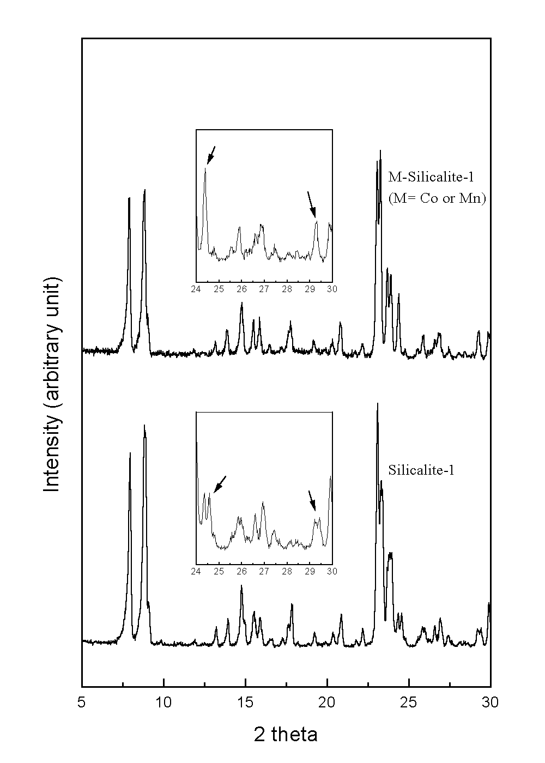
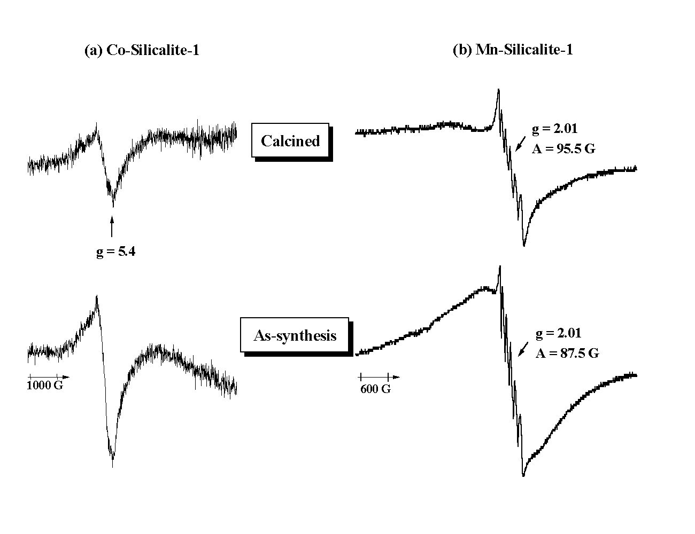
Fig. 2. ESR spectrum of (a)Co-Silicalite-1
and (b) Mn-Silicalite-1

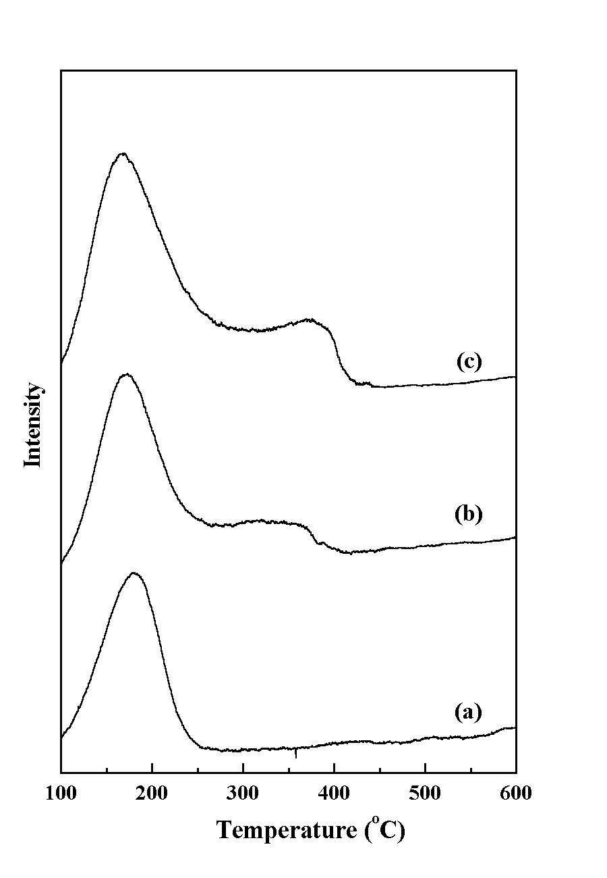

Fig.1. TPD profiles of (a) Silicalite-1,
(b)Co-Silicalite-1 and (c) Mn-Silicalite-1

Fig.3. IR spectrum of of calcined
M-Silicalite-1 (M=Co and Mn)
Fig.1. X-ray powder diffraction patterns
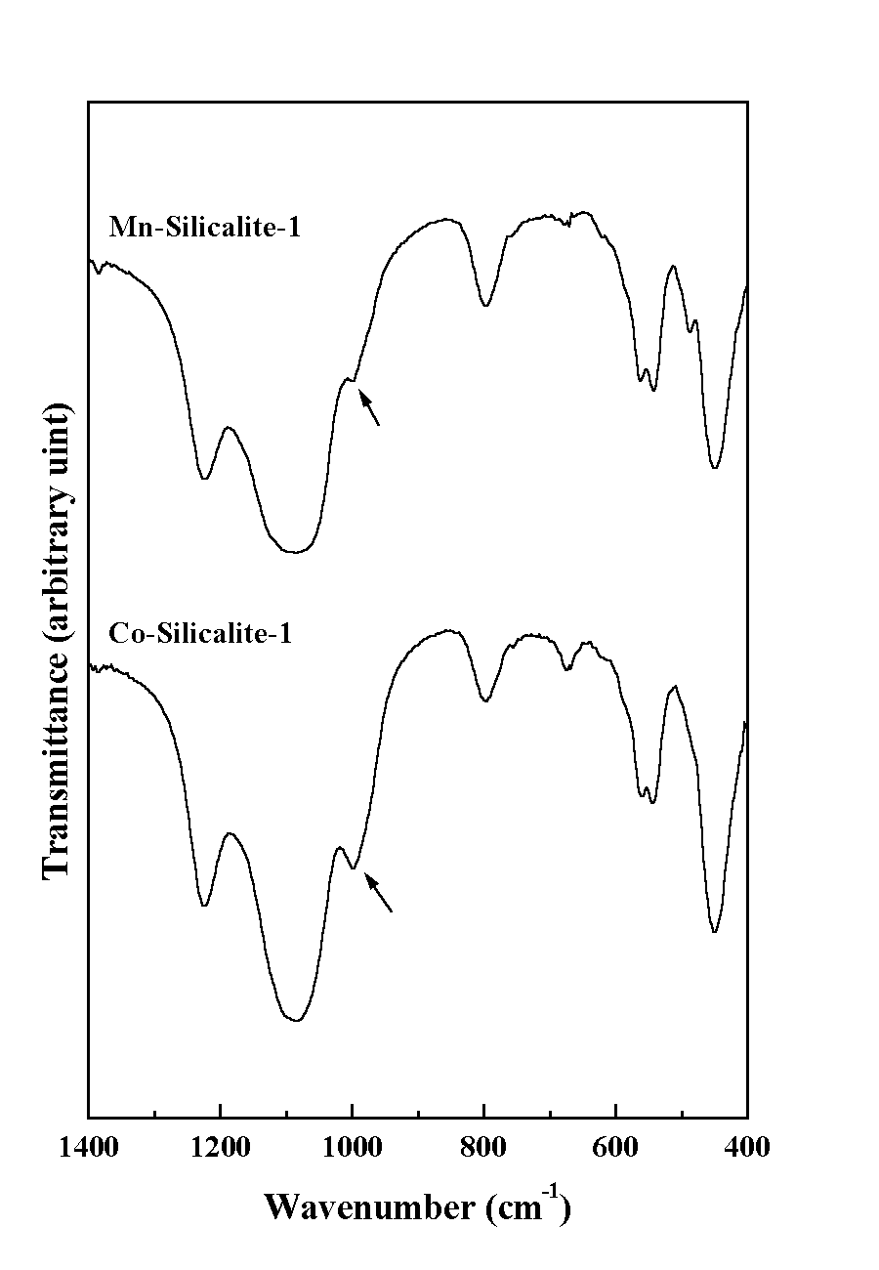of calcined M-Silicalite-1 (M=Co and Mn)

