수력학적 상호작용력이 입자 흡착에 미치는 영향

노창현, 최호석
충남대학교 화학공학과

Effect of Hydrodynamic Interactions on the Deposition of particles

Chang-Hyun Roh, Ho-Suk Choi
School of Chemical Engineering
Chungnam National University

Introduction

The adsorption of large particles on solid surfaces is a problem which has been the subject of a great deal of interest during recent years. This process is mainly constituted by two basic steps: the transport of the objects from the bulk towards the surface and their subsequent adhesion on it. A number of models have been proposed in recent years trying to describe the process. In particular, the random sequential adsorption model(RSA)[1] was initially introduced as a simple model which captures the essentials of its kinetics, neglecting the transport of particles to the surface. In this communication we will focus on the effects of hydrodynamic interactions(HI) in the adsorption process. In our study, the effects of HI on the kinetics and the structure of particle deposits is investigated for two different systems: Brownian particles and large particles($N_{G}=∞$).
At first, we describe an approximate method for calculating the mobility tensors to incorporate the effect of hydrodynamic interactions with the deposition process. Secondly, we have developed a simple Monte carlo algorithm which enables us to generate the same structure and kinetics of the Brownian particle deposits without using complicated sequential Brownian dynamic simulation. Lastly, using the same method as Pagonabarraga and Rubi[2], we investigate the dynamics of large particles as well as the kinetics and the structure of particle deposits.

Theory

Approximation of the diffusion tensor
The diffusion tensor D is related to the friction tensor R through the Einstein relation $D={\text{kTR}}^{ −1}$. Far from the surface, D becomes independent of the position of sphere and is given by the Stokes-Einstein relation $D(∞)={\text{IkT}}/6\text{πμ} a_{P}$, $μ$ being the viscosity of the fluid and I the unit tensor. In general, the position dependence of the diffusion tensor may be derived as follows. Using the linear dependence of the force F and torque L on the translations and angular velocities, $u$ and $Ω$, respectively, one has defined Eq(1).
$F=A⋅u+\overset{\text{\sim }}{B}⋅Ω$ (1)
$L=B⋅u+C⋅Ω$ (2)
where the second rank tensors A,B, and C are components of the resistance matrix. $\overset{\text{\sim }}{B}$ represents the transpose of matrix B. For an isolated sphere there is no coupling between the torque and the translational motion(B=0). However, in the presence of boundaries, e.g., a sphere near a surface, the hydrodynamic interaction produces such a coupling. After elimination of the angular velocity in Eq(1). And Eq(2), one finds
$F=F−B⋅C^{ −1}⋅L=(A−B⋅C^{ −1}⋅B)⋅u$ (3)
This shows that the effective force acting on the particle,
$F_{\text{eff}}=F−B⋅C^{ −1}⋅L$ (4)
is linearly related to the velocity through the effective friction tensor
$R_{\text{eff}}=A−B⋅C^{ −1}⋅B$ (5)
This is the friction tensor that must be used in the Einstein relation to obtain the diffusion tensor.
The lubrication forces depend on the local flow of the fluid in the small regions between the moving particle and (i) the plane and (ii) the adsorbed spheres. Since these regions are well disconnected, one can assume as a first approximation that they contribute additively to the resulting force, and thus also additively to the effective friction tensor. Under this approximation, the friction tensor R, splits up into contributions due to the surface and to the preadsorbed particles. In a dilute suspension of particles, only one or two nearest neighbor interactions are important. Thus, one can have
$R=R_{\text{SP}}+R_{S1}+R_{S2}−2\text{RI}$ (6)
where $R_{\text{SP}}$ is the friction tensors of one sphere in the presence of a plane, without any other sphere being present, and $R_{S1}$and $R_{S2}$ are the friction tensor of two isolated spheres translating through a quiescent fluid; the indexes 1 and 2 referring to the two nearest neighbors. In the limit where the particle is far from the line substrate, the friction tensor becomes the Stokes-Einstein relation RI, where $R=6\text{πμ}a_{P}$. Therefore, both the tensorial character and the spatial dependence of the friction are due to the presence of other objects.
For the case of sphere-plane friction, the explicit analytical expression of $R_{\text{SP}}$ is
$R_{\text{SP}}=R\left[\begin{matrix}\frac{1}{d_{| |,\text{sp}}} & 0 \\ 0 & \frac{1}{d_{,\text{sp}}}\end{matrix}\right]$ (7)
where, from Brenner’s original work,
$d_{| |,\text{sp}}(x)=1−\frac{9}{\text{16}x}+\frac{1}{8x^{3}}−\frac{\text{45}}{\text{256}x^{4}}−\frac{1}{\text{16}x^{5}}$ (8)
where $x={h_{t}}/{a_{P}}$ at the height $h_{t}$ and, when $σ/{a_{P}}<1$,
$d_{| |\text{,,}\text{sp}}(σ)=−\frac{1}{\frac{8}{\text{15}}\text{ln}(σ/{a_{P}})−0\text{.}\text{9588}}$ (9)
where $σ$ represents gap distance between sphere and plane, and, in order to simplify the calculation, Dahneke’s approximation for $d_{,\text{sp}}$ has been used instead of exact form as follows:
$d_{,\text{sp}}=\frac{x}{1+x}$ (10)
For the case of particle-particle friction of equal spheres,
$R_{\text{SS}}=R\left[\begin{matrix}\frac{1}{d_{| |\text{,,}\text{ss}}} & 0 \\ 0 & \frac{1}{d_{,\text{ss}}}\end{matrix}\right]$ (11)
where, for two equal spheres,
$d_{| |\text{,,}\text{ss}}(x)=(A_{\text{11}}(x)+A_{\text{22}}(x))/2−A_{\text{12}}(x)$ (12)
$d_{,\text{ss}}(x)=(B_{\text{11}}(x)+B_{\text{22}}(x))/2−B_{\text{12}}(x)$ (13)

Trajectory analysis
As the particle diffuses more easily parallel rather than perpendicular to the plane due to hydrodynamic interaction, no strong differences of the structure and the saturation coverage of particle deposits are observed with RSA predictions, although significant differences are observed in both initial and asymptotic kinetics. However, if gravity is present and the density of particle is significantly larger than that of fluid, the randomization effect due to diffusion process disappears and the hydrodynamic effect would somehow affect the dynamics of particles. To elucidate the effects of the hydrodynamic interaction, a one-dimensional model is proposed. In this model, spherical particles of radius $a_{P}$ falling down sequentially towards the substrate line due to the presence of a gravity field interact with the nearest preadsorbed particles and also with the line substrate. When they reach the line, they are accepted on the line if there is enough room for them; otherwise, they are rejected. Once the particles adsorbed, they stick on the surface. During the process, the incoming particle is assumed to interact only with its nearest neighbors on the line. In this calculation, inertial and diffusion effects are neglected.
As mentioned in the previous section of this chapter, the additivity of the friction tensors is assumed. Under this approximation, the dynamics of the incoming particles is governed by the equation
$u=D⋅F$ (14)
where D is the mobility tensor and $F=F_{g}=m_{\text{app}}g$, where $m_{\text{app}}g=4{πa}_{p}^{3}{Δρ}/3$ with $Δρ=(ρ_{p}−ρ_{f}),ρ_{p}$ being the density of the particle and $ρ_{f}$ the density of the fluid.
In the presence of one preadsorbed particle, the overall friction tensor can be calculated as follows:
$R=R_{\text{sp}}+R_{\text{ss}}−\text{RI}$ (15)
where $R_{\text{sp}}$ and $R_{\text{ss}}$are given by Eq.(7) and Eq.(11), respectively. Eq.(11) is expressed in polar coordinates and can be transformed into the Cartesian coordinates as follows:
$R_{\text{ss}}=D_{\text{ss}}^{−1}$ (16)
where $D_{\text{ss}}$ is a mobility tensor for sphere-sphere interaction
$D_{\text{ss}}=\frac{1}{R}\left[\begin{matrix}d_{\text{11}} & d_{\text{12}} \\ d_{\text{21}} & d_{\text{22}}\end{matrix}\right]$ (17)
where
$d_{\text{11}}=d_{| |,\text{ss}}{\text{cos}}^{2}θ_{a}+d_{,\text{ss}}{\text{sin}}^{2}θ_{a}$ (18)
$d_{\text{12}}=d_{\text{21}}=(d_{| |\text{,,}\text{ss}}+d_{,\text{ss}})\text{cos}θ_{a}\text{sin}θ_{a}$ (19)
$d_{\text{22}}=d_{| |\text{,,}\text{ss}}{\text{sin}}^{2}θ_{a}+d_{,\text{ss}}{\text{cos}}^{2}θ_{a}$ (20)

Result and Discussion

From the friction tensor, one can calculate the mobility tensor from Eq.(16). Now Eq.(14) is then solved numerically through using a 4-th order Runge-Kutta method. The unit of length is the diameter of the spheres and the unit of time is $9{{\text{υρ}}_{f}}/{a_{p}}g Δρ$, with $υ$ the kinematic viscosity of the fluid. With these units, Eq.(14) is dimensionless and, therefore, does not depend on either the kind of particles or on the medium. Therefore, the final position of the incoming particles will not depend on their mass or volume. The initial conditions are such that the incoming particles will not depend on their mass or volume. The initial conditions are such that the incoming particle is at a height of 50, where the hydrodynamic interaction is negligible, and the horizontal position starts close to the adsorbed particle and is progressively displaced from the axis. In this way, one can study the final position of incoming sphere on the surface, $x_{s}$ as a function its initial distance away from the y-axis in the bulk phase, $x_{b}$. In this calculation, no colloidal forces are taken into account.
Figure 1 represents trajectories of particles near a preadsorbed particle. A small dot represents the center of the adsorbing particle and a solid line represents a sample trajectory near a preadsorbed particle. All particles starting from $x_{b}$<0.5 are eventually fixed at $x_{s}$=1.086. This phenomenon was not observed in previous work[3]. To investigate the contributions coming from the presence of the two nearest adsorbed spheres, we solved Eq.(14) with the approximate friction tensor defined n Eq.(6). Figure 2 shows the trajectory relation for this case while dashed line represents the trajectory relation for BD model. Again the hydrodynamic repulsion layers are observed in the vicinity of two particles.

References

- J.Evans. Rev. Mod. phys. 65 (1993) 1281
- I. Pagonabarraga, J. M. Rubi, phys. Rev. Lett. 73 (1994) 114
- D. J. Jeffrey, Y. Onishi, J. Fluid Mech., 139 (1984), 261

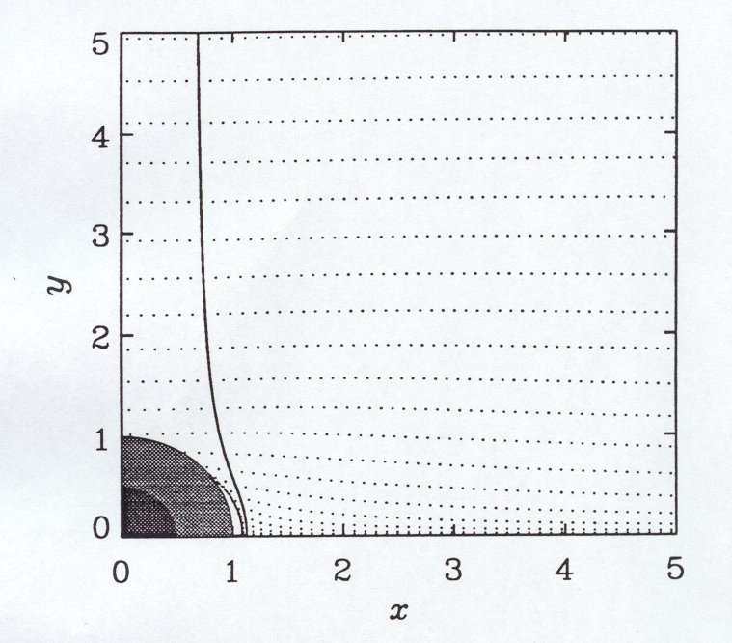
Figure 1 Trajectories of particles. Small dot represents the center of adsorbing particle.

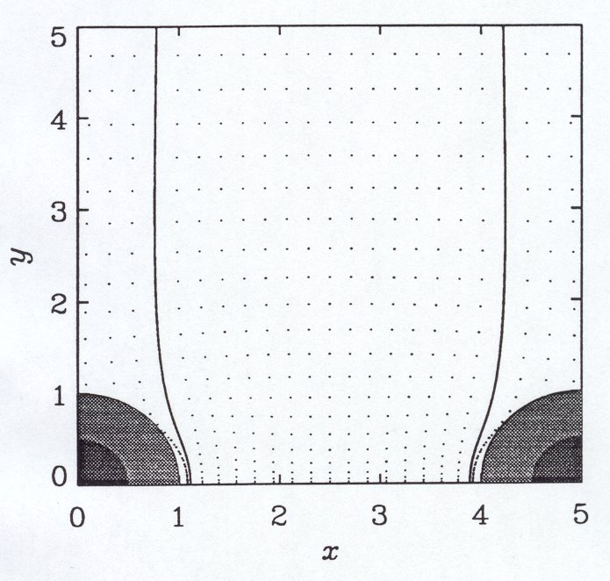
Figure 2 Trajectories of particles. Small dot represents the center of adsorbing particle.

