초임계수 수열합성에 의한 바륨헥사페라이트 미세입자 제조
송규호, 임종성, 김재덕, 이윤용, 이윤우
한국과학기술연구원, 초임계유체공정연구실

Ultrafine Barium Hexaferrite Particles Prepared
by Hydrothermal synthesis in Supercritical Water
Kyu Ho Song, Jong Sung Lim, Jae-Duck Kim, Youn Yong Lee, Youn-Woo Lee
Supercritical Fluid Research Lab., Korea Institute of Science and Technology

Introduction
Barium hexaferrite (BaO.6Fe₂O₃) particles have been investigated for use in perpendicular recording media and permanent magnet because it processed relatively large saturation magnetization, high coercive force and high magnetic anisotropy field. In hydrothermal synthesis of fine barium hexaferrite particles, batch autoclave-type reactors were used frequently and this method requires reaction times on the order of several hours. Hakuda et al. reported that the possibility of continuous production of barium hexaferrite fine particles in supercritical water[1]. They also achieved rapid raising the temperature to a level around the critical temperature of water, followed by heat treatment. In this process of barium hexaferrite synthesis, the rapid heating of precursor solution prevents formation of hematite[2, 3, 4].
The objective of this study is to evaluate the effect of process parameters (temperature, pressure, residence time, and concentration of the aqueous solution) on the particle size, particle size distribution, and magnetic properties of the barium hexaferrite particles obtained by hydrothermal synthesis in supercritical water.

Experimental procedure
The precursor solution used in the experiment was prepared by dissolving iron(III) nitrate and barium nitrate in distilled water. The apparatus used is schematically shown in Figure1. The mixture solution of iron(III) nitrate and barium nitrate was fed into a reactor by a high-pressure pump (minipump, Milton Roy, USA). KOH aqueous solution was fed by another pump (minipump, Milton Roy, USA). The two solutions were mixed at the first mixing point (MP1) at room temperature. Then, the merged solution up with high-temperature water that was fed at 200℃ at the second mixing point (MP2). Finally, at the third mixing point (MP3) where just before the entrance of the reactor, large amount of water in supercritical condition was brought into to heat the stream of the precursors rapidly up to the reaction temperature. The reactor (a cylindrical tube made of SUS 316, O.D.=3/4inch, I.D.=3/8inch, length=310mm) was maintained at a constant temperatur. The effluent from the reactor was cooled to room temperature by a heat exchanger. After cooling, the formed particles were collected in a Tee-type filter (0.5㎛) in front of the back-pressure regulator (Tescom Corp., USA Model 26-1721-24). Morphology observation and particle size measurement were made using scanning electron microscope (SEM, Hitachi, Japan S-4200). The crystal structure of the products was analyzed by and X-ray diffraction (XRD, VG Scientific, England, 2803-S) method. The specific magnetization(s) and the coercive force (H_{c}) of the prepared particles were measured using a vibration sample magnetometer (VSM) at room temperature.

Results and Discussion
The chemistry for synthesis of barium hexaferrite can be expressed as follows:
Hydrolysis & Dehydration:
12Fe(NO₃) ₃ + 36H₂O ↔ 12Fe(OH)₃ + 36HNO₃
Ba(NO₃)₂ + 2H₂O ↔ Ba(OH)₃ + 2HNO₃
12Fe(OH)₃ ↔ 6 Fe₂O₃ + 18 H₂O
Main Reaction:
Ba(OH)₃ + 6 Fe₂O₃ ↔ BaO⋅6Fe₂O₃ + H₂O
Overall Reaction Chemistry:
12Fe(NO₃)₃ + Ba(NO₃)₂ ↔ BaO⋅6Fe₂O₃ + 19 H₂O

The Effect of Process Parameters on the particle size
The variation of the average particle size of the resulting barium hexaferrite is not observed with the variation of Fe/Ba molar ratio(0.5, 1, 2, 5). When atomic molar ratio of Fe/Ba was 5, barium hexaferrite particles with by products were produced. It is observed that saturated magnetization increases as the value of Fe/Ba increases, while coercive force decreases as the value of Fe/Ba increases.
The value of alkali molar ratio(R) was varied from 0.5 to 8 at the fixed values of other operating variables (T_{mp2}=200℃, T_{R}=300℃, Fe/Ba=2, Fe(NO₃)₃=0.05M, t=1min, and P=300bar). As shown in Figure 2, it is interesting to note that the average particle size decreases clearly from 450nm to 160nm with the increase of the alkali molar ratio(R). Particles smaller than 200nm were able to produce when the alkali molar ratio is exceed 2 in this study. Figure 3 illustrates the X-ray diffraction patterns of particles prepared under molar ratios of 0.5, 1, 2, 4, and 8. All patterns show characteristic peak of barium hexaferrite in the present study even though R is as low as 0.5.
We believe that the initial nucleation occurs at the second mixing point (MP2) just before the reactor. It is reported that the temperature control at MP2 is critical for preparing a high quality single phase crystal. Therefore, to selectively obtain highly pure barium hexaferrite, it is recommended the aqueous solution comprising the iron compound, the barium compound. The variation of the average particle size (160nm) of the resulting barium hexaferrite was hardly shown. It is noticed from such experimental results that the variation of the temperature in the supercritical condition could not be affected much the particle size.
The average particle size decreases with increasing pressure. When the pressure exceeds 300bar, barium hexaferrite particles of constant size of 160nm are produced. An increase of the pressure increases the density of the solution and the solubility at the same time. Accordingly, it is effective to reduce the supersaturation degree of the solution and to reduce the number of nuclei to be formed. The pressure change is influential also over the particle size of the resulting barium hexaferrite due to its influence over the solubility of the solvent and the reaction for forming barium hexaferrite.

Conclusion
We found that the variations of particle size and magnetic properties can be attributed to the change of physical and chemical properties of supercritical water with temperature, pressure, and residence time. Barium hexaferrite particles produced are ultra-fine, homogeneous, single-phase, and narrowly distributed due to the unique properties of supercritical water. The barium hexaferrite particles obtained in this experiments show nearly similar soft-magnetic behavior with a saturate magnetization of 15-40emu/g and a coercivity of 1300-2200Oe. Such a low magnetic properties value is due to a small amount of amorphous materials coexistent. The present results suggest that removing the amorphous materials and controlling the process parameters may increase magnetic property value.
Acknowledgments

This work has been supported by the National Research Laboratory Program for Supercritical Fluid (2N19620) and the authors would like to thank to the Ministry of Science and Technology, Korea.

References
[1] Y. Hakuda, T. Adschiri, T. Suzudi, T. Chida, K. Seino, and K. Arai, J. Am. Ceram. Soc., 81(9) 2461-2469 (1998)
[2] K.H. Song, S.H. Do, J.S. Lim, Y-W. Lee, J-D. Kim, Y.Y. Lee, Theories and Applications of Chemical Engineering, 6(1), 2085-2088 (2000)
[3] K. Arai et al, US patent 5433878 (1995)
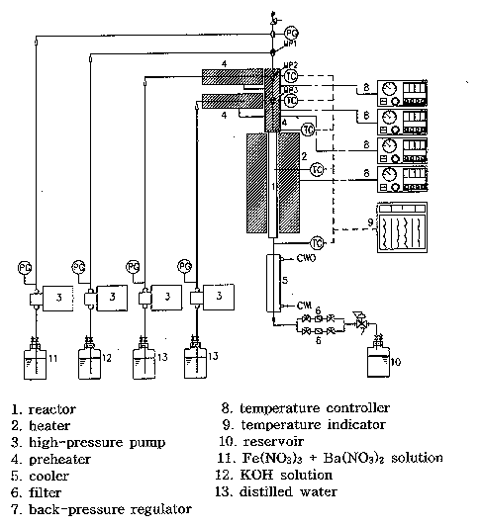
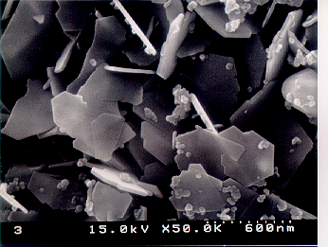
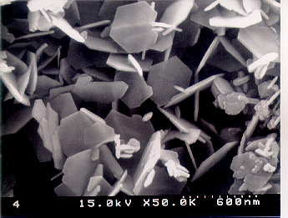
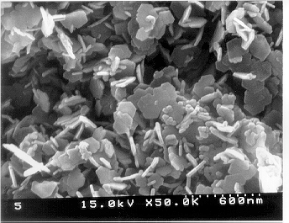
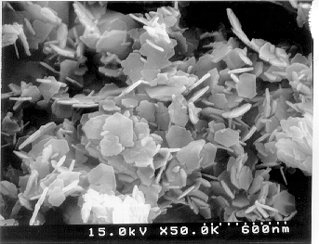
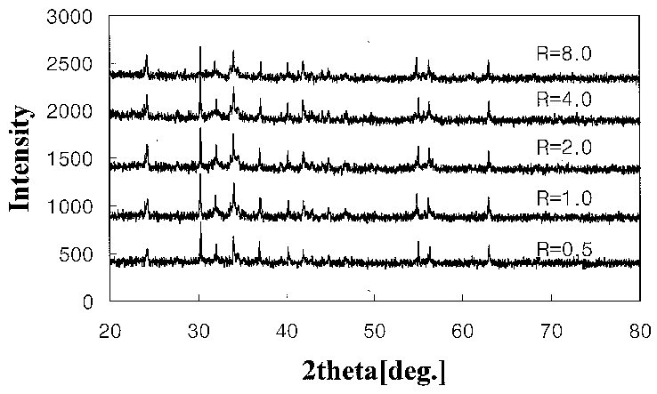
[4] T. Adschiri, Proceedings of the 5th International Symposium on Supercritical Fluids, Atlanta, USA, April 2000
Figure 1. A continuous Hydrothermal
crystallizer
R=0.5
R=1.0
R=2.0
R=4.0

Figure 2. SEM micrographs of barium hexaferrite particles synthesized at T_{mp2}=200ºC, T_{R}=380ºC, Fe/Ba=2, Fe(NO₃)₃=0.05M, t=1min, p=300bar
Figure 3. X-ray diffraction patterns of
Barium hexaferrite particles

