반응상용화를 이용한 고강도 신디오탁틱 폴리스타이렌
블렌드 제조

최 원묵, 박 천일, 박 오옥
대전광역시 유성구 구성동 373-1 한국과학기술원 화학공학과

Preparation of high–impact strength syndiotactic polystyrene
by reactive compatibilization

Won-Mook Choi, Cheon-Il Park and O Ok Park
Department of Chemical Engineering, Korea Advanced Institute of Science and Technology 373-1, Kusong-Dong, Yusong-ku, Taejon, Korea

.
- Introduction
As syndiotactic polystyrene (sPS) with a very high degree of sterospecificity(>96%) has successfully been synthesized by stereospecific polymerization, characterization of this new material has been of considerable interest.[3,4] The sPS is a new cryatalline polymer with a high melting temperature (>270℃). The main advantages of sPS are its high heat resistance, excellent chemical resistance, high degree of crystallinity, low specific gravity, and good dielectric properties. Because of the excellent properties described above, sPS is now considered as a potential engineering thermoplastic user for electrical/electronics, automotive, and industrial films. Although sPS has many desirable properties as an engineering thermoplastic, its disadvantage is its low impact strength. Therefore, an improvement of sPS is essential to expand its applications. However, studies on this subject are still very limited.
Blending of sPS with other rubbers can be a convenient way to increase the impact strength of sPS.. However, sPS is immiscible with EPR due to lack of specific interaction between these two polymers. Hence, the reactive interfacial agent is needed to increase the compatibility. In this study, we introduce the MA functionalized EPR (MA-EPR) and styrene-oxazoline copolymer (RPS) which is partially miscible with sPS and have the reactivity with MA group of MA-EPR, to generate graft or block copolymer at the interface between two polymers. The focus of this work is to understand the influence of chemical reaction on the blend morphology, impact strength and rheological properties of sPS blend as function of the amount of MA of MA-EPR.

- Experimental
  - Materials
sPS was synthesized by using the catalyst pentamethyl-cyclopentadienyl titanium (Cp* TiCl) (Strem Chem.) and the cocatalyst modified methylaluminoxane (MMAO-3A) (Akzo Noble Ltd).. The M_{w} of sPS used was about 400,000 and MWD is about 2.7. The weight-average molecular weight (M_{w}) of sPS was measured by gel permeation chromatography (GPC) at 135℃ using 1,2,4-trichlorobenzene as a solvent. RPS was 5wt% of oxazoline, Epocros RPS1005 of Nippon Schokubai Co. EPR is a commercial grade (070P) supplied from Kumho Polychem. with 68% of ethylene and used without further treatment. MA is used as a powder from Aldrich Chemical Co. without further purification.

Table 1. MA-EPR preparation
Smaple | DCP(phr) | MA(phr) | Graft ratio(wt%)
MA 3 | 0.25 | 3 | 1.02
MA 5 | 0.25 | 5 | 1.95

MA-EPR was prepared by melt melt processing in Brabender mixer at 180℃ for 6 minutes. The initiator used in melt grafting is dicumyl peroxide (DCP) 0.25phr and MA is used 3 and 5 phr. After melt grafting, to remove impurities, such as the initiator and MA, MA-EPR was cut into small pieces and dissolved in the boiling xylene and then precipitated in an excess acetone.

  - Blends preparation
All the polymer samples are completely dried in a vacuum oven at 70℃ for 24 hours before blending. The samples were melt-blended in a Hakke mixer 50g batch at 290℃ for 6 minutes.

Table 2. Composition of sPS blends
sample | SPS(g) | EPR(g) | RPS(g)
M0 | 35 | 15 | 0
M3 | 32.5 | 12.5 (MA 3) | 5
M5 | 32.5 | 12.5 (MA 5) | 5

  - Characterization of blends
The rheological measurement was performed at 280℃ using a Advanced rheological expansion system, ARES with cone-plate fixture under nitrogen atmosphere..
The morphology of samples was observed using a Philips 535M scanning electron microscope (SEM) at an accelerating voltage of 10kV. The cryogenically fractures surface was etched with n-hexane to remove the EPR phase and coated with gold to avoid charging.
Izod impact tester was used to measure impact strength (ASTM D-256). Impact specimens were molded using compressor- molder at 290℃ and then cut into 76x13x3 mm³.

- Results and discussion
The morpholgy of cryogenically fractured surface of blends is shown in Fig. 1. The uncompatibilized sPS/EPR blend shows a typical morphology of an immiscible mixture; very large, coarse, and irregular. Also its interface between sPS and EPR is very neat comparing to other reactive compatibilized blends; sPS/RPS/MA-EPR, which means the interfacial adhesion of two polymers is very weak. In the other hand, introducing RPS and MA-EPR as a reactive interfacial agent to blending system results in the significant reduction of domain size.. From these morphology changes in blends, we can expect that by introducing the reactive interfacial agents, EPR domain will act as an effective stress transfer in the matrix sPS.
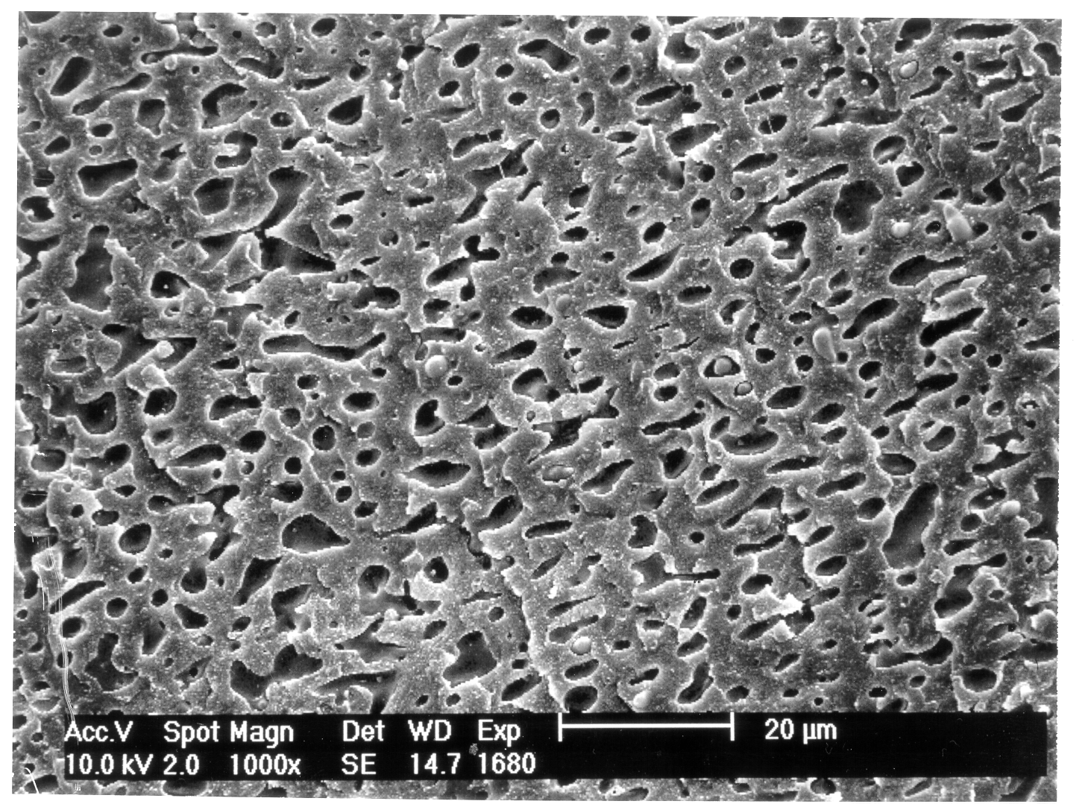
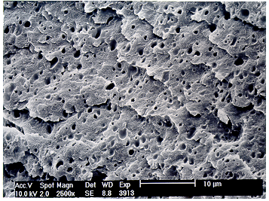
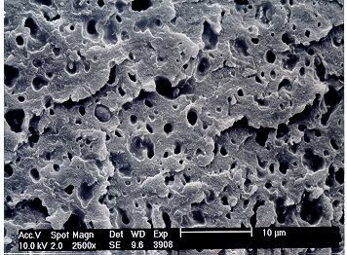
The rheological property, G’ and η* changes of sPS/RPS/MA-EPR at 280℃ were plotted against frequency, as shown in Fig. 2. It is observed that adding the reactive interfacial agents, RPS and MA-EPR instead of EPR, result in a significant increase of G’ and η*. This is obviously due to the in-situ formation of PS-graft-EPR copolymer at the interface during blending by the chemical reaction of two functional group, MA (MA-
(a)
Figure 1. SEM micrograghs of cryogenically fractured surfaces of
sPS/RPS/EPR blends; (a) M0, (b) M3, (c) M5 (magnification: 2500X)
(c)
(b)
10μm

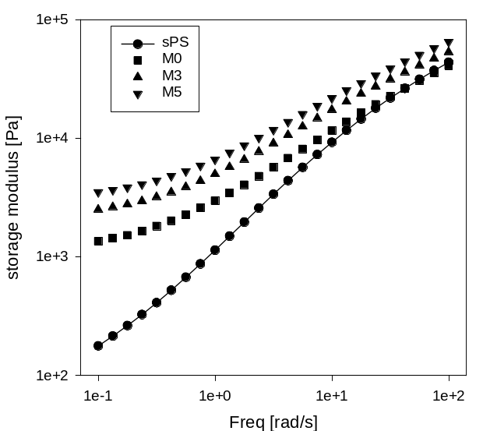
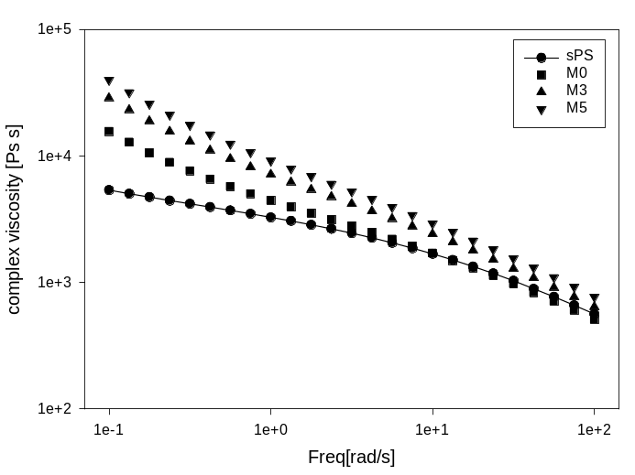
EPR) and oxzoline (RPS). PS-graft-EPR copolymer causes the reduction of particle size and the coupling effect - when PS-graft-EPR copolymer is formed at the interface of two polymers, it gives better interfacial adhesion between the sPS matrix and the dispersed EPR phase, as PS and EPR block in PS-graft-EPR copolymer penetrate into the sPS matrix and dispersed EPR domains, respectively.
Figure 2. Storage modulus(G’) and complex viscosity(η*) for sPS/PRS/MA-
EPR blends at 280℃
The reactive compatibilization on the impact strength of sPS/RPS/MA-EPR blends is examined. As shown in Fig. 3., the impact strength of the blend M5 increased about 6 times and 3 times higher than that of sPS and sPS/EPR physical blend respectively, which implies that the addition of interfacial agents (RPS, MA-EPR) effectively improved the interfacial adhesion between sPS and EPR phase and made the dispersed EPR act as an effective stress transfer in sPS matrix. This mechanical property improvement of blends is also shown in the SEM micrographs, Fig, 4., fractured surface after impact test. In the case of sPS/EPR, the dispersed EPR maintained its morphology and easily pulled out at
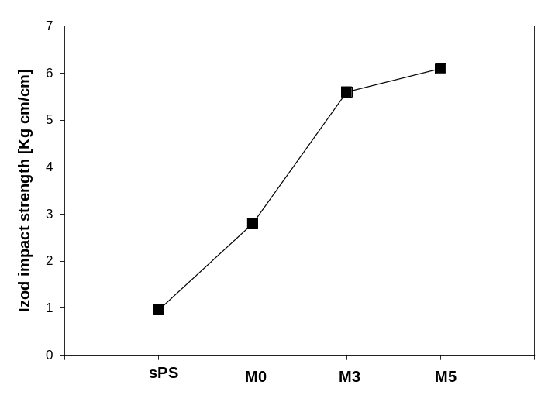
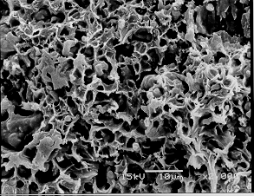
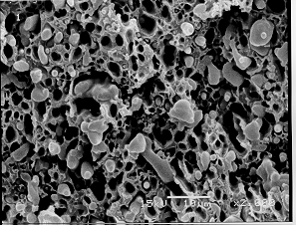
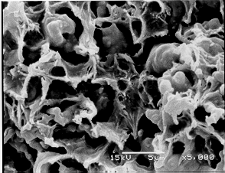
the impact test, implying a poor adhesion between sPS matrix and dispersed EPR phase. As adding the reactive interfacial agents, the fracture surface of the blend sample after the impact test became rougher. Moreover the EPR particles seem to adhere strongly to the sPS matrix, resulting in an improved impact strength of reactive compatibilized blends.
Figure 3 . The changes of impact strength of sPS/RPS/EPR-MA blends
(a)
(b)
(c)
Figure 4. SEM micrograghs of fractured surfaces of sPS/RPS/MA-EPR after
impact test ; (a) M0, (b) M5 (x2000), (c) M5(x5000)

- Conclusions
The effect of reactive compatibilization on the morphology, rheological properties and impact strength of sPS/EPR blends is examined. From the morphological analysis, the size of the dispersed EPR decreased and the interface between sPS and EPR became rougher as adding RPS and MA-EPR for reactive compatibilization. In the rheological properties, the reactive compatibilized blends show the improved G’ and η* , indicating the small dispersion and coupling effect. The impact strength of reactive compatibilized blends is much higher than that of pur sPS and sPS/EPR blend. The SEM micrograhs after the impact test show that the sPS/RPS/MA-EPR blend has a good adhesion between the sPS matrix and dispersed EPR, whereas the sPS/EPR physical blend exhibits a poor adhesion between two phases.

5. References

- J.R Campbell, S.Y. Hobbs, T.J. Shea, V.H.Watkins, Polym. Eng. Sci., 1990; 30, 1056
- R.R. Gallucci, US Patent, No. 5,26037, 1993
- N.Ishihara, T. Semiya, M.Kuramoto, Macromolecueles, 1986; 19, 2465
- L.C. Lopez, R.C.Cieslinski, C.L. Putizig, polymer; 1995, 36, 2331

