적분 공정을 위한 변형된 Smith Predictor들 : 비교와 제안

곽 희진, 성 수환, 이 인범
포항공과대학교 화학공학과, 공정산업의 지능자동화센터

Modified Smith Predictors for integrating Processes : Comparisons and Proposition

Hee Jin Kwak, Su Whan Sung and In-Beum Lee
Department of Chemical Engineering, Automation Research Center, POSTECH

Introduction
Smith predictor is a common and an effective dead time compensator. But many researchers pointed out that it couldn’t be used for integrating processes because of the steady state error.
To overcome this problem, many modified Smith predictors with different structures have been proposed. Modified Smith predictors proposed until now are classified two categories based on the manner that the modeling error signal is treated. Smith predictors included in the first category feedback modeling error signal and others do not feedback it. Here, the modeling error feedback makes the system stability depend on the magnitude of the modeling error. Therefore, we name Smith predictors having modeling error feedback term Smith predictors with dependent structure (dependent Smith predictors) and others Smith predictors with independent structure (independent Smith predictors).
In this paper we will review previous Smith predictors and discuss advantages/ disadvantages of them briefly. In addition to reviewing, we propose a modified Smith predictor for integrating processes. Numerical simulations show that the proposed Smith predictor gives better control performances for both servo and regulatory problems than previous approaches and shows enhanced robustness.

Previous Approaches and Proposed Smith Predictor
a. Smith Predictors with Dependent Structure
For the first time, Watanabe and Ito[1] proposed the dependent Smith predictors for integrating processes. However, it shows too slow set point response and cannot guarantee zero steady state error. Mataušek and Micić[2], [3] overcame these drawbacks by using an additional controller, F(s), as given in Figure 1.
Figure 1. Smith predictor proposed by Mataušek and Micić [2] and [3].

The most important characteristic of dependent Smith predictor can be found in the following characteristic equation.
$Δ_{\text{dependent}}=1+K_{r}(G_{p}−G_{m}+G_{m}∗)+F(s)G_{p}(1+K_{r}G_{m}∗)$ (1)
As shown in equation (1), the servo controller, K_{r}, has role in amplifying the model mismatches. Generally, since the servo controller is tuned with high gain to achieve high control performances for the set point tracking, the amplified mismatches can be large enough to make the overall system unstable. Therefore Smith predictors with dependent structure cannot be free from the trade-off relations between control performances and the system stability. Numerical simulations will confirm this fact.
b. Smith Predictor with Independent Structure
Aström et al.[4] proposed an independent Smith predictor. Though it provides significant performance improvement owing to the new structure, it fails to give effective tuning rules.
Figure 2. Smith predictor proposed by Aström et al.[4].

A logical design procedure for Aström’s Smith predictor is proposed by Zhang and Sun[5]. However, since the proposed procedure depends on the rule of thumb, control performances are not improved. Tian and Gao[6] proposed an other Smith predictor that has an additional controller. But this approach shows just slightly better control performance than the previous approach[2] in spite of the increased structural complexity.
Here note that independent Smith predictors have potential possibility of achieving better control performance than dependent ones from the standpoint of the structure. So it is clear that if the controllers of the independent Smith predictor are designed appropriately, better control performances can be obtained. It is the motivation of this work.
c. Proposed Smith Predictor
The structure of the proposed independent Smith predictor is shown in Figure 3 and its structure was originally proposed to solve the problem related with Smith predictors for unstable processes[7]. Here, y_{d}(s) denotes the desired trajectory and G_{cs}(s), G_{cd}(s) are controllers for servo and regulatory problem, respectively.
Figure 3. Structure of the proposed Smith predictor

This approach can be applied to high order integrating processes such as (2) different from the previous approach.
$f(y^{(n)}(t),y^{(n−1)}(t),⋯,y^{(1)}(t))=g(u^{(m)}(t−θ),u^{(m−1)}(t−θ),⋯,u^{(1)}(t−θ),u(t−θ))$ (2)
If the desired trajectory(y_{d}(s)) satisfies the following conditions,
$\frac{d^{(i)}y_{d}(t)}{{\text{dt}}^{(i)}}=\frac{d^{(i)}y(t)}{{\text{dt}}^{(i)}}$,$0≤t≤θ$ and $i=1,2,⋯,n$ (3)
perfect nominal control performance for servo problem is obtained by using the synthesized controller, G_{cs}(s), given in (4).
$g(u_{s}^{(m)}(t),u_{s}^{(m−1)}(t),⋯,u_{s}^{(1)}(t),u_{s}(t))=f(y_{d^{(n)}}(t+θ),y_{d^{(n−1)}}(t+θ),⋯,y_{d^{(1)}}(t+θ))$ (4)
In this research, we use the following desired trajectory.
$y_{d}(s)=G_{d}(s)⋅y_{s}(s)=\frac{\text{exp}(−θs)}{(τ_{\text{de}}s+1)^{n}}y_{s}(s)$ (5)
The servo controller compensates the time delay and achieves good control performance, as much as desired by adjusting the parameter, τ_{de}.
However, because disturbances and plant/model mismatches always exist in practice, a feedback controller is needed. We choose the conventional PID controller as G_{cd}(s). Here the tuning procedure of this PID controller is adopted the tuning rule proposed in our previous paper[7]. The only one difference is that the internal feedback loop controller is the proportional controller tuned by tuning rule recommended for integrating processes[8]. Since the proposed tuning rule makes it possible to use internal feedback controller implicitly, better control performances can be obtained without increasing structural complexity.

Simulation Study for Comparisons
To compare the control performances and robustness of Smith predictors, we choose the process (6) for simulation since it is used in previous papers [3] and [6].
$G_{p}(s)=\text{exp}(−5s)/s$ (6)
A unit step set point is introduced at time t=0 and a load disturbance d= -0.1 is introduced at t=70, as in [3] and [6]. Here, on purpose to compare, we give the servo controller of our Smith predictor low gain to achieve same set point control performances as [3] and [7].
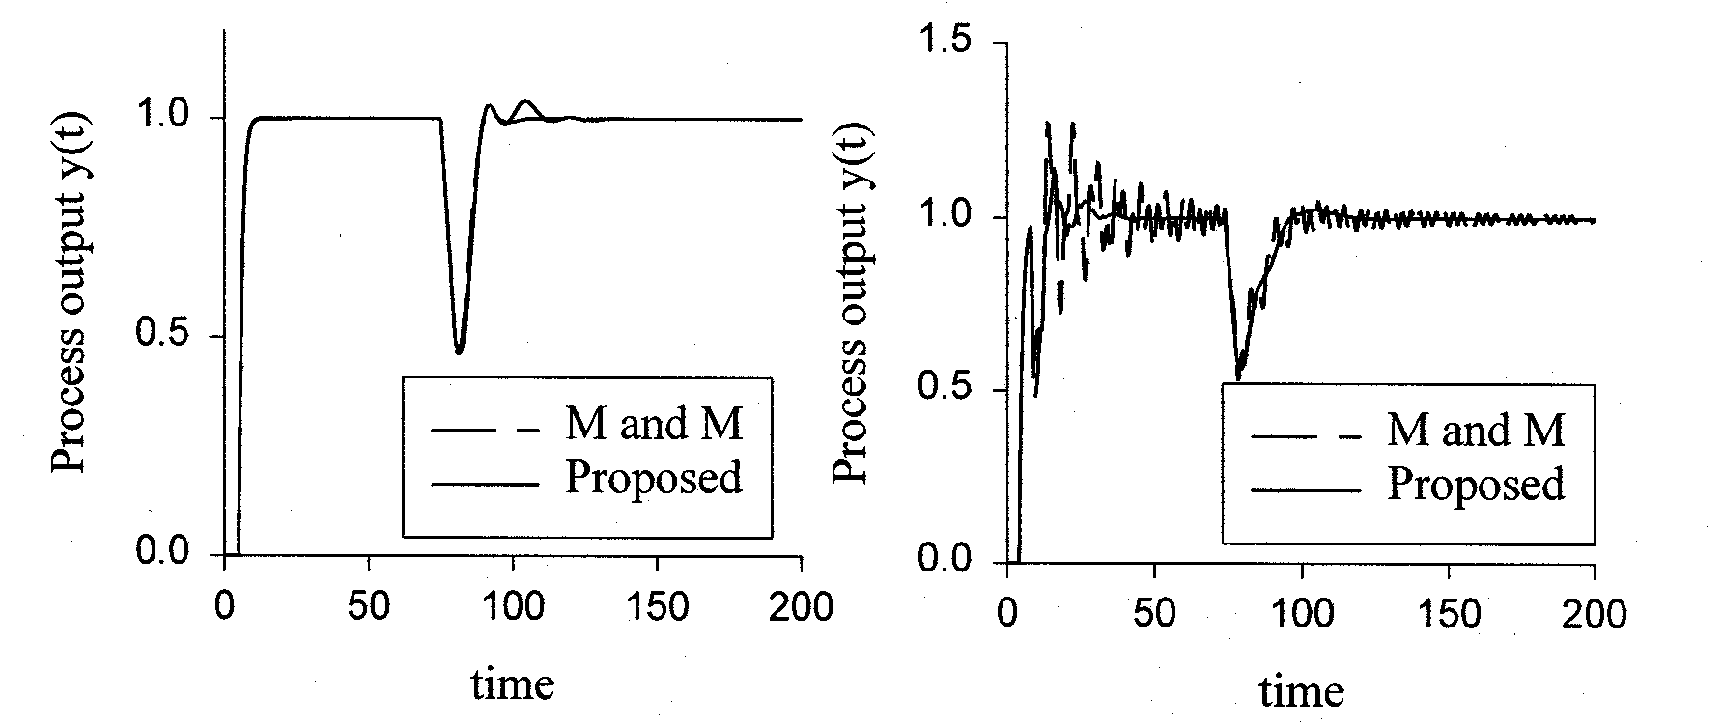
(a) (b)
Figure 4. Control results; (a) nominal case, (b) 20% estimating error

Figure 4 shows control results of Mataušek and Micić’s approach[3] and proposed Smith predictor. As shown in Figure, nominal case show similar control performance but when estimating error is exist dependent Smith predictor show too oscillatory control result.
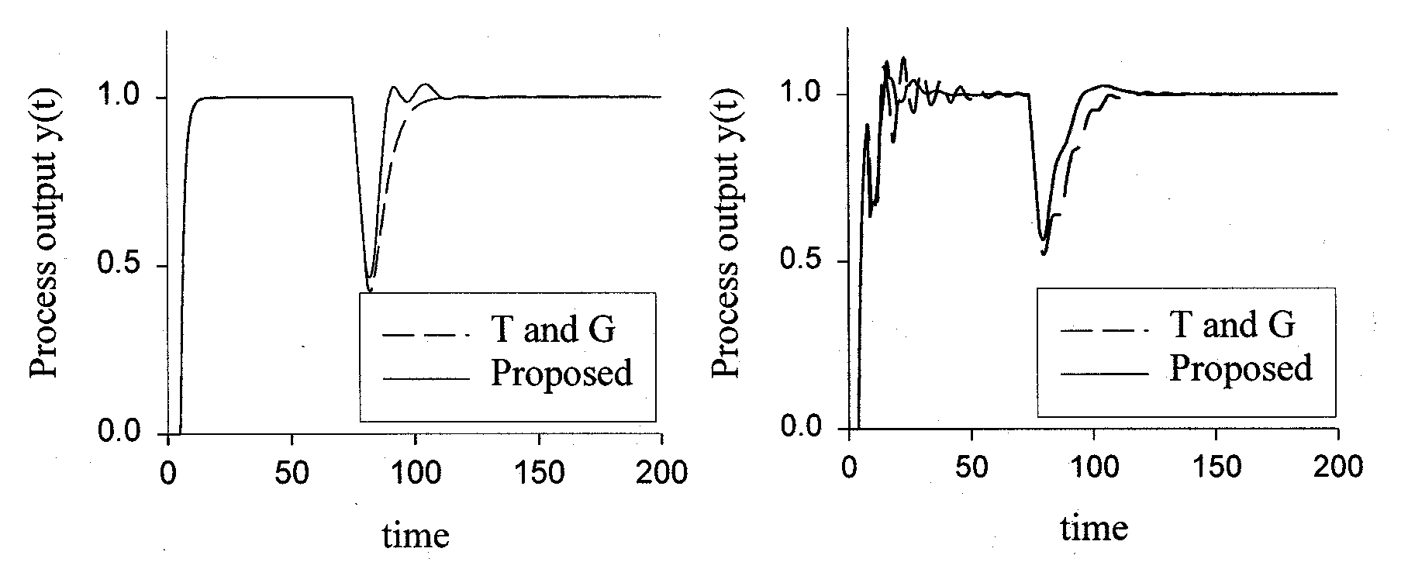
(a) (b)
Figure 5. Control results; (a) nominal case, (b) 20% estimating error
Figure 5 shows control results of two independent Smith predictors- Tian and Gao[7] and ours. As given in figure, the proposed Smith predictor shows faster disturbance rejection performances both nominal case and model mismatch case.

Conclusion
In this paper, we reviewed previous Smith predictors for integrating processes. Through reviewing them, we concluded that independent Smith predictors have possibility of achieving better control performances compared with those having dependent structure. However, in spite of structural superiority, since the controllers of the independent Smith predictor are not designed appropriately, control performances of them are not better than that of dependent Smith predictors. Based on this fact, we proposed a Smith predictor for integrating processes with independent structure. It shows better control performances than previous Smith predictors and enhanced robustness.

Acknowledgement
This work was supported in part by the Korea Science and Engineering Foundation (KOSEF) through the Automation Research Center at Pohang University of Science and Technology.

Literature Cited
1. Watanabe, K. and Ito, M.: IEEE Transactions on Automatic Control, 26,1261(1981).
2. Mataušek, M.R. and Micić, D.: IEEE Transactions on Automatic Control, 41,1199 (1996).
3. Mataušek, M.R. and Micić, D.: IEEE Transactions on Automatic Control, 44, 1603(1999).
4. Aström, K. J., Hang, C. C. and Lim, B. C.: IEEE Transactions on Automatic Control, 39, 343(1994).
5. Zhang, W. D. and Sun, Y. X.: Ind. Eng. Chem. Res., 35, 2769(1996).
6. Tian, Y. and Gao, F.: Ind. Eng. Chem. Res., 38, 2979(1999).
7. Kwak, H. J., Sung, S. W., Lee, I. and Park, J. Y.: Ind. Eng. Chem. Res., 38, 405(1999)
8. Kwak, H. J., Sung, S. W. and Lee, I.: Ind. Eng. Chem. Res., 36, 5329(1997)

