펜탄을 포함한 Poly(ethylene-co-butene)₁₀과의 상거동 및 혼합물 밀도 측정

김근빈, 변헌수

여수대학교 화학공학과

Phase Behavior and Mixture Density Measurement of Poly(ethylene-co-butene)₁₀ in Pentane

Kunbin Kim, and Hun-Soo Byun

Department of Chemical Engineering, Yosu National University, Yosu, Chonnam 550-749, Korea.

Introduction

The phase behavior of supercritical fluid solutions of polymers is sensitive to the polymer-solvent dissimilarities due to solvent polarity, solvent size, polymer molecular weight, or hydrogen-bonded aggregate size.[1] Supercritical fluid based synthesis, modification, and processing of organic and inorganic materials is a rapidly growing area of research with industrial significance.[2]
Small-angle neutron scattering (SANS) has recently been used to characterize intra- and intermolecular interactions of slightly branched poly(ethylene-co-butene) (PEB) polymers in supercritical fluid (SCF) and liquid solvents at high pressures.[3] Accurate densities of the SCF-polymer solutions are needed to properly extract polymer chain dimensions form scattering data and to account for compressibility effects on the scattering intensities. Unfortunately, there is a very limited amount of data available in the literature on the densities for these solutions under such extreme conditions. This paper provides experimentally determined densities for both protonated and deuterated n-alkanes and semi-dilute solutions of poly(ethylene-co-butene) (PEB) in protonated and deuterated n-alkanes at pressures to 3,000 bar and temperatures to 150℃. It is important to recognize that mixtures consisting of deuterated and protonated components will exhibit pair-wise intermolecular interactions that are slightly different in magnitude from those found with mixtures consisting of all hydrogenated components, which can result in differences in the density of these two types of mixtures. For the density measurements reported here, a high-pressure variable volume cell is adapted with a linear-variable differential transducer (LVDT) to measure the cell volume at different temperatures and pressures.

Experimental Section
Figure 1 shows a schematic diagram of the high-pressure cell used in this study. The body of the cell is constructed of high nickel content steel. Thick window is fitted to one end of the cell and is sealed with an elastomeric O-ring. A PID temperature controller connected to a platinum resistance temperature device (RTD) controls to the temperature of the surrounding air bath and cell within ± 0.3℃. The temperature of the cell is measured with a Type-E thermocouple that is accurate to within ± 0.5℃ and is connected to a digital multimeter. Figure 2 shows that a reproducible, linear calibration curve is obtained with this technique. The error of the calculated density obtained from the correlation given by Michels and Michels (~ 0.5 to 1.5%),[4] the error in the measured pressure and temperature, the sensitivity of the LVDT, and the error from the least squares fit of the linear calibration curve. The densities presented here have an estimated accumulated error of 1.0 to 1.5% for pressures to 3,000 bar and temperatures to 150℃, which is similar in magnitude to the error reported in the literature for high pressure densities of n-alkanes.

Materials
N-pentane (99.7% minimum purity) is obtained from Fisher Chemicals, and nppentane-d₁₂ (98.0% minimum purity – D, 98%) is obtained from Cambridge Isotopes Laboratories. Pamela Wright and Lewis Fetters, Exxon Research and Engineering Company, provided the poly (ethylene-co-butene) (PEB) copolymers.

Results and Discussion
Figure 3 shows the experimental densities of n-pentane at 50, 75, 110, 130, and 150℃ for pressures up to 2,415 bar. A detailed comparison of the n-pentane density data is compared to data and correlation found in the literature to assess the accuracy of the experimental technique employed in this study.
Figure 4 shows the densities of n-pentane-d₁₂ at 30, 50, 75, 100, 110, 130, and 150℃ and pressures to 2,415 bar. The specific density of n-pentane-d₁₂ is greater than that of n-pentane-h₁₂ at the same pressures and temperatures. The molar density of n-pentane-d₁₂ is consistently slightly greater than the molar density of n-pentane-h₁₂. This trend in molar density is consistent with studies in the literature reporting that dueteration of a hydrocarbon slightly reduces the polarizability of the compound, but, increases the molar density due to a smaller C-D bond length relative to a C-H bond. The maximum difference in molar densities of n-pentane-d₁₂ compared to n-pentane-h₁₂ is ~ 0.7% for 50, 100, and 150℃ for all pressures up to 2,415 bar.
A comparison of n-pentane densities at 50℃ obtained in this study with the data of Bridgman[5], Gehrig and Lentz,[6] and Easteal and Woolf.[7] All the data sets are within 0.8% of each other over the entire pressure range. The dinsities reported are slightly lower than those of Gehrig and Lentz,[6] are slightly higher than thowe of Easteal and Woolf[7] for pressure greater than ~700 bar, and they agree very well with the data of Bridgman.[5]
The Tait equation provided by Gehrig and Lentz[6] is the only correlation in the literature that is in close agreement with the data in this study for n-pentane at temperatures above 50℃ and pressures greater than 700 bar. Figure 4 shows the densities of n-pentane obtained in this work compared to experimental data and the calculated values from the Tait equation of Gehrig and Lentz[6] at 50, 100, and 150℃. Except for the 50℃ data, the correlation for pentane agrees to within 0.1 to 0.5% of the data reported here for pressures up to 2,500 bar.
The Tait equation for n-pentane provided by Asseal and coworkers[8] only agrees with the pentane densities reported here at 50℃ and at pressures less than 500 bar. At higher pressures the experimental pentane densities differ from those calculated from the Tait equation by considerably more than 0.10%, the reported, average accuracy of this equation. However, Asseal and coworkers[8] report parameters for the Tait equation those are determined from a generalized fit to a series of n-alkanes ranging from methane to n-hexadecane and to a limited amount of high-pressure densities for pentane. In addition, the parameters for pentane at atmospheric pressure reported by Asseal and coworkers are also incorrect or misprinted from the original publication of Cibulka.[9]
The n-pentane data agree with the correlation of Cibulka and Hnedkovsky[10] for temperatures up to 150℃ and pressures less than 700 bar with a maximum deviation of approximately 0.8%. At higher pressures, the correlation underpredicts the densities for all isotherms and the deviation increases with increasing temperature. Maximum deviations of 1.5, 2.0, and 2.2 % are found between the experimental data reported here and calculated densities at pressures from 700 to 2,500 bar and temperatures of 50, 100, and 150℃, respectively.
The densities of n-pentane-d₁₂ at 30, 50, 75, 100, 110, 130, and 150℃ and pressures to 2,415 bar. The specific density of n-pentane-d₁₂ is greater than that of n-pentane-h₁₂ at the same pressures and temperatures. The molar density of n-pentane-d₁₂ is consistently slightly greater than the molar density of n-pentane-h₁₂. This trend in molar density is consistent with studies in the literature reporting that dueteration of a hydrocarbon slightly reduces the polarizability of the compound, but, increases the molar density due to a smaller C-D bond length relative to a C-H bond. The maximum difference in molar densities of pentane-d₁₂ compared to pentane-h₁₂ is ~ 0.7% for 50, 100, and 150℃ for all pressures up to 2,415 bar.
The densities of n-pentane + 5.3 wt% h-PEB-10 and of n-pentane-d₁₂ + 5.1 wt% h-PEB-10, respectively, for isotherms at 110, 130, and 150℃ and pressures to 2,415 bar. The densities of the n-pentane-d₁₂ + 5.1 wt% h-PEB-10 system are greater than those of the n-pentane-h₁₂ + 5.3 wt% h-PEB-10 at the same temperatures and pressures.

Conclusions
Densities are reported for pure n-pentane,n-pentane-d₁₂ with protonated and deuterated polyolefins for pressures up to 3,000 bar and temperatures to 150℃. Good agreement is found for pentane densities obtained here at 50℃ and pressures to 3,000 bar with the data of Bridgman,[5] Gehrig & Lentz,[6] and Esteal and Woolf.[7] The densities obtained in this study have an estimated accumulated error of 1.0 to 1.5%, which may be a conservative estimate based on comparisons with pentane data obtained from the literature. The data reported here provide information needed to improve the accuracy of the Tait equation and they provide information at higher pressures and temperatures than those currently in the literature.

References

1) Darr, A, J. and Poliakoff, M.: Chem. Rev. 99, 495(1999).

2) Gregg, C. J., Stein, F. P. and Radosz, M. J.: Macromolecules, 27, 4981(1994).
3) DiNoia, T. P., Kirby, C. F., van Zanten, J. H. and McHugh, M. A.: Macromolecules, to be submitted 2000.
4) Michels, A. and Michels, C.: Proc. R. Soc., London Sec. A, 160, 348(1937).
5) Bridgman, P. W.: Proc. Am. Acad. Arts Sci, 66, 185(1931).
6) Gehrig, M. and Lentz, H.: J. Chem. Thermokyn, 11,291(1979).
7) Easteal, A. J. and Woolf, L. A.: Int. J. Thermophysics, 8, 231(1987).
8) Asseal, M. J., Dymond, J. H. and Exadaktilou, D.: Int. J. Thermophysics, 15, 155(1994).
9) Cibulka, I.: Fluid Phase Equilib, 89, 1(1993).
10) Cibulka, I. and Hnedkovsky, L.: J. Chem. Eng. Data, 41, 657(1996).

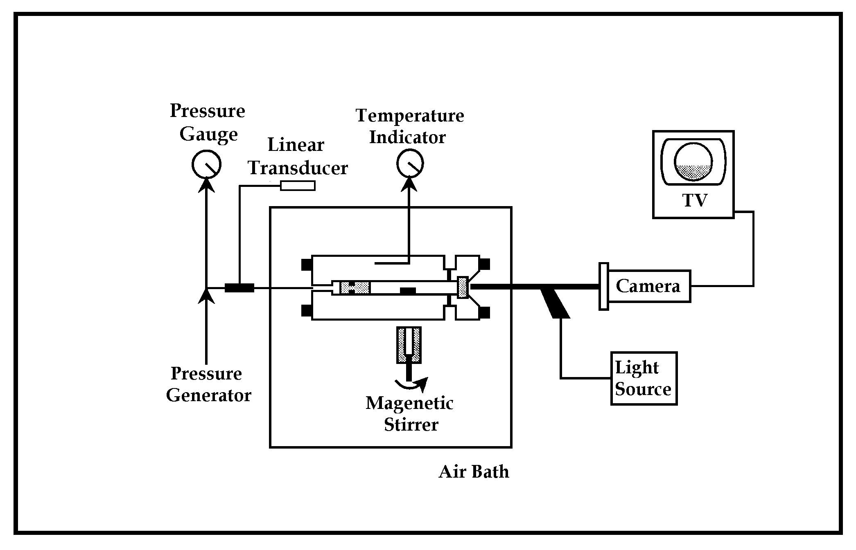  Fig 1. Schematic diagram of the experimental apparatus used in this study. | 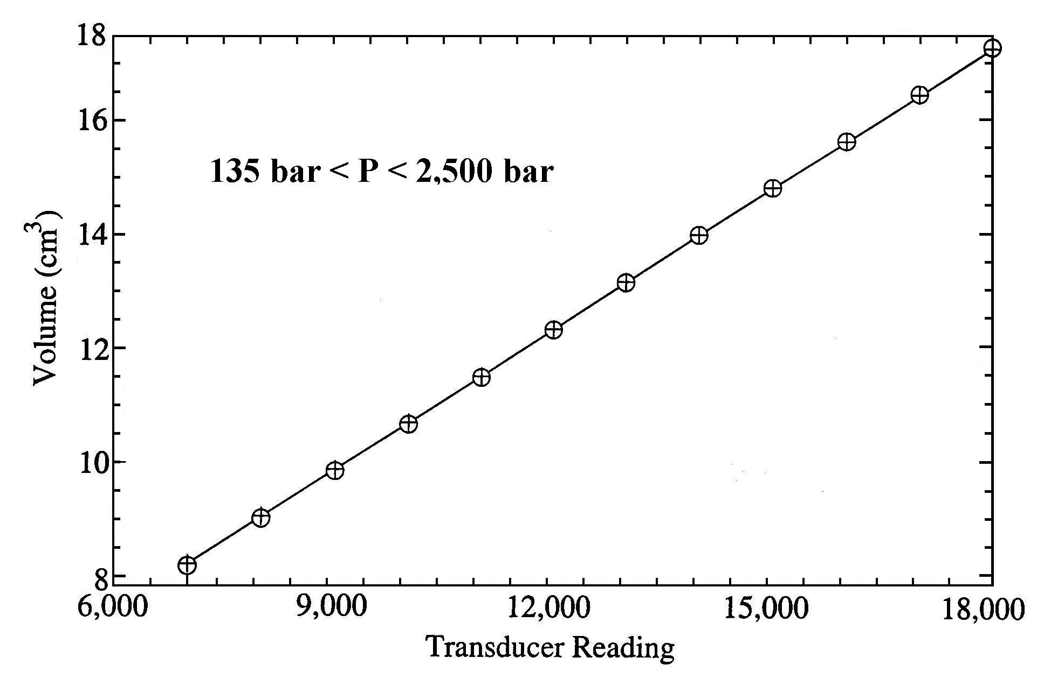  Fig 2. Calibration curve of the high-pressure, variable view cell with co2 at 40℃ for two independent calibration runs (closed circles and open diamonds) performed one year apart.
Fig 3. The experimental densities of n-pentane-h₁₂ obtained in this study at 50, 75, 100, 110, 130, 150℃ for pressures up to 2,415 bar. | Fig 4. The densities of n-pentane-d₁₂ obtained in this study at temperatures of 30, 50, 75, 100, 110, 130, 150℃ and pressures to 2,415 bar.

