Kinetics of Solvent Exchange from Ethanol to
Near-Critical Carbon Dioxide in Silica Gel

Grzegorz Rogacki∗
Faculty of Process and Environmental Engineering,
Technical University of Lodz, Poland

Introduction
From the standard point of view gel is a cross-linked polymer network being in equilibrium with a continuous liquid medium [1]. Depending on pressure, temperature and first of all on the liquid type and composition gels may swell or shrink. Swelling or shrinkage can be either continuous or can reveal a phase transition phenomena. On their way to a new thermodynamic 오류! 연결이 잘못되었습니다., gels can swell up by a factor of hundreds or collapse into a compact mass [2]. These kinds of gels are thought to have elastic network and becoming increasingly important in medicine and biotechnology. Simultaneously the so-called sol-gel technology has successfully developed new low temperature methods for preparation of ceramic materials [3]. In this field the polymer network of a gel is referred to as a ‘skeleton’ [3], ‘solid network’ [4] or ‘backbone’ [5]. The rigidity of the network is a condition for yielding monolithic products like xerogels, aerogels or glasses and it is treated by many researchers as obvious despite the fact that a vast group of inorganic gels are fundamentally different, colloidal systems and materials obtained from these gels require melting or sintering to achieve a coherent monolithic form [6]. In general, a typical sol-gel process involves transition metal alkoxides which through hydrolysis and polycondensation lead to polymeric oxide network.
In the case of the silica system the rigidity of polymerized oxide network makes the gel almost completely indifferent to the type and composition of interstitial liquid and in the extreme case this liquid can be replaced by gas phase giving a new type of material – silica aerogel.

Solvent exchange
In the so-called low-temperature aerogel production the primary gel solvent (mainly alcohol) is replaced by liquid or supercritical carbon dioxide. Because of nano-scale of porosity of silica gel one can expect that the only possible mechanism of mass exchange inside the gel body is diffusion. By changing the duration of diffusion stage during low-temperature production of parallelepiped aerogel monoliths, it was shown that the quality of obtained samples could range from completely damaged specimens to perfect monoliths (Fig. 1) and that the process was completely diffusion dependent [7]. It was also shown that using models known for heat conduction [8] it was possible to assess the value of effective diffusion coefficient of the ethanol-liquid CO₂ system inside the silica network. The obtained values of the coefficient had magnitude of about 3.10⁻⁹ m²/s and were temperature dependent [7].

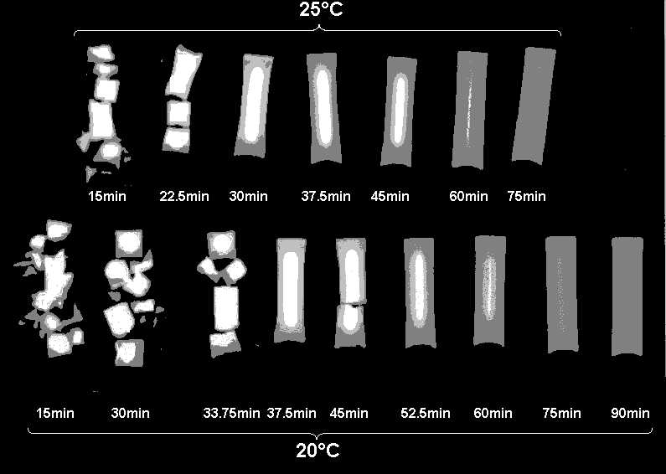

Fig. 1. Samples of aerogel dried at different diffusion time

Experimental procedure
Knowledge of the effective diffusivity during the low-temperature aerogel production is of primary importance in the design of the process at any larger scale. So far, determination of this coefficient can be achieved only experimentally because its value results from the superposition of diffusion in the CO₂ being near the critical point and the diffusional resistance of the subtle and complicated gel solid network.
Experimental determination of the effective diffusion coefficient of near critical CO₂ in the alcogel was carried out in the setup shown in Figure 2. It consists of a windowed autoclave with a thermostatic system, BPR, on-line gas chromatograph, CO₂ pump and liquid CO₂ cylinder. The autoclave 60 cm³ in volume was equipped with a replaceable high-pressure cell fitted to the cylindrical shape of gel samples of 9 mm in diameter and 63 mm long (volume ~4cm³). The gel samples were prepared using a standard two-step method with molar ratios TEOS:EtOH:H₂O of 1:6:6 and catalysts ratio TEOS:HCl:NH₄OH of 1:5⋅10⁻⁵:3.6⋅10⁻³. Gellation took place after 48 h, then the samples were immersed in absolute ethanol and cured for 320 days at room temperature. During aerogel production the gel sample was placed in the high-pressure cell filled with methanol to protect sample from solvent evaporation. After connection, the cell to the autoclave, the whole system was filled with liquid CO₂. Next, the autoclave was turned upside down to move the sample from the cell in the main chamber. Then the thermostatic system was set at desired temperature and autoclave rocking was started to mix up the fluid around the gel sample. Using CO₂ pump the liquid CO₂ constant flow of 7 cm³/min was set and the unsteady-state process of ethanol transfer from the gel sample into surrounding CO₂ was started. The leaving stream of CO₂ containing small and changing amount of extracted ethanol was decompressed in the BPR and analyzed with the GC every three minutes giving the histories of ethanol concentration in the autoclave. This procedure was repeated for different process temperatures. Figure 3 illustrates the concentration history obtained at 33°C.

CO₂ pump
Thermostat

BPR

Autoclave Pressure Cell

Gas Chromatograph CCChromatograph
Fig. 2. Setup for measurement of the effective diffusivity

Effective diffusion coefficient
The measured output concentration of ethanol C was a result of mass balance of the autoclave volume V at the constant flow rate F of CO₂.

dC/dt = (dQ/dt – F.C)/V (1)

where dQ/dt = f(D_{eff}⋅t/R²) as the solution of Fick’s equation for the infinite cylinder of the radius R equal to the radius of cylindrical gel sample. The value of D_{eff} was identified using the least squares method to fit the numerical solution of equation (1) to experimental data for each temperature [9]. Identified diffusion coefficients are listed in Table 1.
During solvent exchange in the silica gel from the primary alcoholic solution into near critical CO₂ the only possible mechanism of mass transfer is diffusion. Experimentally measured diffusivities have attributes of the effective values because of diffusional resistance of the gel skeleton which is strongly dependent on specific gel preparation conditions. It should be also mentioned that in the vicinity of the critical point of carbon dioxide (31.1°C, 73.8 bar) the effective diffusion coefficient changes rapidly with temperature and pressure.

Fig. 3. Measured and calculated ethanol  concentrations during solvent exchange | Table 1. Values of effective  diffusivity of EtOH-CO₂-  silica gel system
 | Temperature/°C | D_{eff} /10⁹ m² s⁻¹
 | 20 | 3.05
 | 28 | 3.54
 | 33 | 4.46
 | 42 | 5.52

Conclusions
Silica gel is a model example of inorganic polymer system where chemical bonds make the gel network rigid. As a result, silica gel is practically unresponsive to the type of solvent creating its interstitial fluid. In the low-temperature aerogel production supercritical process enables exchange primary solvent into gas phase but because of nano-scale of the gel porosity the process of exchange is controlled by molecular diffusion. In the carefully controlled condition, it is possible to identify the value of effective diffusion coefficient of this process.

References
1. Maurer G., J.M. Prausnitz, “Thermodynamics of Phase Equilibrium for Systems Containing Gels”, Fluid Phase Equilib, 115, pp. 113-133 (1996)
2.Tanaka T. “Gels”, Sci. Am., 244 (No.1) pp. 110-123 (1981)
3. Brinker C.J. and G.W. Scherer, “ Sol-Gel Science: The Physics and Chemistry of Sol-Gel Processing”, Academic Press, Inc. San Diego, CA, (1990)
4. Livage J., “The Gel Route to Transition Metal Oxides”, J. Solid StateChem., 64, 322-330 (1996)
5. Quinson J.F. at al, “Swelling of Titania Gels in Decane”, J. Non-Cryst. Solids, 99, 151-159 (1988)
6. Partlow D. P., B. E. Yoldas, “Colloidal Versus Polimer Gels and Monolithic Trensformation in Glass-Forming Systems”, J. Non-Cryst. Solids, 46, 153-161 (1981)
7. Rogacki G., P. Wawrzyniak, “Diffusion of ethanol-liquid CO₂ in Silica Aerogel”, ”, J. Non-Cryst. Solids, 186, 73-77 (1995)
8. Chapman A.J., Heat Transfer, 2nd ed. Macmillan, London (1972)
9. Wawrzyniak P., G. Rogacki, J. Pruba and Z. Bartczak, “Diffusion of Ethanol-Carbon Dioxide in Silica Gel”, J. Non-Cryst. Solids, 225, 86-90 (1998)

 At the present Visiting Scientist at Clean Technology Research Center, Korea Institute of Science and Technology, Seoul, Korea

