초고집적 반도체 세대의 공정 기술
김 재 정
서울대학교 공과대학 응용화학부

Semiconductor Processes In ULSI era
Jae Jeong Kim

Micro Processing Research Lab., School of Chemical Engineering, Seoul National University
San 56-1, Shillim-dong, Kwanak-gu, Seoul, 151-742, Korea
E-mail: jjkimm@snu.ac.kr

Introduction
As the complexity and performance of devices increase, more processing steps and new materials have been needed to fabricate. It was found that process modules that served well before were no longer sufficient because the devices would have degraded performance. It takes to replace the original unit process step in order to maintain or improve the device performance.
The purpose of this paper is to present fundamentals and trends front end process steps [1) lithography; 2) etch; 3) well formation; 4) isolation; 5) gate & gate dielectric; 6) capacitor] to create silicon devices in the Ultra Large Scale Integrated circuit (ULSI). Since device performance is an important criterion for front-end process optimization, we discuss how process steps change with device performances.

Process Is
1. Lithography
As the minimum feature size has been shrunk, the light sources of the lithographic tools are developed in the sequence of g-line, i-line, KrF, ArF, F2. Advances in device manufacturing are carrying us beyond the 0.15 μm design rule, and optical lithographic systems using deep ultraviolet (DUV) sources - the KrF excimer laser(248 nm) and the ArF excimer laser (193 nm) - have already been developed with the PSM method [1].
ArF lithography has been shown to be suitable foe not only the 130 nm generation but also the 100 nm generation, but the lithographic tools for smaller design rules have not been decided [2].
2. Etching
As the minimum feature size moves toward sub-quarter micron, etching process technology capability should be increased to define such small patterns [3]. Typical requirements for the etching technology are the precise critical dimension (CD) control, the high selectivity to the mask materials or sub-layer, low contamination process, etc. Recently developed low pressure high density plasmas are becoming widely used in etching process because they are advantageous for such demands.
3. Well formation
The first consideration in the Complementary Metal Oxide Semiconductor (CMOS) process is to determine how the substrate well be formed for the two types of transistors. Conventional wells are formed by implanting dopants and diffusing them to the desired region. The twin-tub process allows separate wells to be implanted into very lightly doped silicon [4]. This allows the doping profiles in each well region to be tailored independently so that neither type of device will suffer from excessive doping effects. However, they diffuse laterally as well as vertically, retrograde wells are commonly used. When a high-energy implant is used to place the dopants at the desired depth without further diffusion, much less lateral spread will occur. To prevent the Kirk effect [5], the use of a p+ buried layer beneath the nMOS devices must be used.
4. Isolation
For MOS circuits, threshold voltage for the field oxide areas must be higher to isolate individual devices. The localized oxidation isolation method (LOCOS) has been the most dominant isolation process used in IC technologies [6]. Although conventional LOCOS has been used for a long time, it has serious limitations in the sub-micrometer device because of its long bird’s beak. The simplest way is to etch back a portion of the field oxide after it is grown. The most promising approach is the poly-buffered LOCOS [7]. The polycrystalline silicon (poly-Si) acts as a cushion against damaging stresses, and a bird’s beak of 0.1 to 0.15 μm is possible.
No matter how we modify the LOCOS process, it is difficult to reduce the bird’s beak length to much less than 0.1 μm per side with totally flat topology. Therefore, for sub-quarter micrometer device, new approaches to isolation with totally flat topology are needed. In shallow trench isolation (STI), trenches are anisotropically etched into the silicon substrate through dry etching [8]. Active regions are those that are protected from the etch when the trenches are created. This technique has the advantages of having no bird’s beak and no boron encroachment.
5. Gate & gate dielectric technology
As device dimensions continue to shrink, how to maintain a low parasitic gate resistance becomes essential in ULSI manufacturing, since a large gate resistance can dramatically degrade the device’s high speed performance. WSix (polycide) has been used because of its low resistivity [9]. However, because of the requirements of materials with resistivity lower than WSi₂ in sub-quarter micron devices, W/poly-Si gate structure is proposed as an alternative [10, 11]].
To further enhance performances for DRAM, dual gate process will be used in near future and salicide process may be implemented in the process. For CMOS devices in the sub-micrometer range, a major issue is the scaling of the PMOS transistors. For ease of fabrication, n+ doped poly-Si gates are used for both n-channel and p-channel devices. In the dual gate process, BF₂ implantation was usually used simultaneously for pMOS’s source, drain, and gate implant doping [12]. However, for scaled CMOS technology with narrow gates (0.18 μm) and the corresponding shallow junction, it is becoming increasingly difficult to maintain low sheet resistance and junction leakage for conventional Ti or Co salicide [13~15]. One attractive approach is to use a Selective Epi Growth (SEG) structure, because it is compatible with shallow junctions formations and has more margin against salicide-related diode leakage [16].
Thermally grown SiO₂ has been used as the primary gate dielectric material. However, continued scaling of the gate dielectric has precipitated the need for a greater and more detailed understanding of the issues pertaining to integration and reliability. Oxide/nitride combination allows at least some scaling of CMOS. High-k dielectrics are being studied as alternatives to SiO₂, which may permit further MOS scaling. The most common of these are the simple metal oxides such as Ta₂O₅ [17, 18] and TiO₂ [19].
6. Capacitor technology
A DRAM cell consists of one transistor and one storage capacitor. For bit densities of up to one megabit, planar-type storage capacitors are used. DRAM chips utilized a thin dielectric containing a mixture of SiO₂ and Si₃N₄ (NO) sandwiched between two electrodes made of doped crystalline (SIS). However, higher capacitance density was needed by the use of 1) complex electrode structures providing a large surface area; 2) thinner capacitor dielectrics; and 3) higher permittivity dielectric materials. The extension of Ta₂O₅ MIS (doped poly-Si+SAES) capacitor below 0.15 μm technology is difficult due to insufficient cell capacitance. The MIM capacitor using high dielectric constant material (BST) is inevitable below 0.15 μm technology and beyond. The MIM BST (node:barrier/Pt or Ru) capacitor requires lower thermal budget than NO and Ta₂O₅ [20].

5. Metallization
The demand for multilevel metallization has forced advances in all fronts, from film deposition to new architecture. Precise control of metal deposition and uniformity on large wafers is achieved by new designs of magnetron sputtering, and reactive sputtered and collimated deposition of Ti/TiN become standard processes. New metallization materials to reduce RC delay and IR drop are urgently needed. CVD W has been widely adopted and will be followed by CVD TiN and CVD & electroplating Cu for future applications.
CVD Cu and electroplating Cu is by far the most studied substitute for Al and W [21, 22]. The use of Cu for multilevels of interconnects has been demonstrated by dual damascene [23]. A lower dielectric constant (low k) also reduces the line capacitance and thus cuts down the cross talk between metals. Both organic polyimides and the inorganic SiOF may serve this purpose. Commonly used Plasma-TEOS dielectrics have a dielectric constant (k) about 4.2; low-k alternatives have a k value of < 3.0 (e. g.., Parylens-N (k=2.7) and HSQ (k=2.2)); and “ultra low-k” materials provide a dielectric constant of <2.0 [24]. CMP and damascene builds the foundation for global planarization and totally planar structures and allows the building of multilevels of metals.

References
- J.Bokor, A.R. Neureuther, and W. G. Oldham, IEEE Circuits & Devices Magazine , 12 (1) , 11 (1996).
- P. Burggraaf, Solid State Technology , 42 (2) , 31 (1999).
- G. S. Oehrlein, Surface Science, 386, 222 (1997).
- R. D. Rung et al., IEEE Trans. Elec. Dev., 28(10), 1115 (1981)
- S. M. Sze, “Physics of Semiconductor Devices”, 2nd, Wiley, New York, 1981
- E. Kooi et al., J. Electrochem. Soc., 123(7), 1117 (1976)
- R. H. Havemann et al., U. S. Patent 4,541,167 (1985)
- J. M. Sung et al., IEEE Electron Dev. Lett., 11(11), 549 (1990)
- J. S. Byun et al., IEDM Tech., (1997)
- B. H. Lee et al., IEDM Tech., (1998)
- H. Wakabayashi et al. IEDM Tech. Dig., 447 (1996)
- C. Y. Lu et al., IEEE Trans. Elec. Dev. Lett., 10(5), 192 (1989)
- D. K. Sohn et al., IEDM Tech. (1998)
- J. A. Kittl et al., SSDM, 270 (1998)
- J. U. Bae et al., VLSI Tech. 53 (1999)
- H. Wakabayashi et al. IEDM Tech. Dig. (1997)
- K. W. Kwon et al., IEEE Trans. Elec. Dev., 43, 919 (1996)
- T. Devorvre et al., VLSI Tech., 131 (1999)
- H. S. Kim et al., Appl. Phys. Lett., 69, 3860 (1996)
- K. N. Kim et al., VLSI Tech., 33 (1999)
- Gang bai et al., VLSI Tech, 48 (1996)
- X. W. Lin et al., Solid State Technology, 63 (1998)
- S. Ventkatesan, et al. IEDM, 769 (1997)
- M. Matsuura, et al., IEDM (1997)

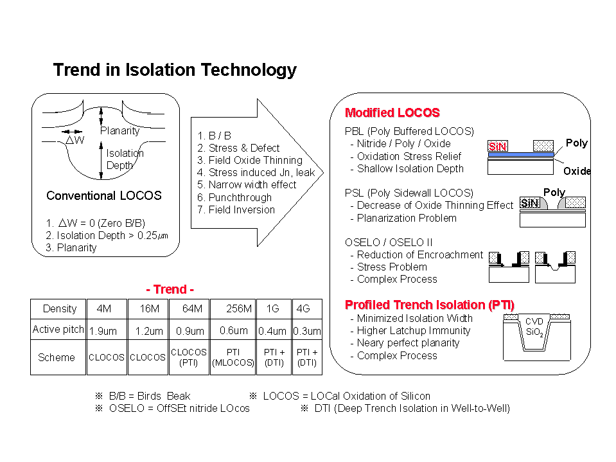
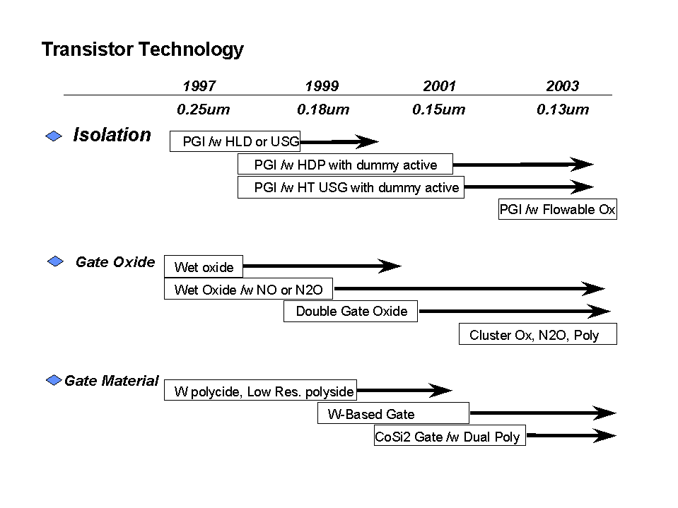
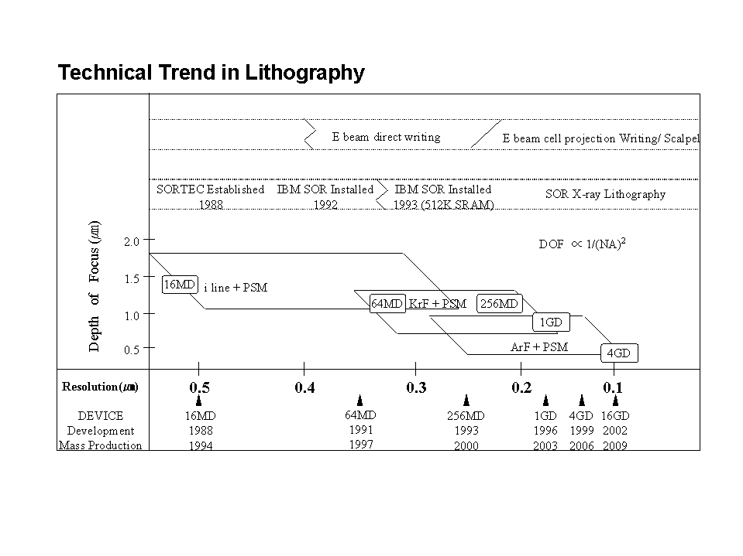
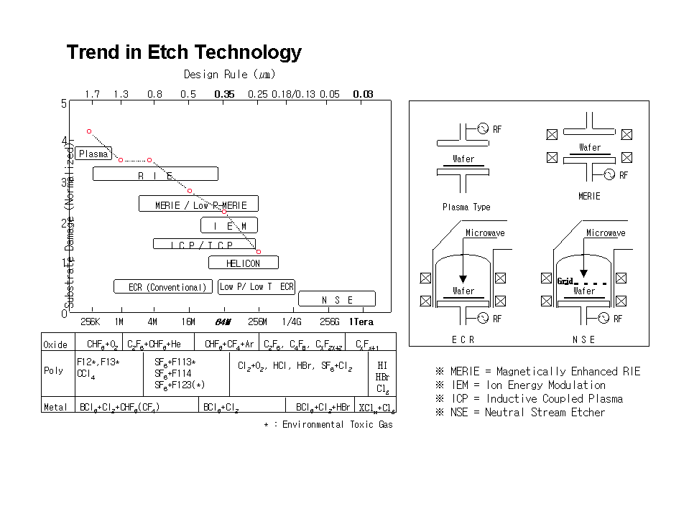
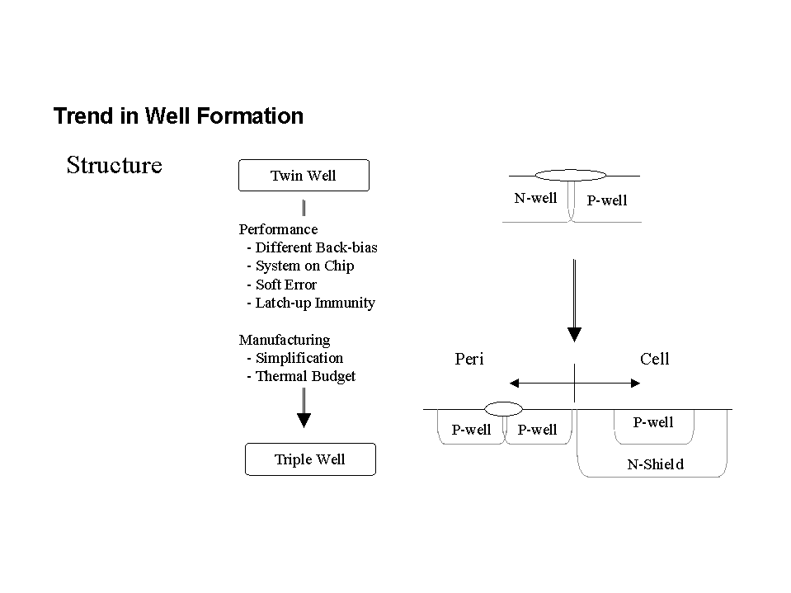
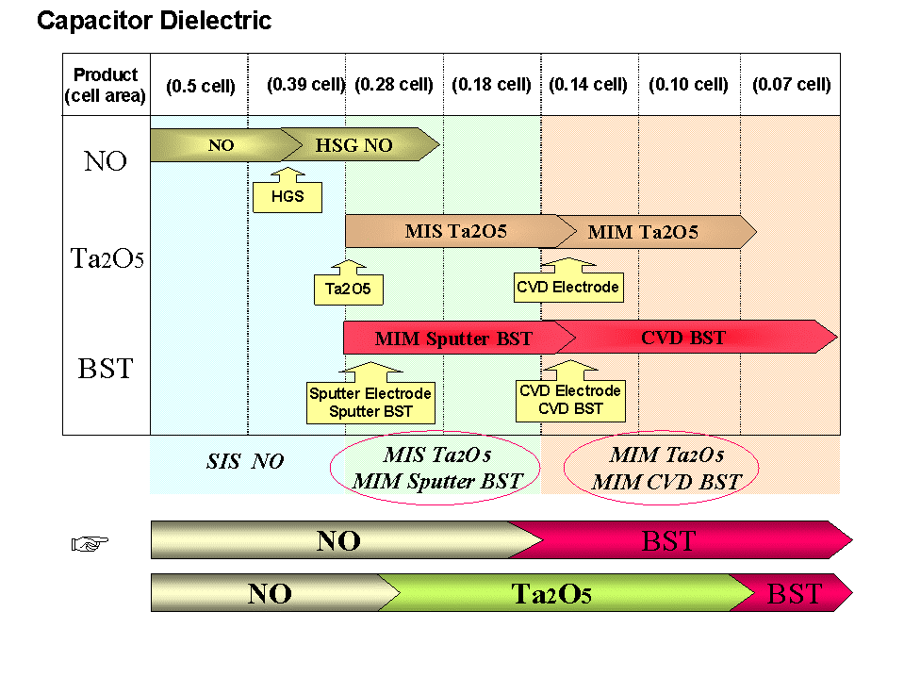
Figure 5. Trend in Transistor Technology
Figure1. Trend of Lithogarphy
Figure 2. Trend in Plasma Etching
Figure 4. Trend in Isoaltion Technology
Figure 6. Trend in Capacitor Dieletric
Figure 3. Trend in Well Formation

