철산화물 담지 촉매상에서 이산화탄소를 온화한 산화제로 사용한 에틸벤젠의 산화-탈수소반응

박민석, 박중남, 장종산, 이경열, 박상언
한국화학연구원, 분자활성공학실

OXI-DEHYDROGENATION OF ETHYLBENZENE WITH CARBON DIOXIDE
AS A MILD OXIDANT OVER SUPPORTED IRON OXIDE CATALYSTS

Min Seok Park, Jung-Nam Park, Jong-San Chang, Kyoung Yul Lee, and Sang-Eon Park
Catalysis Center for Molecular Engineering, Korea Research Institute of Chemical Technology (KRICT), P. O. Box 107, Yuseong, Daejeon 305-600, Korea

INTRODUCTION
Recently, utilization of CO₂ has attracted considerable attention as an oxidant, a promoter and a reactant for the production of useful chemicals[1-5]. This approach can open new technology for CO₂ utilization. CO₂ can play a role as the soft oxidant in the oxidative conversions of hydrocarbons[4-6]. Moreover, CO₂ can suppress the total oxidation in the oxidative coupling of methane and alkylaromatics together with the increase of selectivity and the low rate of coke formation.
Styrene is commercially produced by the EB dehydrogenation using potassium-promoted iron oxide catalysts with a large excess of superheated steam. However, the use of steam has a drawback of losing latent heat of condensation during subsequent separation particularly in a mass process[7]. The energy consumption required for the EB dehydrogenation using carbon dioxide is estimated to be much lower than that for the currently operating process using steam[7]. In addition to energy saving, the use of CO₂ with replacement of steam can give a beneficial advantage for increase in equilibrium conversion. Considering these aspects, it is desirable to design a new catalytic system based on the use of carbon dioxide instead of steam. Some selected catalytic systems have shown promoting effects in the presence of carbon dioxide[5-8]. The aim of this work is to investigate the effect and the role of carbon dioxide in EB dehydrogenation over zeolite-supported iron oxide catalysts.

EXPERIMENTAL
Zeolite-supported iron oxide catalyst was prepared by precipitation of aqueous suspension of FeSO₄ onto zeolite support in slightly alkaline solution at 60 ºC under N₂ atmosphere to avoid oxidative condition[5]. Highly siliceous NaZSM-5 zeolite (Uetikon PZ-2/980, Si/Al = 490, S_{BET} = 388 m²/g, V_{p}=0.222 ml/g) was used as a support. Loading of iron oxide was in the range of 1.5 - 20 wt%, which were designated as FeNaZ catalysts, i.e., 5FeNaZ denotes 5 wt% loading of iron oxide which is based on Fe₃O₄ supported on NaZSM-5 zeolite. Loading of iron oxide was 5.0 wt% as Fe₃O₄. Zeolite-supported Fe₂O₃ (5Fe₂O₃-NaZ) was prepared by the incipient-wetness method by using an aqueous solution of iron(III) nitrate. A commercial catalyst (bulk K-Fe₂O₃, Nissan Girdler) were compared their catalytic activities with FeNaZ.
The reaction was carried out in a conventional fixed bed reactor at 600ºC under atmospheric pressure[5]. Before feeding ethylbenzene into the reactor, the catalyst was treated in a nitrogen stream from RT to 600ºC with a heating rate of 10ºC/min. The effluent from the reactor was condensed by passing a glass condenser at ca. - 80ºC. The liquid and gas products were analyzed by GC(Donam Corp., DS6200).

RESULTS AND DISCUSSION
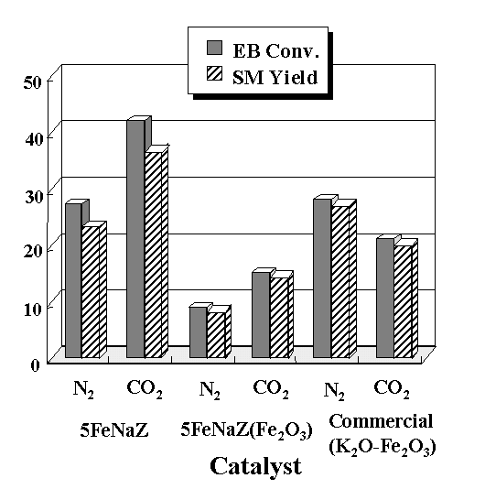Fig. 1 displays the results of the dehydrogenation reaction over various iron-based catalysts depending on the presence or the absence of carbon dioxide. The FeNaZ catalyst shows a beneficial effect of carbon dioxide on the dehydrogenation of EB, that is, enhancement of styrene yield by 14% comparing with that under N₂ flow. However, the commercial catalyst exhibits poor activity in the presence of CO₂. Actually, it was active only under steam flow (64% EB conversion, 95% SM selectivity). It is noted that iron oxide phases on the zeolite-supported catalysts determine their catalytic activities under CO₂ carrier. The activity of Fe₂O₃-NaZ calcined under air atmosphere much decreases as compared to that of FeNaZ, indicating that α-Fe₂O₃ phase formed by air calcination is inactive for the reaction. Contrary to using nitrogen carrier gas, the dehydrogenation with carbon dioxide over FeNaZ catalyst produces styrene, water and carbon monoxide together with small amounts of hydrogen, which is less than 25% of the amount of carbon monoxide produced. The formation of water as well as carbon monoxide implies that on the FeNaZ catalyst CO₂ molecule dissociates CO and surface oxygen which can abstract hydrogen from EB, and then results in the generation of water:
Fig. 1. Effect of CO₂ as the soft oxidant to catalytic activity in EB dehydrogenation. Reaction conditions: Temp. = 600ºC, LHSV = 1.0 h⁻¹, CO₂ (N₂)/EB = 80/1.
The enhancement of the dehydrogenation activity in the presence of carbon dioxide is certainly ascribed to the promotion of this oxidative process by carbon dioxide.
In addition to enhancement of catalytic activity, the use of carbon dioxide as a carrier gas has also a great influence on the catalyst stability[5]. The activity of 5FeNaZ catalyst under a N₂ stream decreased monotonically with reaction time, while the catalytic activity under a CO₂ stream is maintained without significant decay of the activity. It is deduced that surface enrichment of adsorbed CO₂ species on zeolite-supported iron oxide catalyst leads to enhancing the coke resistance and as a result to extending catalyst lifetime during the reaction.
Table 1 represents effect of iron oxide loading to dehydrogenation activity together with the data on surface area and pore volume. 5FeNaZ exhibits the highest dehydrogenation activity under CO₂ flow. It is noted that any decrease of catalyst surface area and pore volume is not observed even at loading of 10 wt% iron oxide. This unexpected result seems to be ascribed to the presence of mesopores (30 - 40 Å) of commercial microporous zeolite which was used in this study. Actually, about 5% of total pore
Table 1. Catalytic activities of Fe/γ-Al₂O₃ catalyst for EB dehydrogenation with carbon dioxide depending on calcination conditionª
Catalyst | S_{BET} (m²/g) | V_{p} (ml/g) | X(EB) (%) | S(SM) (%)
1.5FeNaZ | 396 | 0.242 | 31.2 | 84.7
5FeNaZ | 394 | 0.235 | 42.1 | 88.9
5 Fe₂O₃-NaZ | 358 | 0.213 | 14.9 | 96.5
10FeNaZ | 390 | 0.233 | 35.7 | 92.3
18FeNaZ | 380 | 0.243 | 33.5 | 80.5

ªReaction conditions: Temp. = 600ºC, LHSV = 1.0 h⁻¹, CO₂/EB = 80/1, Time-on-stream = 4 h.*Notation: X(EB), EB conversion; S(SM), SM selectivity.

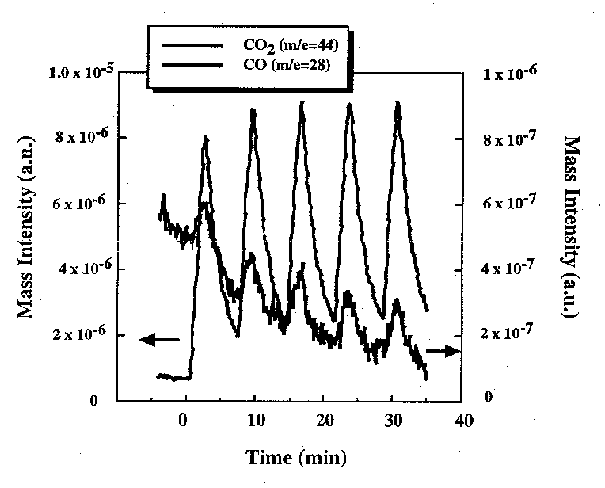
volume was attributed to mesopores and their pore sizes were modified by loading iron oxide, indicating the interaction between iron oxide and mesopores. According to XRD analysis, crystallized iron oxides have not been observed on the FeNaZ catalyst up to 10 wt% loading of iron oxide, suggesting that iron oxide phase is amorphous and is well dispersed[9]. This result implies that the iron oxide phase is highly dispersed in ZSM-5 zeolite support. According to XPS analysis, the Fe 2p spectra of ZSM-5 zeolite supported iron oxide catalysts showed characteristic of Fe₃O₄ oxide with an apparent lack of satellite structure at 719.1 eV, different from Fe₂O₃ oxide[10]. Therefore, iron oxide in the FeNaZ catalysts was found to be mainly metastable Fe₃O₄-like phase, highly dispersed in commercial ZSM-5 zeolite.
Fig. 2. Periodic reaction of CO₂ on 5FeNaZ pretreated with CO₂ + H₂ gas mixture for 1h. Reaction conditions: Temp. = 600ºC, W_{cat} = 30 mg, total flow rate of gases = 25 ml/min, Periodic feeding of 10% CO₂ gas diluted in He for 2 min followed by feeding He carrier gas for 5 min.
It is likely that oxygen deficiency of iron oxide in the supported catalyst is one of the most important factors on promoting the catalytic activity in the presence of CO₂. It is indirectly proved by producing CO molecules from CO₂ pulse reaction on reduced surface of the FeNaZ catalyst. Fig. 2 displays mass spectra of the reaction stream according to several CO₂ pulses on the reduced FeNaZ catalyst at 600ºC. Prior to this test, the catalyst was exposed to gas mixture of CO₂ and H₂ (CO₂/H₂ = 30) at 600ºC for 1h. This result indicates that reduced iron oxide catalyst can be oxidized under CO₂ atmosphere, producing CO and surface oxygen. Tamaura and co-workers have extensively studied on the decomposition of CO₂ over oxygen-deficient magnetite (Fe₃O₄) and the role of its oxygen deficiency on this reaction[11]. High reactivity of oxygen-deficient magnetite was ascribed to the oxygen transfer that gives rise to the high reduction potential of the Fe²⁺ ions for CO₂. However, dispersion of oxygen-deficient sites of iron oxide is essential for high activity in EB dehydrogenation with CO₂[9]. Based on the above catalytic results, it is suggested that dispersion of oxygen-deficient Fe₃O₄-like phase in high surface area zeolite matrix is more efficient for the CO₂ dissociation into CO. In this respect, oxygen-deficient sites of supported iron oxide could produce CO efficiently from the CO₂ dissociation, and the adsorbed oxygen on the catalyst surface could play a role on hydrogen abstraction of ethylbenzene. Therefore, it is deduced that activity enhancement of the FeNaZ catalyst in the presence of CO₂ is mainly due to the presence of Fe²⁺ species and its oxygen deficiency.

CONCLUSIONS
In dehydrogenation of ethylbenzene with carbon dioxide over ZSM-5 zeolite-supported iron oxide catalyst, ethylbenzene was predominantly converted into styrene by an oxidative manner. It was found that carbon dioxide in this reaction plays a role as the soft oxidant to greatly improve catalytic activity as well as coke resistance of catalyst. An active phase for the dehydrogenation with carbon dioxide was suggested as rather reduced and isolated magnetite(Fe₃O₄)-like phase having oxygen deficiency in zeolite matrix.

ACKNOWLEDGEMENT

This research was performed for the Greenhouse Gas Research Center, one of the Critical Technology-21 Programs, funded by the Ministry of Science and Technology (MOST) of Korea. We also thank Daebo Industrial Inc. (Korea) for financial support.

REFERENCES
[1] J.S. Yoo, Catal. Today 41, 409(1998).
[2] M. Aresta, I. Tommasi, E. Quaranta, C. Fragale, J. Mascetti, M. Tranquille, F. Galan, and M. Fouassier, Inorg. Chem. 35, 4254(1996).
[3] O.V. Krylov and A.Kh. Mamedov, Ind. Eng. Chem. Res. 34, 474(1995).
[4] S.-E. Park, J.-S. Chang, and M.S. Park, Prep. ACS Fuel Chem. Div. 41(4), 1387(1996).
[5] Chang J.–S., Park S.–E., and Park M.S., Chem. Lett. 1123, (1997).
[6] Park J.–N., Noh J., Chang J.–S, and Park S.-E., Catal. Lett. 65, 75(2000).
[7] Mimura N., Takahara I., Saito M., Hattori T., Ohkuma K., and Ando M., Catal. Today, 45, 61(1998).
[8] Sugino M., Shimada H., Turuda T., Miura H., Ikenaga N., and Suzuki M., Appl. Catal., 121, 125(1995).
[9] Chang J.–S., Noh J, Park S.–E., Kim W.Y., and Lee C.W., Bull. Kor. Chem. Soc. 19, 1342(1998).
[10] Chang J.–S., Park S.–E., Kim W.Y., Anpo M., and Yamashita H., Stud. Surf. Sci. Catal. 114, 387(1998).
[11] Tamaura Y. and Tabata M., Nature 346, 255(1990).

