확장 페트륙 증류탑의 구조해석과 설계

최 한욱, 김 영한
동아대학교 화학공학과

Structural Analysis and Design of an Extended Petlyuk Column

Han Wook Choi and Young Han Kim
Dept. of Chem. Eng., Dong-A University

Introduction
Higher thermodynamic efficiency of a fully thermally coupled distillation column (FTCDC), also known as the Petlyuk column, than the efficiency of a conventional distillation system has widely been recognized ever since it was introduced a half century ago. The high efficiency has been proved in the field applications of many chemical companies as well.
Comparing the distribution of liquid composition in the FTCDC with a diagram of residue curves indicates their resemblance. One of the residue curves matches the liquid composition profile of a packed distillation column in total reflux operation, and therefore the thermodynamic efficiency of the distillation associated with the curve is ideal. When the liquid profile of a distillation system follows the residue curves, the efficiency of the system is predicted to be high. The profiles of an FTCDC and an extended FTCDC are close to the curves, which gives the answer for the high efficiency of the systems.
A structural design giving an answer for the optimal structure of an extended FTCDC and reducing the computational burden is applied to example systems for an approximate design [1]. The extension of the procedure to rigorous design is explained and implemented to three example systems in this study. The outcome of the rigorous design can be used as the initial process values for a dynamic simulation of the column in the study of column operation.

Analysis of Various Structures
When the profile of liquid composition distribution of an extended FTCDC follows one of the residue curves, the thermodynamic efficiency of the column is ideal. It is because the residue curves denote the composition profile for a packed distillation column in total reflux operation. Thus, comparing the composition profile of an extended FTCDC with the residue curves tells how efficient a certain structure of the column is. The liquid composition profile of Sargent and Gaminibandara’s column is shown in Figure 1 along with its structural description. The interlinking of the first and the second columns is made near to the left and right ordinates, but the locations are not so close to the ordinates, where the second and the third columns are interlinked. In addition, the middle of the second column is linked to the third column. In this arrangement, there are some composition differences between the interlinking trays to result in mixing. The mixing is an irreversible process and reduces the thermodynamic efficiency of the column. For example, the upper interlinking between the first and the second columns can be made at the location near to component A to reduce the composition difference between two interlinking trays, but it is impossible for component B to be transported from column I to column II through the interlinking. Therefore, the composition discrepancy at the interlinking trays is inevitable. When the diagram of Kaibel’s column is examined in Figure 2, the difference is greater than that in the Sargent and Gaminibandara’s column. Though all the components of A and B have to be transported through the upper interlinking, close connections are only available near to the corner of components A and D. Because the composition of component B in an interlinking stream is higher than the Sargent and Gaminibandara’s column, there is large composition difference between the interlinking trays.
Meanwhile, Agrawal’s column as given in Figure 3 does not produce large composition difference at the interlinking trays. There is little mixing in this arrangement. An efficiency comparison [2] of the three structures in Figures 1 through 3 indicates that the Agrawal’s column has the highest efficiency, the Sargent and Gaminibandara’s column is the next, and the Kaibel’s is the lowest. This means that the structural analysis using the composition profile and residue curves is useful to predict column efficiency and to devise a new column structure.

Structural Design
The design methods utilizing rigorous process model and commercial design packages for an extended FTCDC do not search the optimal column structure in separate procedure. Instead, they iteratively calculate product compositions until desired products are yielded. Because there are 10 degrees of freedom concerning to the column structure, many different sets of the structures have to be examined to see if one of them gives the optimum cost of column construction and operation.
The minimum numbers of trays of an extended FTCDC are found from the stage-to-stage computation. Assuming that the feed tray has equal liquid composition to the composition of a saturated liquid feed and the tray efficiency is ideal, one can calculate the liquid composition of the stages above the feed tray.
Note that the structure from the proposed design leads to high thermodynamic efficiency because the profile of liquid composition of the whole system is based on the minimum trays. In the design of a practical column, proportionally increasing all the numbers makes the structure sustained to keep the high efficiency. There is an optimum ratio between the practical and the minimum columns for the lowest cost of investment and operation. In this study, however, a rule of thumb ratio of two is adopted from a literature, which is within the range used in the industrial practice. The outcome of the structural design for example systems is listed in Table 1 in which the symbols are given in Figure 4.

Operational Decisions
The optimum transfer of components B and C is derived in the calculation of the minimum liquid flow rates for the three columns in Figure 4. For the simplicity of explanation, Figure 3(a) is utilized. From column I, components B and C go to column II through either top or bottom of the column. Let the portion of component B from the top of the column be $γ_{B}$ and component C be $g_{C}$. Then they are given as [1]
$g_{B}=\frac{α_{B}−α_{D}}{α_{A}−α_{D}}$ (1)
and
$g_{C}=\frac{α_{C}−α_{D}}{α_{A}−α_{D}}$ (2)
The minimum liquid flows are given as
$L_{1^{M}}=\frac{α_{D}F}{α_{A}−α_{D}}$ (3)

$L_{2^{M}}=V_{2^{M}}−{Fz}_{A}−{Fz}_{B}g_{B}β$ (4)
and
$L_{3^{M}}=\frac{α_{\text{AB}}{\text{Fz}}_{A}}{α_{\text{AB}}−ϕ} − F z_{A}$ (5)
where ϕ is a solution of the Underwood equation.
The three systems are an alcohol system of methanol-ethanol-1-propanol-1-butanol (S1), an aliphatic hydrocarbon system of n-hexane-cyclo-hexane-n-heptane-n-octane (S2), and an aromatic hydrocarbon system of chloroform-benzene-toluene-chlorobenzene (S3). They are selected from different groups of organic compounds. Feed compositions of the system S3 are equimolar (F1), 0.7-0.1-0.1-0.1 (F2), and 0.4-0.4-0.1-0.1 (F3).

Results and Discussion
Taking twice the minimum numbers gives the structural information for a practical distillation system of an extended FTCDC. The steady state simulation is conducted to find liquid flow rates for the system producing overhead, bottom, and two side products of specified composition. The computation results for three example systems and three feeds for the third system are summarized in Table 1. Also, the profile of liquid composition of the first system with equimolar feed is demonstrated in Figure 5. Generally the shapes of the composition profile are similar in two figures except that of the main column. There is a mis-match between feed and feed tray compositions. The feed composition is denoted with a star symbol, while the tray composition is the nearest circle. This is common in a practical distillation column, in which more than the minimum number of trays is necessary for the discrepancy. Because of the mis-match, remixing of two middle components is observed in the figure.
The table contains the tray related numbers from structural design of practical systems as well. The description of the headings is shown in Figure 4. The numbers in parentheses are originally calculated numbers from the minimum design, but the specified products are unavailable with the numbers. Mostly the composition of overhead product is too high, and so the upper interlinking location in column III is moved upward to lower the composition. The composition discrepancy at feed tray also causes some adjustment of feed tray location.
Because the design of this study utilizes the minimum trays of a distillation system, high thermodynamic efficiency is guaranteed. In addition, the computation to find ten variables of structural information required in the design using commercial software is eliminated. The reduction of computational load is significant in the design of an extended FTCDC having many interlinking to result in a lot of design variables.

Conclusion
A rigorous design procedure for extended fully thermally coupled distillation columns is proposed and implemented to three different real systems. The design is based on the minimum tray structure to give high thermodynamic efficiency by making liquid composition profile similar to the residue curves of equilibrium distillation. Because of the known structure the design becomes simple, while most of field designs utilizing commercial software require a lot of computation to obtain the structure.
The outcome of example system design proves the performance of the proposed design. In addition, the design gives all the process values in the steady state operation of the designed system, which are utilized as the initial condition of a dynamic simulation of the system for the operation study. In structural analysis, an examination of different structures of the extended FTCDC is conducted to explain the relation between the discrepancy of liquid composition profile and residue curves and the thermodynamic efficiency of the column.

References
[1] Y.H. Kim, Structural design of extended fully thermally coupled distillation columns, Ind. Eng. Chem. Res. 40 (2001) 2460-2466.
[2] A.C. Christiansen, S. Skogestad, K. Lien, Complex distillation arrangements: extending the Petlyuk ideas, Computers chem.. Engng. 21 (1997) S237-S242.

Table 1. Design result of the example systems

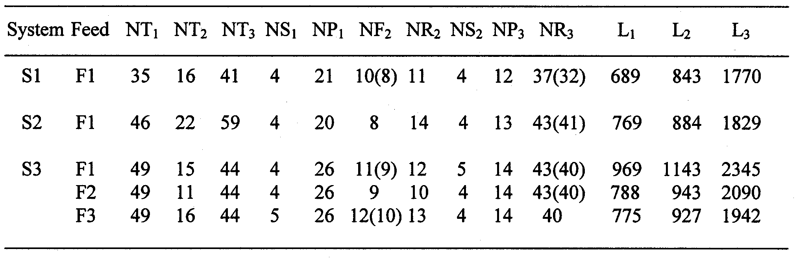

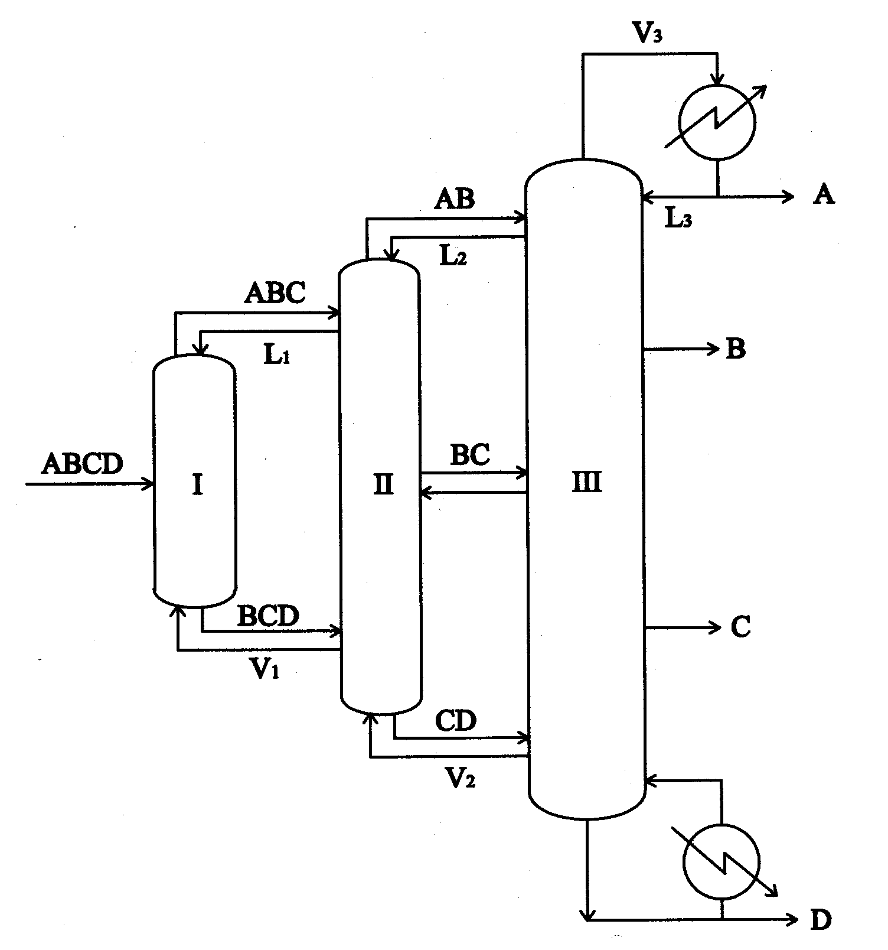

(a) (b)

Figure 1. Schematic of Sargent and Gaminibandara arrangement for quaternary separation and liquid composition profile.

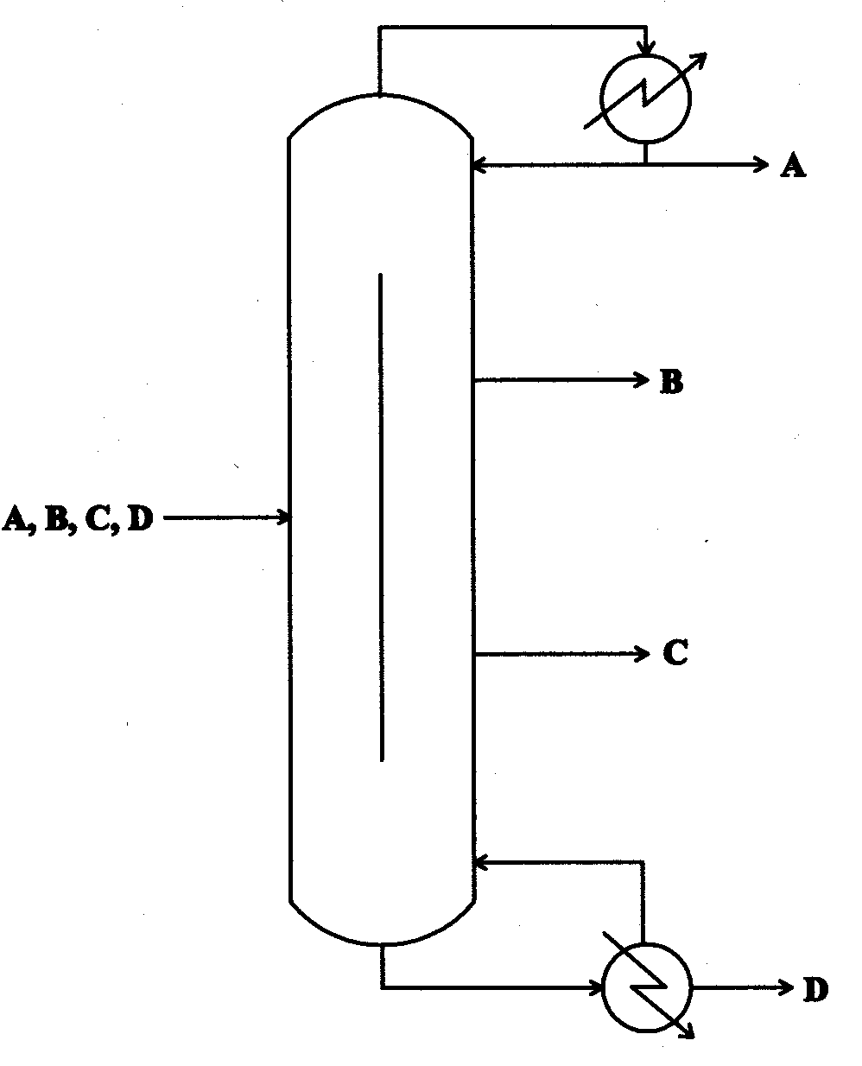

(a) (b)

Figure 2. Schematic of Kaibel arrangement for quaternary separation and liquid composition profile.

(a) (b)

Figure 3. Schematic of Agrawal arrangement for quaternary separation and liquid composition profile.

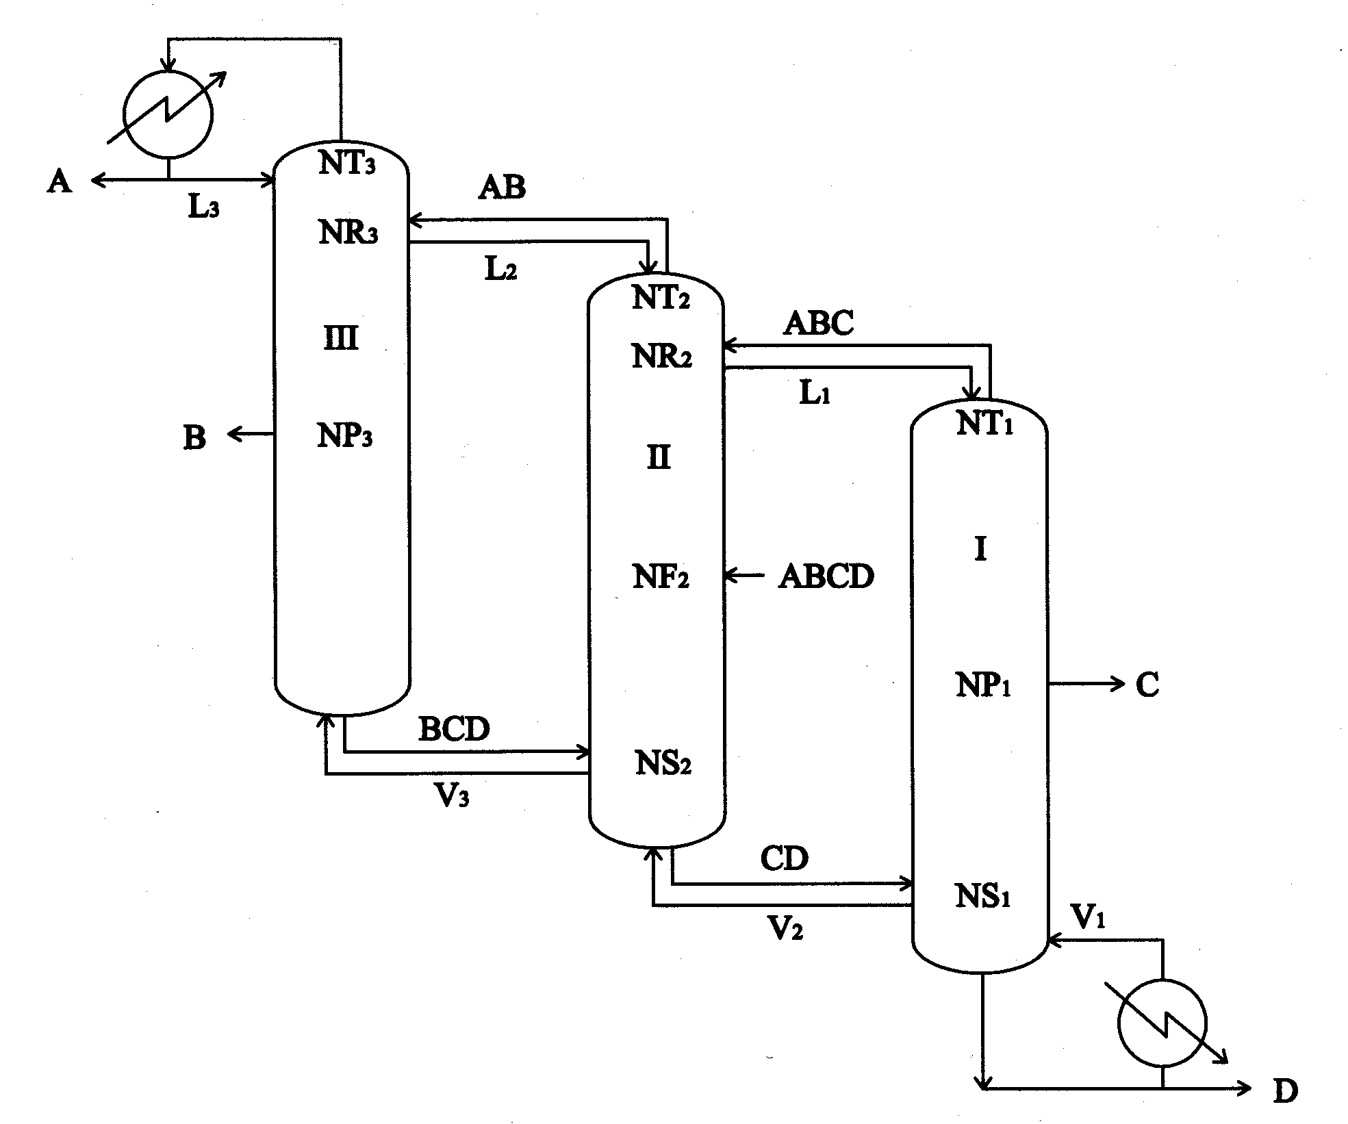

Figure 4. Schematic diagram of a modified extended Petlyuk column.

Figure 5. Liquid composition profile in an extended Petlyuk system with a practical number of trays.

