혼합 계면활성제를 이용한 메조포러스 실리카의 기공크기 및 메조상의 제어

송명근, 조성호, 김종득
대전광역시 유성구 구성동 373-1 한국과학기술원 화학공학과

The Control of Pore-Size and Mesophases of Mesoporous Silica by
Mixed Cationic-Nonionic Surfactants Templating Approach

Myung-Geun Song, Sung-Ho Jho, Jong-Duk Kim
Department of Chemical Engineering, Korea Advanced Institute of Science and Technology, 373-1 Kusung-dong, Yusung-gu, Taejon 305-701, Korea

Introduction
The discovery of M41S family of mesoporous molecular sieves (1,2,3) has stimulated great interest in the surfactant-directed assembly of mesostructures because of their potential application as versatile catalysts, catalyst supports, separation media, encapsulation, and hosts for inclusion compound and nanowires. One of the important studies in the synthesis of mesoporous materials is to explore possibilities for fine-tuning the size of pores and wall-thickness. Thus far, several ways have been introduced to control the pore sizes. One has involved increasing the length of the alkyl chain of the surfactant, which lead to a large diameter of templating micelles. Recently, employing the combination of surfactants for the mixed self-assembly of mixed micellar templates which give rise to materials with d-spacings tunable was introduced, since mixed surfactant systems offer new possibilities in the design of surfactant-templated silica materials in that their structure and morphology can be controlled through the choice of two or more surfactants with different properties and the adjustment of composition. (4,5).
In this work, the effect of mixed systems of cationic and nonionic surfactant on mesophases of silica was studied, especially the effects on the pore size and wall-thickness of final silica product. Employing cationic surfactant in combination with nonionic species in the synthesis of mesoporous materials may allow for the self-assembly of mixed micellar templates which give rise to materials with d-spacings tunable on a subangstrom length scale.

Experimental
Materials and Synthesis; The silica source used in this study was TEOS (tetraethyl orthosilicate, Janssen, 98%). Cetyltrimethylammonium bromide, CTAB (Aldrich) and polyoxyethylene (10) cetyl ether, C₁₆EO₁₀ (Sigma) was used without further purification. A typical synthesis involved mixing of known amounts of cationic and nonionic surfactants in deionized water, and then HCl solution was added into mixed surfactant solution. The mixed surfactant solution was stirred for several hours for the entire solubilization of surfactants, and TEOS was added dropwisely to a solution and then stirred for 24 hours at room temperature if not otherwise specified. The suspension was stocked at room temperature for 3 days. The solid product was filtered, washed with distilled water, and dried in oven at 60ºC. The as-synthesized materials were calcined in air at a rate of 1ºC/min reaching to a maximum of 550°C for 8 hours for the removal of surfactants.
Analyses; Powder X-ray diffraction (XRD) patterns were obtained on a Rigaku D/MAX-III diffractometer using Cu K_{α} radiation (λ=1.54178Å). The N₂ adsorption-desorption isotherms of the samples were obtained with an Micromeritics ASAP-2000 apparatus using nitrogen as adsorbed at 77K. The samples were degassed at 300ºC for 5 hours and the pore structure data were analyzed from the adsorption curve by the Barrett-Joyner-Halenda (BJH) method.

Results & Discussions
Figure 1 shows the powder XRD (PXRD) patterns of mesoporous silica synthesized with a surfactant composition of 100mol% of CTAB and C₁₆EO₁₀ respectively. The sample(a) was synthesized with a molar ratio of 1TEOS : 1.9HCl : 0.14C₁₆EO₁₀ : 130H₂O stirring for 3 days at 65~70ºC, and sample(b) with 1TEOS : 3.15HCl : 0.12CTAB : 130H₂O at room temperature. The two mesostructures shown in this figure exhibit 2d hexagonal phase (p6mm) with different length of d₁₀₀ spacing for (a) 4.65nm ( unit cell parameter, a₀ = 5.37nm)and (b) 3.38nm (a₀ = 3.90nm). Generally, the d-spacings of mesoporous silica templated with nonionic surfactants are greater than that synthesized by using cationic surfactant, CTAB, because the micelles of nonionic surfactants are larger than that of CTAB. The PXRD patterns of mesoporous silica prepared from mixed micellar systems are shown in Figure 2. The materials synthesized with a molar ratio of 1TEOS : 3.15HCl : 0.12CTAB : 0.12XC₁₆EO₁₀ : 130H₂O, where X varies as (a)0, (b)0.01, (c)0.05, (d)0.10, (e)0.25, and (f)
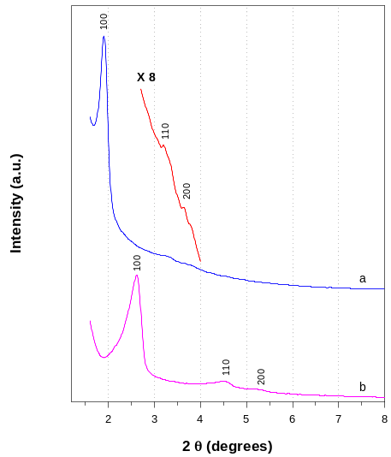
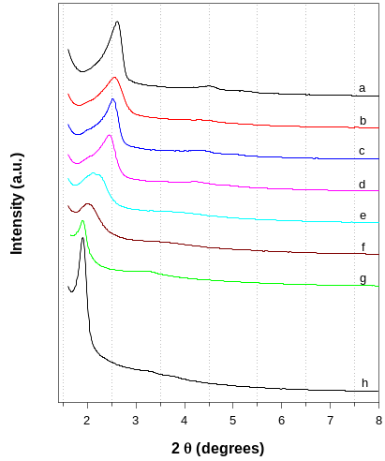
Figure 1 Figure 2

0.5, (g) 1.0, and (h) with 100mol% of C₁₆EO₁₀, since the molar ratio of CTAB to TEOS was fixed as 0.12. Figure shows that the interplanar d-spacing is increased with the amount of C₁₆EO₁₀, while the structural ordering of mesophases is slightly decreased. This indicates that the CTAB micelles can be expanded by the dissolution of C₁₆EO₁₀ molecules and rearranged into larger CTAB-rich micelles. The C₁₆EO₁₀-rich micelles also can be formed, but the proportion to CTAB-rich micelles would be very low, due to the strong electrical repulsion between cationic CTAB head groups and this leads to the limited solubility of CTAB molecules into C₁₆EO₁₀ micelle core. Furthermore, the electrostatic interactions between CTAB and TEOS are stronger than the hydrogen bonds which link the EO chain in nonionic surfactant and TEOS, and therefore the polymerization of silica would be preceded on the surface of CTAB-rich micelles.
Figure 3 shows the change of d-spacings, which are measured with the first order diffraction peaks shown in Figure 2, and the pore size by N₂-desorption isotherm of mesoporous silica. The wall-thickness of mesopores can be predicted by the difference of d-spacing and pore size, and the results are shown in Figure 4. Figure 3 and 4 show that the mesopore size and wall-thickness increased with the amount of nonionic surfactant. This indicates that the pore size of mesoporous materials can be controlled by the mixed surfactants templating. Furthermore, the hydrothermal stability of mesoporous materials can
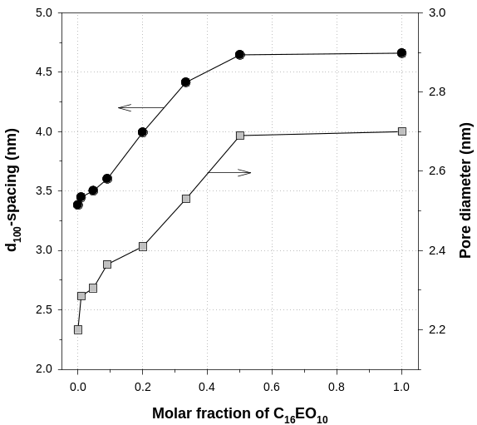
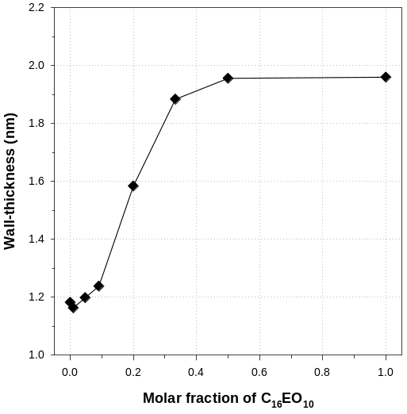
Figure 3 Figure 4

be improved by this method, due to the increment of wall-thickness of mesostructures. The mesophases which are shown in Figure 2 are one-phase ordered and disordered p6mm structures. When the molar ratio of HCl in reactant composition increases, two-phase mesostructures were observed, due to the formation of oxonium ion in the hydrophilic portion of nonionic surfactants, and the limited solubility of nonionic surfactants into cationic surfactant-rich micelles. Therefore, there exist two kinds of separated micelles in strong acidic solution, and different kinds of micelles may lead the two-phase mesostructures of mesoporous silica.

References
1. Kresge, C.T, Leonowicz, M.E., Roth, W.J. Vartuli, J.C, Beck, J.S., Nature, 1992, 359, 710.
2. Beck, J.S., Vartuli, J.c., Roth, W.J., Leonowicz, M.E., Kresge, C.T., Schmitt, K.T., Chu, C.T., Olson, D.H., Sheppard, E.W., McCullen, S.B., Higgins, J.B., and Schlenker, J.L, J. Am. Chem. Soc., 1992, 114, 10834.
3. Vartuli, J.c., Kresge, C.T., Leonowicz, M.E., Chu, A.S., McCullen, S.B., Johnson, I.D., Sheppard, E.W., Chem. Mater., 1994, 6, 2070.
4. Kushalani, D.; Kuperman, A.; Ozin, G.A.; Tanaka, K.; Garces, J.; Olken, M.M. Adv. Mater. 1996, 7, 842.
5. Chen, F.; Song, F.; Li, Q. Mircopor. Macropor. Mat. 1999, 29, 305.

