버섯류 액체배양에 의한 기능성 생물고분자의 생산
윤종원
대구대학교 생물공학과

Functional biopolymers from edible mushrooms
Jong Won Yun
Department of Biotechnology, Taegu University

INTRODUCTION
Much interest has been generated in the subject of polysaccharides produced by numerous microorganisms, especially edible mushrooms due to their various biological and pharmacological activities, including immuno−stimulating activity, anti−tumor activity, and so on. Because solid culture of mushrooms takes long time to complete a fruiting body, many attempts are being made to obtain useful cellular materials or to produce effective substances from a submerged mycelial culture.

MATERIALS & METHODS
Methodology of research for biopolymer production from various edible mushrooms.

Edible mushrooms (total 24, 9 target species)

Starting species : Paecilomyces japonica, Paecilomyces cinclairri, Cordyceps militaris

Submerged cultures & Biopolymer prouction
• Basic culture optimization & strategy for yield improvement
• Rheological & morphological study by image analyzer
• Biopolymer characterization by MALS : MW & MW distribution of biopolymers
• Preliminary investigation of biopolymers by SPM

Functionality & Applications
Biopharmaceuticals: immuno-stimulating, hypoglycemic, hypolipidemic effects, etc.
Cosmetic materials: anti-UV agent.

RESULTS
Screening for biopolymer production
Nutritional status of various edible mushrooms for submerged culture of mycelial growth and exo-biopolymer production (for 19 strains)
Optimization of submerged cultures
Optimization of submerged culture conditions for exo-biopolymer production by Paecilimyces japonica. Journal of Microbiology and Biotechnology, 10(4) 482~487 (2000): sucrose and maltose were the best carbon sources for biopolymer production from mushrooms.
Changes in morphology of Paecilomyces japonica and its effect on broth rheology during production of exo-biopolymers. Applied Microbiology and Biotechnology. 56, 88~92 (2001) (Fig.1): compact pellets was the best productive morphological form.

Effect of carbon source on the mycelial growth and exo-biopolymer production by submerged culture of Paecilomyces japonica.Journal of Bioscience Bioengineering. 91(5) 522~524 (2001). The morphological and rheological properties between maltose and sucrose media were comparatively studied.

Optimization of submerged culture conditions for the mycelial growth and exo-biopolymer production by Cordyceps militaris. Letters in Applied Microbiology. 33(1) 76~81 (2001).

Effect of substrate concentration on broth rheology and fungal morphology during exo-biopolymer production by Paecilomyces japonica in a batch bioreactor. Enzyme and Microbial Technology. in press (2001) (Fig.2).
Effect of aeration rate and agitation intensity on the mycelial morphology and exo-biopolymer production in Cordyceps militaris (2001): The most favorable morphological and rheological conditions were maintained at 40 g/l of maltose media.
Stimulatory effect of plant oils and fatty acids on the exo-biopolymer production in Cordyceps militaris (2001) (Fig.3): Several plant oils significantly increased the biopolymer production (over 3-6 folds).
Production of red pigment by submerged culture of Paecilomyces sinclairii (Fig.4).
Functionalities
Production of Exo-polymers by Submerged Mycelial Culture of Cordyceps militaris and its hypolipidemic Effect. Journal of Microbiology and Biotechnology, 10(6) 784~788 (2000).
A preliminary study on hypoglycemic effect of exo-polymers produced by five different medicinal mushroom. Journal of Microbiology and Biotechnology, 11(1), 167~171 (2001).

Hypoglycemic effects of mycelia produced from a submerged culture of Phellinus linteus (Berk. et Curt.) Teng (Aphyllophoromycetideae) in streptozotocin-induced diabetic rats. International J. of Medicinal Mushrooms, 3(1). In press (2001).
Production of a hypoglycemic, extracellular polysaccharide from the submerged culture of the mushroom, Phellinus linteus. Biotechnology Letters, 23 (7), 513~517 (2001).
Hypoglycemic effect of Phellinus linteus exo-polymers (2001).
The hypolipidemic effects of exo-polymers produced from submerged mycelial culture of Auricularia polytricha in Rats (2001).
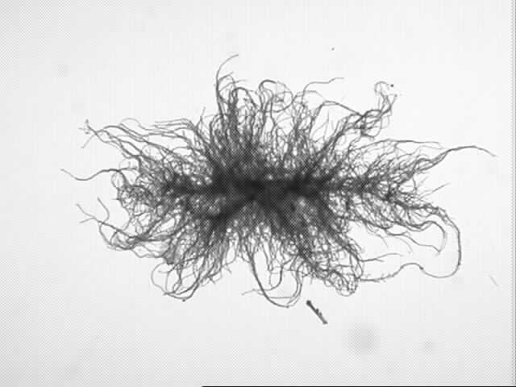
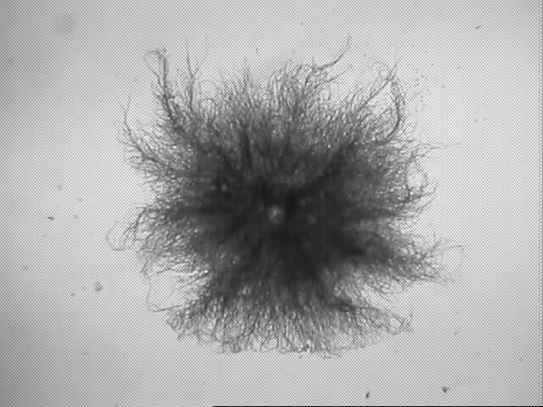
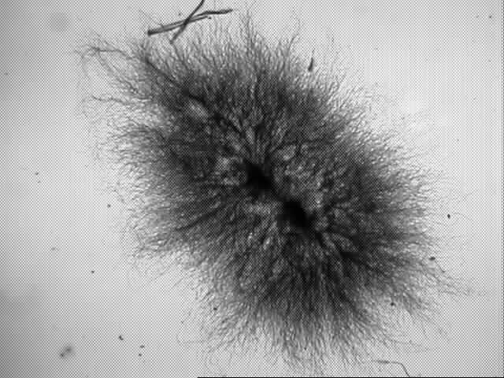
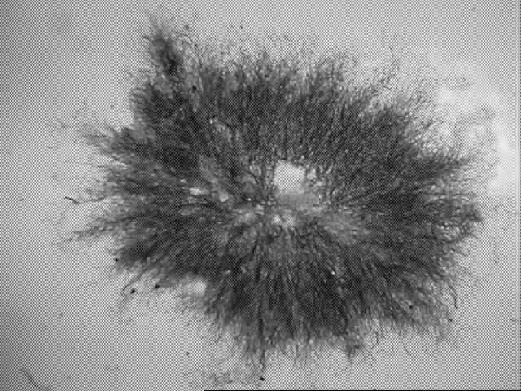
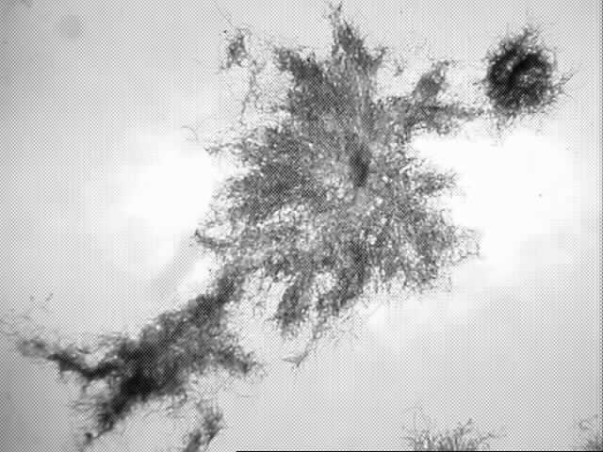
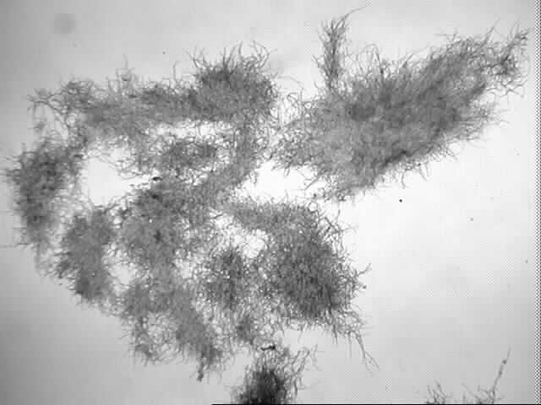
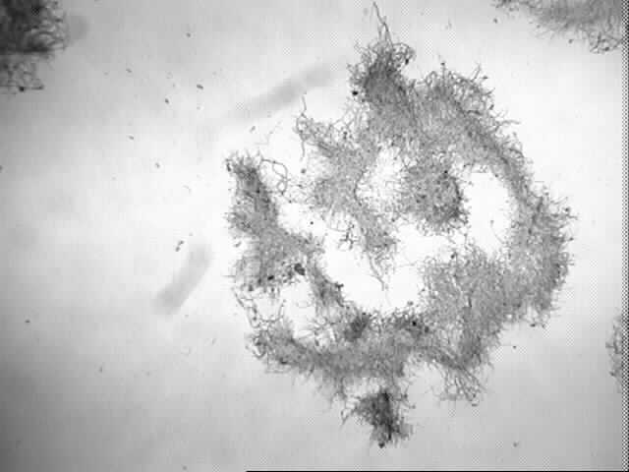
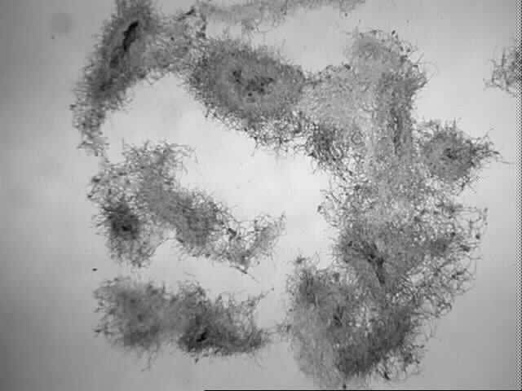
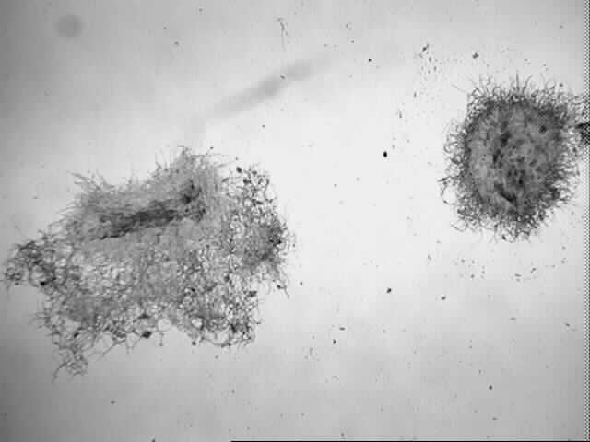
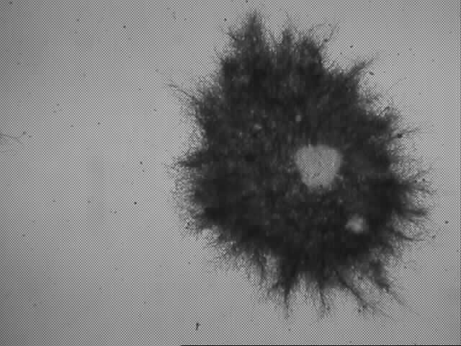
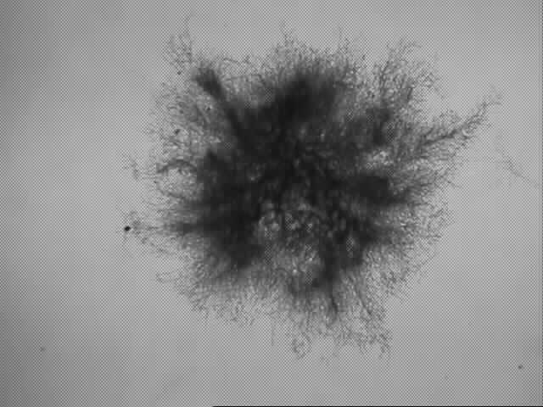
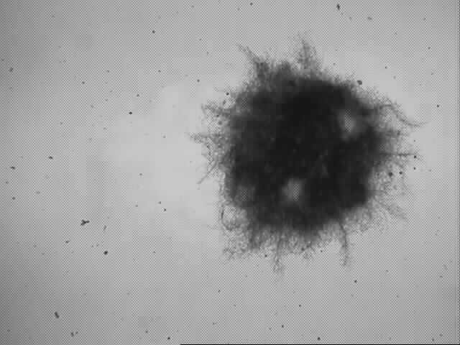
The hypoglycemic effects of exo-polymers produced from submerged mycelial culture of Lentinus edodes in diabetic rats (2001).
2d
9d
11d
12d
5d
6d
7d
3d
1d
4d
8d
10d
Fig. 1. The morphological changes in P. japonica,
using sucrose as the carbon source in a batch bioreactor. 1d-12d ; Days 1-12
Fig. 2. Effect of sucrose concentration on mean area of
the pellets of Paecilomyces japonica in batch bioreactor.
() 20 g/l, () 40 g/l, () 60 g/l sucrose medium.

Fig. 3. Effect of olive oil on the mycelial growth () and exo-biopolymer production (○) of C. militaris in shake flask culture.
Fig. 4. Time profiles of sugar consumption (), mycelial growth (○), and pigment production () in P. sinclairii in a 5-l batch bioreactor under optimal culture condition.

