Carboxylated alginic acid를 이용한 중금속 제거의 특성

전충, 박재연, 유영제
서울대학교 응용화학부

Characteristics of Heavy Metal Removal using Carboxylated Alginic Acid

Choong Jeon, Jae Yeon Park and Young Je Yoo‡
School of Chemical Engineering, Seoul National University

Carboxylated alginic acid prepared through oxidation reaction with potassium permanganate had a high uptake capacity of 3.1 mmol/g dry mass at pH 4 and showed higher affinity to heavy metals compared to alkaline metals(Ca²⁺, Mg²⁺) in mixed metal system. The pH_{zpc} value of the carboxylated alginic acid was 2.31, which was lower than pH_{zpc} (2.83) of natural alginic acid. Increased number of carboxyl groups was confirmed by IR and ¹³C-NMR spectrum analysis, elemental analysis and carboxyl group number count. Lead adsorption by carboxylated alginic acid is an endothermic process since binding was increased as the temperature increased.

Introduction
Alginic acid is a biopolymer carrying carboxyl groups capable of forming complexes with metal ion. The uptake capacity of alginic acid is similar to ion exchange resin. In general, the commercial ion exchange resin has an uptake capacity of 0.83-1.94 mmol/g dry resin for strong acidic ion exchanger and 1.23-3.91 mmol/g dry resin for the weak acidic ion exchanger[1]. To compete with the commercial ion exchange resin, adsorbents must have an uptake capacity of 2-3 mmol/g dry mass for a divalent metal ion. It was known that hydroxyl groups on the surface of the adsorbents have relatively high pKa values compared with other functional groups. In order to increase uptake capacity of alginic acid, the hydroxyl group of alginic acid which has low affinity to heavy metals was modified into several functional groups through chemical reactions. Besides, the effect of environmental conditions on the removal of heavy metals removal using chemically modified alginic acid was investigated.

Materials and methods
Several chemical modification methods were performed for the purpose of increasing the uptake capacity of alginic acid. The reaction procedure for introducing carboxyl groups into the hydroxyl groups of alginic acid was as follows. 5g of alginic acid was oxidized in 10mM solution of potassium permanganate at 30℃ for 30min. It was reported that the use of potassium permanganate within the range over the 10mM was very dangerous because of the explosive property. Reacted mixture was separated by centrifugation and washed thoroughly with deionized water and dried in a drying oven at 60℃. All sorption experiments were performed by suspending 50mg powdered biomass in 100ml of metal solution in a shaking incubator at 30℃ for 24hours. 1N HNO₃ and 1N NH₄OH were used for pH adjustment. The solution was centrifugated at 10,000 rpm for 20 min, and then the final metal concentration of supernatant was measured using Atomic Absorption spectroscopy (Perkin-Elmer, U.S.A.) and ICP(Inductively Coupled Plasma Spectroscopy: Perkin-Elmer,UK). ¹³C NMR spectra were recorded using 32K data points, a spectral width of 31,250 Hz, a 90º pulse and a total of 19,000 scans on a JEOL alpha 500. The carboxylic acid content and total acid content of the modified alginic acid were determined using Schnitzer and Khan's method [2].

Results and Discussion

Chemical modifications of alginic acid
Among various chemical modification methods, carboxylated alginic acid formed through the oxidation reaction by potassium permanganate showed the highest uptake capacity, as shown in Table 1. The uptake capacity of carboxylated alginic acid showed about 3.1 mmol Pb²⁺/g dry mass at pH 4 and increased by about 25% compared to the control. This value was thought to be one of the highest uptake capacities of other adsorbents ever reported.

Table 1. Uptake capacities of chemically modified alginic acid

Chemical modification methods | Lead uptake capacity (mmol/g dry-mass)
Alginic acid (Control) | 2.32±0.03
Phosphorylated alginic acid | 2.95±0.04
Carboxymethylated alginic acid | 2.56±0.04
Sulfonated alginic acid | 2.66±0.08
Carboxylated alginic acid | 3.09±0.06

The number of total acidity and carboxyl groups of alginic acid and carboxylated alginic acid are shown in Table 2. As a result, carboxyl group of carboxylated alginic acid was increased to about 20% compared to natural alginic acid. An increase of 1.41 mequiv carboxyl groups/g-dry mass corresponds to 0.705 mmol carboxyl groups/g-dry mass for divalent metal ion. So, the adsorption capacity of metal ion can be highly increased. For lead ion, sorption capacity can be increased by 0.705 mmol/g-dry mass.

Table 2. The acid number of carboxyl and total groups

Biomass | Acid number (mequiv/g)
Biomass | Carboxyl groups | Total groups
Alginic acid | 7.02±0.03 | 8.65±0.02
Carboxylated alginic acid | 8.43±0.02 | 8.71±0.02

¹³C-NMR spectrum analysis
¹³C-NMR measurements were performed to compare the composition and the transformation of functional groups between alginic acid and carboxylated alginic acid. As shown in Fig.1(A), there was a clear difference when each peaks of alginic acid and carboxylated alginic acid are compared. The peaks in spectra are assigned according to the previous report for alginate. In general, C-6 carbon peaks of mannuronic and guluronic acid are appeared in the range of 175-180 ppm. Especially, in the case of carboxylated alginic acid, new three peaks are generated around 172, 174 and 182 ppm. It was known that the carbon peaka in carboxyl groups are shown in the range of 170-185 ppm. This result means that hydroxyl groups in natural alginic acid were oxidized and transformed into the carboxylic acid form. ¹³C-NMR spectrum of the anomer carbon region are shown in Fig.1(B).C-1 carbons of mannuronic and guluronic acids show peaks in the range of 100-104 ppm, and the each peak is seperated owing to the vicinal residue bonded with carbon. Four peaks in the anomeric region of the spectra are corresponding to MG, GG, MM and GM in the order from lower-magnetic field side. In the case of raw alginic acid, peaks with MM rich and GG poor composition are shown. This demonstrates that the alginic acid used in this study has a mannuronic acid rich composition. However, the frequency of the GG sequence more abundant than that of MM sequence in carboxylated alginic acid as compared with raw alginic acid. Kohn et al., reported that segments rich in GG blocks showed enhanced binding with metal ions. However fractions enriched in MM blocks and alternating units did not exhibit such effects. This composition change also appeared in C-6 carbon peaks. Consequently, it is certain that composition change of alginic acid and newly generated carboxyl groups 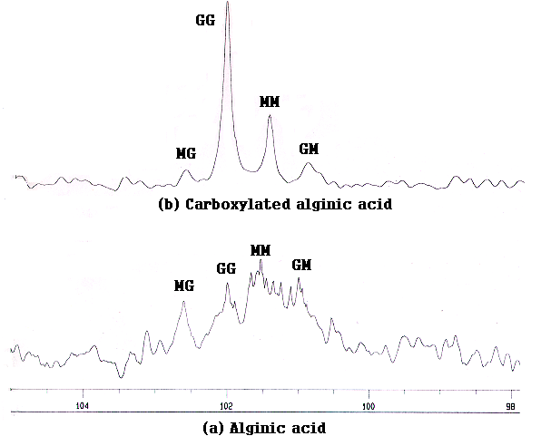attributed to increased binding of lead ion for carboxylated alginic acid.
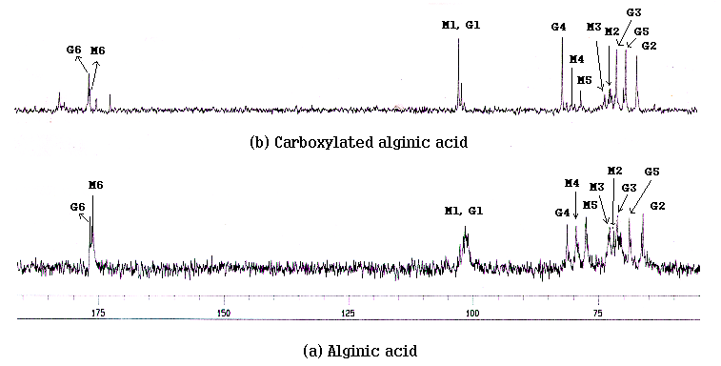 (A) (B)

Fig.1 (A) ¹³C NMR spectrum of alginic acid and carboxyaled alginic acid
(B) ¹³C NMR spectrum of anomeric carbon region

Charateristics of heavy metal adsorption using carboxylated alginic acid
Fig. 2 shows the isothermal lead uptake capacity of alginic acid, phosphorylated alginic acid and carboxylated alginic acid at pH 4. The estimation values of maximum lead uptake capacity using Langmuir isotherm fitting are 2.5, 3.0 and 3.5 mmol/g dry mass, respectively. As shown in this figure, maximum uptake capacity of carboxylated alginic acid increased by about 1mmol/g-dry mass than that of alginic acid. The effect of temperature on lead adsorption of carboxylated alginic acid was investigated as shown in Fig.3. The lead adsorption by carboxylated alginic acid was determined to be an endothermic process since increased binding occurred as the temperature was increased. In general, the formation of a coordination complexes between transition metal cations and carboxylated ligands is endothermic, whereas amine ligands complex formation is exothermic[3].
Fig.2 Fig.3
The investigation for the selectivity to various heavy metal using carboxylated alginic acid was carried out. The uptake capacity of a metal from mixture metal solution are shown in Table 3. From the result, the uptake capacity order of carboxylated alginic acid is as follows ; Pb²⁺ >> Cu²⁺ > Cd²⁺ > Zn²⁺, Co²⁺ > Ca²⁺ > Mg²⁺ . Among the heavy metals, selectivity to the lead ion was very high. The major advantage of biosorption is to discriminate the alkaline metals and to prefer heavy metals. While sorption capacity of carboxylated alginic acid for lead ions was about 2.0 mmol/g at pH 4, sorption capacities for calcium and magnesium were negligible. Park et al., [4] reported that selectivity order predicted from the activation energy using molecular modeling was Cd>Zn>Mg which has consistent with the experimental data.

Table 3. Uptake capacities of various metal ions in mixed-metal solution by
carboxylated alginic acid

Metallic ion species | Uptake capacity (mmol/g-dry mass)
Metallic ion species | pH 2 | PH 4
Pb | 1.73±0.03 | 2.02±0.04
Cu | 0.22±0.02 | 0.32±0.01
Cd | 0.12±0.01 | 0.13±0.01
Zn | 0.03±0.01 | 0.09±0.001
Co | 0.04±0.005 | 0.11±0.001
Ca | 0.01±0.001 | 0.05±0.002
Mg | 0.004±0.001 | 0.008±0.002

References
- Bolto, B. A. and Pawlowski, L.,“Wastewater Treatment by Ion-exchange”, pp 209-
253, 1 th ed. Great Britain, New York, U.S.A. (1988)
2. Schnitzer, M. and Khan, S. U., “Humic Substances in the Environment”, pp 29-54,
Marcel Dekker : New York. (1972)
3.Volesky, B., “Biosorption of heavy metals”, pp 320-321. 1st ed., CRC Press, Inc.,
New York (1990)
4. Jae Yeon Park, Choong Jeon and Young Je Yoo, “ Prediction of Selectivity Order
of Biosorption between Alginic Acid and Metals by Molecular Analysis”, in
Preparation.

