초임계수에서 가수분해와 부분 산화를 이용한 TPA 공정 산업 폐수의 분해

김영래, 정승준, 임종성, 이윤우, 김재덕, 이성철*
초임계유체공정연구실, KIST, 한양대학교 화학공학과*

Decomposition of Industrial wastewater from TPA process with Hydrolysis and Partial oxidation in Supercritical water

Young-Lae Kim, Seung Joon Chung, Jong Sung Lim, Youn-Woo Lee, Jae-Duck Kim,
Sung-Chul Yi*
Supercritical fluids Research lab, KIST
Department of Chemical Engineering, Hanyang University*

Introduction
Industrial wastewater treatment is one of the most important and urgent problems in environment management around the world. In particular, since a large amount of industrial wastewater of TPA process and polyester manufacture process come a significant environmental problem, to develop a management process for industrial wastewater of non-degradation organic compounds is of great importance. Supercritical water oxidation (SCWO) has attracted attention for the treatment of industrial wastewater, especially toxic and non-degradation wastewater. Several authors have reviewed research on SCWO, and there have been some reports on the application of SCWO for sludge and wastewater. SCWO is an environmentally acceptable technology that produces disposable clean liquids, clean solid (metal oxides), and clean gas (CO₂ and N₂). During the SCWO process, oxidation takes place in water above its critical point (374ºC, 221bar). Supercritical water has unique features with respect to its density, dielectric constant, ion product, viscosity, diffusivity, electric conductance, and solvent ability. From the engineering point of view, supercritical water oxidation has been proved to be a powerful technology to eliminate a wide range of wastewater. Also, for complex industrial wastewater, the suitability of SCWO as a treatment has been tested many times, but fewer attempts to study the recovery of valuable products involved can be found in the literature. Control of the wastewater composition is a key of the development of the process, but considered to be a difficult task. The use of special solvents may be one idea for controlling the product distribution. In general, the use of a solvent can change reaction rate, equilibrium, and the overall reaction pathway. Especially, the use of supercritical fluids as a reaction solvent is gaining a great attention because of the significant variation of solvent properties around a critical point that may enable the control of reaction by pressure, temperature or oxidants. We focus our attention on the use of supercritical water (SCW), which can dissolve hydrocarbons, expecting the control of product distribution and the decomposition effect of the wastewater. Therefore, the effect of temperature, pressure, oxidant amount, and reaction time on the decomposition of industrial wastewater from TPA process was investigated in a batch reactor.

Experiment
The experimental setup of this work is used in batch type. An internal volume of reactor is 1379 cm³, its material is used with hastelloy-C autoclave of cylindrical vessel type equipped with magnet drive agitator having variable speed arrangement. For reactor heating or keep at fixed temperature, it equipped with electronic heater. And material and water feed inlet line, pressure gauge, release valve, and safety rupture were situated on top of the rector vessel. A thermocouple was well immersed in the reaction mixture. The autoclave was charged with a known concentration of wastewater. The reaction mixture was heated to the desired temperature. Once the temperature was attained, hydrogen peroxide was fed to the reactor at desired experimental amount, and water was then fed in the vessel to a predetermined pressure level. This time was considered as zero time for a reaction and the samples were collected periodically. During sampling, the water pressure was maintained in order to keep the reaction condition at constant pressure. The reaction temperature was controlled using a temperature controller. For quantitative analysis of gas phase such as CO₂, gas chromatography equipped with a thermal conductivity detector was used. Liquid products were analyzed by using a high performance liquid chromatography. The respective response factors for each liquid product in this work were estimated from the correlation of the response factors of the known similar compounds. Also, previous work on the analysis of p-xylene oxidation products provided us sources for determining unknowns. Further confirmation of the products was made by GC-MS to reconfirm the identification of the HPLC peaks for the liquid products.

Result and discussion
In this experiment, variables that affect reaction rate and yield in the batch reactor are temperature, pressure, concentration of wastewater in water and amount of hydroxyl peroxide. Temperature varied from 374℃ to 600℃ with regard to initial concentration of wastewater from 370.1mg/L to 746.2mg/L. To quantify the effect of oxygen, the amount of hydrogen peroxide ranged from 0% to 100% of theoretically required oxygen amount of hydrogen peroxide. Most of the attempts were performed behind 100% for the purpose of finding out the effect of product distribution and thorough oxidation yield of TPA. The amount of water supplied to the reactor varied from 60ml to 1100ml, which results in the pressure variance from 220bar to 300bar.

. Effect of the Temperature
Conversion of industrial wastewater itself was shown in Figure 1 with regard to temperature (374-600 ºC). Figure shows that more than 95% of the wastewater decomposed into water and CO₂ within 30 minutes at most of the temperature except 400ºC. It is well received fact that Supercritical Water passing critical point change its characteristic dramatically. Also, we can infer the fact can be supported by this experiment. At the high temperature without oxidant, amount of decomposition increase rapidly, which is equal to the effect of oxidant. However, severe condition(high temperature, pressure) acts on the disadvantage, considering economical respect. Therefore, temperature was decreased to make condition milder, while several amount of hydroxy peroxide was injected. As shown in Figure 2,3,4, decomposing rate of wastewater with oxidation of hydroxy peroxide (20-70%) is roughly equal to the rate with hydrolysis of supercritical water in substance itself.

. Effect of the oxidant amount
Figure 2,3,4 shows the effect of partial oxidation by oxidant(hydroxy peroxide) at 374, 400, 450℃. After reaction, the amount of TOC was detected much less than that of initial TOC (370.1mg/L-746.2mg/L). Though we could not see individual dependency with regard to the amount of oxidant (<70%) owing to rapid oxidation rate, dependency on initial amount of TOC could be investigated. The fact that TOC of liquid phase was detected much less than that of gas phase (CO2) was shown in Figure 2,3,4. Therefore, we can infer from the figure the fact that almost all (>99%) of the organics in wastewater was decomposed.

. TOC Analysis
What is one of the important decomposing mechanism and kinetics of wastewater because they can help to design plants which treat wastewater effectively. However, organic carbons in wastewater are various and reactions in SCWO are complex. Thus, wastewater after TPA process in this experiment is composed of complex organics as shown below. Table 1 shows components and composition of organics.

Products | Concentration (mg/L) | Products | Concentration (mg/L)
4-Acetoxymethyl-  benzoic acid | 17.5-34.4 | 4-Carboxybenzylalcohol | 57.5-109.5
Terephthalic acid | 3.2-11.5 | 4-Carboxybenzaldehyde | 1.5-2.8
Benzaldehyde | 0.2-1.1 | Benzyl alcohol | 0.1-1.1
Acetophenone  p-Tolualdehyde | 0.3-0.8  3.7-9.6 | Benzoic acid  p-Toluic acid | 106.2-249.9  177.6-327.7
Table 1. Components and Concentration in Industrial wastewater from TPA process

There have been lots of studies on mechanism of TPA oxidation. In this experiment, following pathway was proved and can explain how that components of wastewater after TPA process decompose.
p-CnHn  CnHn (Aldehyde or Carboxylic acid)  CO₂ + H₂O

Conclusion
Decomposing experiment of industrial wastewater in TPA process was performed at supercritical water condition. Furthermore, decomposing efficiency was up to 95-99%. Also Individual factor at each condition and mechanism in this experiment was investigated.

Acknowledgment
This experimental work carried out by foundation of the National Research Laboratory for supercritical fluid.

References
1. Antonello Viola and Giacomo Cao, Journal of Chromatographic Science, 34, 27-33, 1996
2. Giacomo.Cao, Massimo Pisu and Massimo Morbidelli, Chemical Engineering Science, 49, 5775-5788, 1994
3. Young-Lae Kim, Jae-Duck Kim et. al, Theories and Applications of Chem. Eng., 6, 3981-3984, 2000
4. Takehiro Mizuno, Motonobu Goto, Akio Kodama, and Tsutomu Hirose, Ind. Eng. Chem. Res., 39, 2807-2810, 2000
5. Masaru Watanabe, Makoto Mochiduki, Shuhei Sawamoto, Tadafumi Adschiri, Kunio Arai, J. of Supercritical Fluids, 20, 257-266, 2001

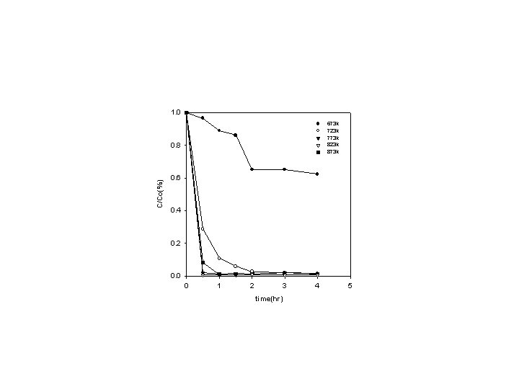
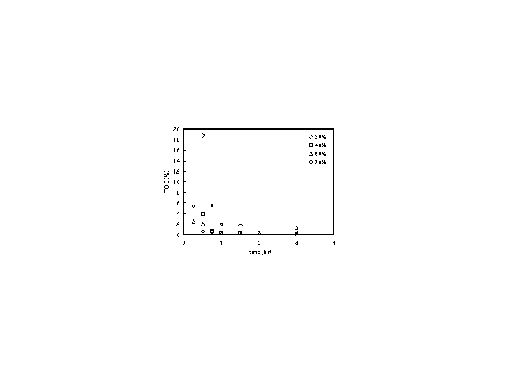

Figure 1. Conversion of Industrial wastewater Figure 2. Effect of the oxidant amount at
in supercritical water 374ºC on residual TOC
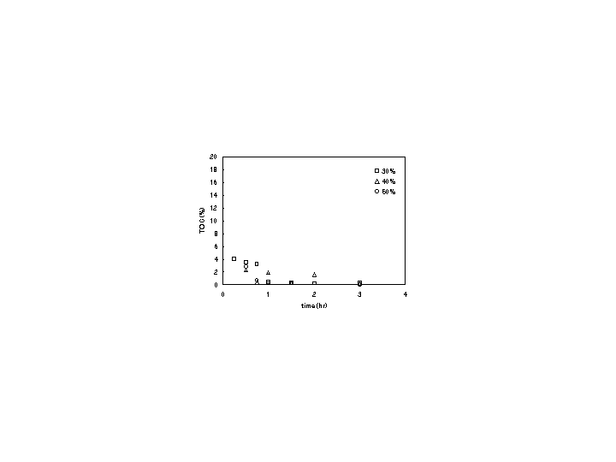
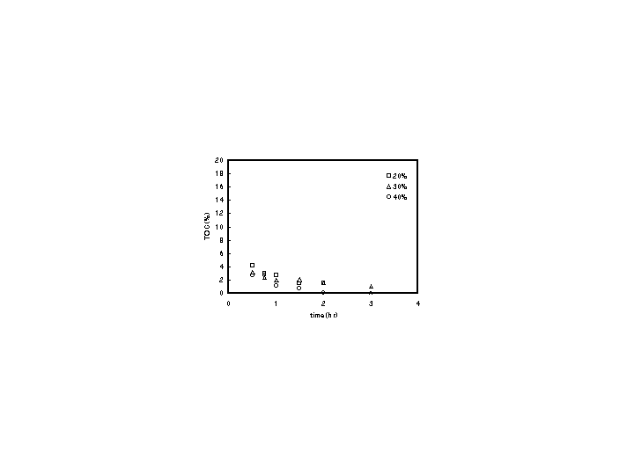

Figure 3. Effect of the oxidant amount at Figure 4. Effect of the oxidant amount at
400ºC on residual TOC 450ºC on residual TOC

