블록 공중합체를 이용한 중간세공성 실리카 제조에서 pH와 팽윤제의 영향

최대근, 양승만
한국과학기술원 화학공학과

The effects of pH and swelling agent on the fabrication of mesoporous silica using block copolymer templates

Dae-Geun Choi and Seung-Man Yang
Department of Chemical Engineering, KAIST

INTRODUCTION
Mesoporous ceramic oxides with large specific surface areas have potential applications in chemical and physical processes, especially for chromatography and catalysis. Since the discovery of MCM-41 in 1992 [1], many research groups have focused their interests on mesoporous materials [2]. MCM-41 is formed by a surfactant-assisted reaction pathway as a result of the attractive electrostatic interaction between a ceramic precursor and an ionic amphiphile. One of the limitations of calcined MCM-41 materials prepared by using cationic surfactants without additional treatment with TEOS is their instability in water [3-4].
An alternative approach to mesoporous molecular sieves is the exploitation of nonionic surfactants at low concentration, which affords similar materials to MCM-41. Pinnavaia and co-workers [5] used nonionic surfactants in aqueous solutions to synthesize wormlike disordered mesoporous silica and alumina in neutral media assembled by hydrogen-bonding interactions. Most of the mesoporous silica materials organized with nonionic surfactant species that display periodic structural order are made under acid condition.
In this study, mesoporous silica was fabricated by using triblock copolymer templates (poly (ethylene oxide) (PEO) and poly(propylene oxide) (PPO)). We prepared SBA-15 with long-range 2-dimensional hexagonal arrangement and mesocellular silica forms (MCF) with larger pores by using xylene as a hydrophobic swelling agent. Also, we investigated the effects of pH and the concentration of organic solvent.

EXPERIMENT
The block copolymer (EO₂₀PO₇₀EO₂₀ (Pluronic P123), MW = 5800) used was obtained BASF and used as received. Tetramethoxysilane (TMOS, Aldrich) and tettaethoxysilane (TEOS, Aldrich) in hydrochloric acid (HCl, Junsei) were used as a silica source to prepare the silica mesophases. Ordered silica mesostructures were synthesized similar to be reported by Zhoa et al. [6].
A 4.0 g pluronic P123 was dissolved in 30 g of water and 120 g of 2 M HCl solution. Amounts of xylene ranging from 0 to 8 g were added to the polymer solution, and the mixture was stirred for at least 1 h. Then 8 g of TMOS was added, and resulting mixture was stirred at 308 K for 20 h. Ammonium hydroxide was used for pH change. The mixture was aged at 353 K for 5 h. The solid product was filtered, washed with water, and dried in oven for 4 h at 413 K. The block copolymer template was removed by solvent extraction (using ethanol and hydrochloric acid for 1 h), as well as by calcination in an electric furnace at 773 K for 6 h. The pore spacing and structure of the prepared mesoporous materials were observed by using an X-ray diffractometer (Rigaku, d/max-RC) under the strength of 40 Kv and 45 mA. A typical XRD analysis required several hours. The scattering data were collected in a continuous scan mode from 0.6° to 10° (2θ) with a sampling interval of 0.01° at a scanning rate of 1°/min. A transmission electron microscope (EM912, Carl Zeiss in KBSI) was used to examine the microstructure and grain size of the prepared powders. To observe the individual grains, the aggregated powders were dispersed in ethanol (0.5 wt %) and sonicated for 20 min. Nitrogen adsorption measurement at 77 K were performed on an ASAP 2010 volumetric adsorption analyzer. Before the measurement, the samples were out-gassed for 4 h at 473 K. Pore sizes, specific surface areas, and pore volumes were calculated using BET and BJH desorption method. Finally, SEM images of the prepared mesoporous silica were taken to clarify the macroscale structure.

RESULTS AND DISCUSSION
It is well-known that EO_{m}PO_{n}EO_{m} triblock copolymers in water form micelles, in which the core and shell are composed of PO blocks and EO blocks, respectively [7-8]. Also, various structures such as bicontiuous cubic, hexagonal, or lamellar mesophases can be produced by adding a small amount of a hydrpphobic swelling agent, such as butanol or xylene [9]. Therefore, the pore size and ordering could be influenced by the pH and the concentration of organic solvent. As illustrated in Figure 1, a well ordered hexagonal array of mesopore is observed at low pH. However, as pH increased by adding ammonium hydroxide, the pore structure was transformed from ordered to disordered state as shown in Figure 1. After 30 minutes adding TMOS as a silica source to the polymer solution, NH₄OH was added for pH change.
X-ray diffraction and nitrogen adsorption results were consistent with the TEM images. The XRD peak intensity and resolution were diminished gradually as the pH increased. It could be interpreted that the structure was transformed from ordered to disordered state as the pH increased. Calcined SBA-15 prepared with the P123 in the absence of NH₄OH has a pore size of 38 Å, a pore volume of 0.49 cm³/g, and a BET surface area of 605 m²/g. This result were in good agreement with those previeosly reported by Zhao et al.[6].The pore size and BET surface area increased as pH increase until pH 7. As the xylene/copolymer weight ratio (R) increased, the pore size increased with the xylene content up to a certain saturation value above which the pore size remained constant. (see Figure 2)

ACKNOWLEDGMENT
This work has been supported partially by a grant from the Brain Korea 21 Project. The authors thank BASF for donation of the Pluronic P123 block copolymer.

REFERENCE
1. C. T. Kresge, M. E. Leonowicz, W. J. Roth, J. C. Vartuli, J. S. Beck, Nature, 359, 710(1992).
2. C. G. Göltner, M. Antonietti, Adv. Mater. 9, 431(1997).
3.Ryoo, R.; Jun, S. J. Phys. Chem. B, 101, 317(1997).
4.. Kim, J. M.; Kwak, J. H., Jim, S.; Ryoo, R. J. Phys. Chem., 99, 16742(1995).
5. Bagshaw, S. A.; Prouzet, E.; Pinnavaia, T. J. Science, 269, 1242(1995).
6. Zhao, D.; Huo, Q.; Feng, J.; Chmelka, B. F.; Stucky, G. D. J. Am. Chem. Soc., 120, 6024(1998).
7. Wanka, G.; Hoffman, H.; Ulbricht, W. Macromolecules, 27, 4145(1994).
8. Alexandridis, P.; Hatton, T. A. Colloids Surf., A, 96, 1(1995).
9. Holmqvist, P.; Alexandridis, P.; Lindman, B. Macromolecules, 30, 6788(1997).

FIGURE 1. TEM images of mesoporous structures prepared under different pH conditions: (a) H 1 prepared with NH₄OH/Mixture = 0.033, pH = 0.44; (b) H 2 prepared with NH₄OH/Mixture= 0.1, pH = 0.71; (c) H 3 prepared with NH₄OH/Mixture= 0.143, pH = 4.54; (d) H 4 prepared with NH₄OH/Mixture= 0.2, pH = 9.02.

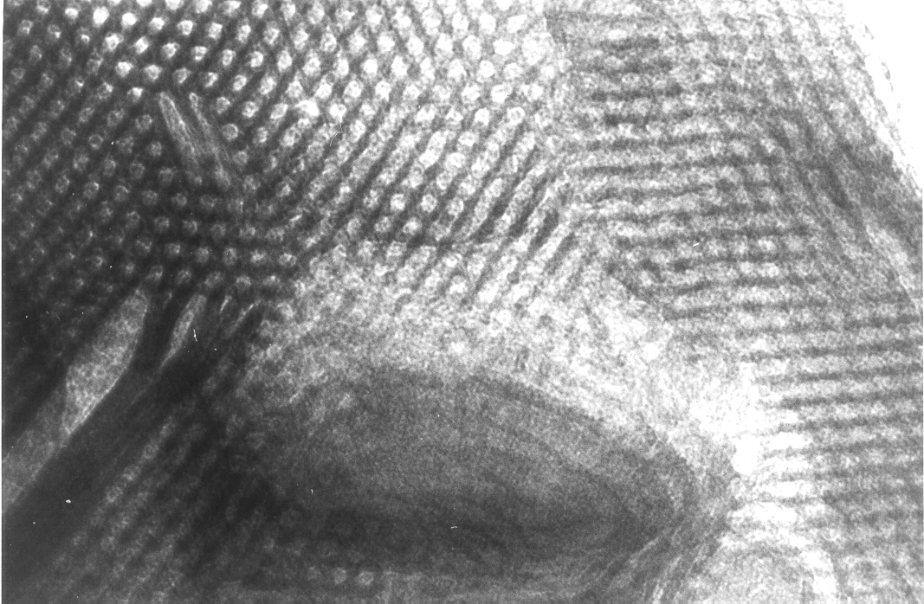
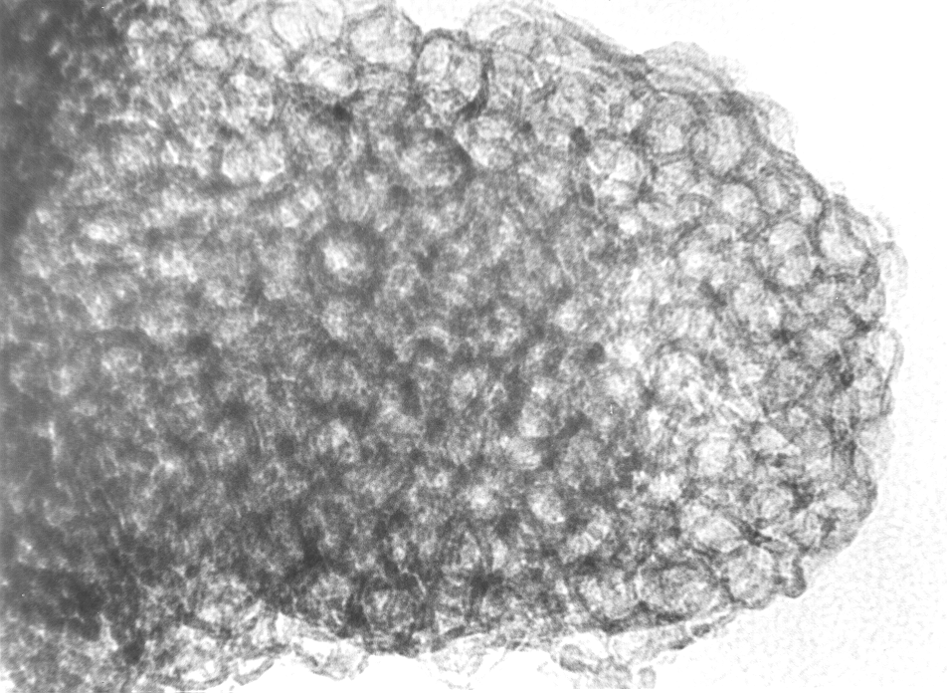
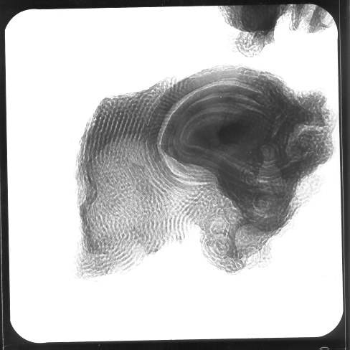
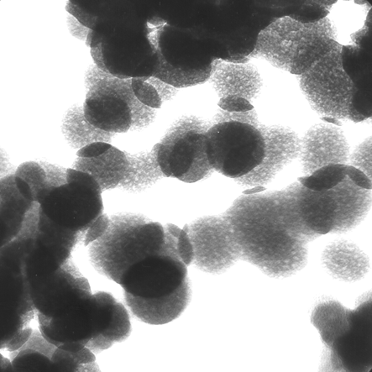
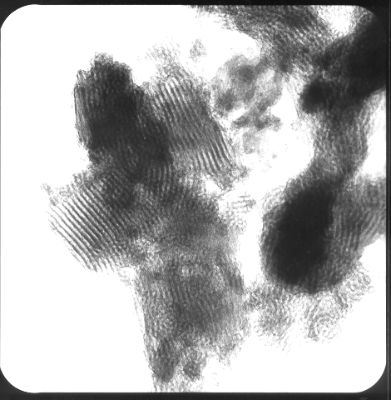
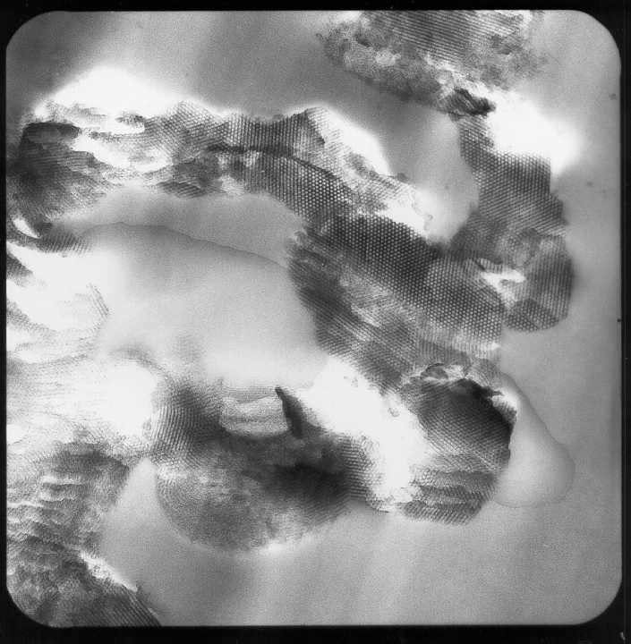
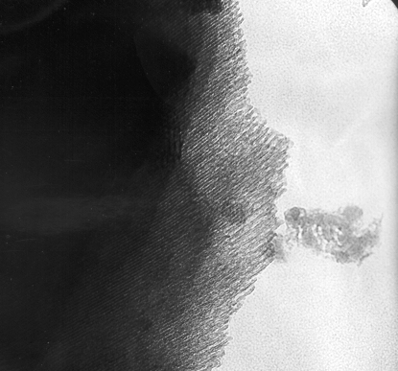
FIGURE 2. TEM images of mesoporous structures prepared under different xylene content
R=0.125
R=0.75
R=0.25
100 nm
b
a
da
c

