반도체 소자용 구리 무전해도금 공정에서
팔라듐 촉매의 전처리 조건에 따른 구리박막의 지형학적 선택도의 변화

오윤진, 김성희, 조성민, 정찬화
성균관대학교 화학공학과

The Effect of Pd-Activator Conditioning on Topographical Selectivity in Electroless Copper Deposition of Semiconductor Processing

Youn-Jin Oh, Sung Hee Kim, Sung Min Cho,
and Chan-Hwa Chung

Dept. of Chemical Engineering, Sungkyunkwan University, Suwon 440-746, Korea

Introduction
In recent years, the copper (Cu) electrochemical plating process, which is based on the dual-damascene technology, has been developed to replace the conventional aluminum-base metallization in memory and logic-device manufacturing process. It is due to its low resistivity (1.67µΩ·cm), high melting point (1085℃), and high electromigration resistance [1,2]. This electrolytic plating method is less expensive and less complicated in conditioning the process than Metal Organic Chemical Vapor Deposition (MOCVD) [3,4] or sputtering method [5]. However, in current electrolytic plating process, it requires copper seed layer because copper is hardly electroplated directly on metal barrier layers such as TiN and TaN. Therefore, various deposition techniques such as sputtering, MOCVD, and electroless deposition have been proposed for the preparation of a thin metal seed layer [1,2]. However, for dual-damascene processing with very high aspect ratio features, the step coverage of sputtered barrier and Cu seed layers expected to become the limiting factor for subsequent filling with electroplated copper. Recently, the electroless plating process, in which copper is directly deposited on the metal barrier without any seed layer, has been studied as another alternative [6,7]. In electroless plating process, deposited copper film has high step coverage and complete gap filling because it depends only on its surface reaction. Furthermore, it is relatively easy to integrate such a process in currently available copper electroplating processes and integration process steps to be reduced remarkably. Therefore, we can expect low process cost and high adaptability to the electrolytic deposition that comes in next sequence.

Experiment
In our present works, we have used the patterned wafer that has via holes or trenches with the aspect ratios of 0.5~5. The titanium nitride (TiN/Ti) as a metal barrier is deposited on silicon oxides [8]. Our experimental sequence of electroless copper plating is as follows. First, the wafer is cleaned with sulfuric acid and hydrofluoric treatment. Secondly, cleaned wafer is activated in Pd activator solution [7,9,10]. The palladium activator solution is composed of PdCl₂, HCl, NH₄OH, and HF in table Ⅰ. In the Pd pre-treatment, we were able to vary the size, the density, and growing position of palladium particles on the TiN barrier by changing the conditions of Pd pre-treatment. By employing post-treatment, we have also tried to remove palladium particles selectively which are populated on the top surface of TiN, remaining particles in via holes. The post treatments are DI water rinse and dipping in washing solution. Finally, we executed electroless copper plating after all these pre-treatments.
The electroless bath was composed of 0.03M CuSO₄∙5H₂O, 0.05M EDTA, 0.1M HCHO, and 0.25M TMAH. Triton X-100, a,a’-dipyridyl, and poly-ethylene glycol (PEG) were also added as addictives. The pH of bath was 12.5 and the temperature was 50~75℃ during the electroless copper deposition.

Result and Conclusion
As an experiment sequence, the wafer is cleaned with sulfuric acid and hydrofluoric acid. In XPS analysis, metal or organic contaminants were not found and TiO₂ was completely removed. However, the top surface is etched and the roughness of surface morphology relatively increases during the cleaning treatments. The cleaned wafer is immediately immersed into Pd-activator solution. In this solution, palladium exists in a specific Pd-ammine complex, mostly Pd(NH₃)₂Cl₂ in PdCl₂-HCl-HF-NH₄OH bath [10]. HF in the solution removes the TiO₂ that was formed on The TiN surface when it is exposed in the air. Furthermore, the etching reaction between HF and TiO₂ generates electrons, which initiate autocatalytic reaction of palladium deposition [8].
In our experiments, we have found that the size and density of palladium particles are different according to the compositions of Pd-activator solution, process temperatures, and post-cleaning conditions. The size of deposited particles increased as activation temperature increases from room temperature to 50℃. At room temperature, palladium particles are in the range of a few tens of nanometer, whereas the particles grow up to about 200~300 nm when activation temperature goes to 50℃. On the other hand, the particle density on the surface relatively decreases as activation temperature increases. Especially, we have observed that the chemical states of palladium particles are somewhat different with varying the Pd activation condition. These different growing characteristics of palladium particles may affect on the growth of copper in electroless plating process. Therefore, we have studied on the process of copper fill-up growth according to the palladium activation conditions. We have set several experiment conditions for Pd activation and post-treatment as shown in table Ⅱ, which presents quite different growing features of copper.
Firstly, we have executed the palladium activation treatment at room temperature for 5min. As mentioned above, the size of palladium particles are in the range of a few tens of nanometer and the density of particles are relatively high when wafer is activated at room temperature. We have also examined the effects of water rinse after the palladium activation. In case that Pd activated TiN surface as shown is not rinsed, copper film is uniformly deposited on the entire TiN surface in Fig. 1. On the other hand, when the Pd activated surface is rinsed before the electroless copper plating, copper film cannot be formed on the surface and only the copper particles are sporadically spread on the surface as shown in Fig. 2.
In case that Palladium pre-treatment on the TiN surface was performed in the Pd-activation solution of 50℃. We have monitored the effect of post-treatment, i.e. water rinse, on the copper-film growth feature. In the experimental results, the size of palladium particles increase up to about 200~300 nm when activation temperature goes to 50℃. The Pd particles mainly populates in the via holes when the water rinsing process is performed after the Pd activation. Figure 3 shows the deposited copper film after palladium activation at 50℃ without water rinse. Copper film is uniformly grown as in 25℃-activation and no water rinse. However, when we executed electroless copper plating after water rinsing on the Pd-activated surface at 50℃, copper grew selectively in via holes as shown in Fig. 4.
To summarize, we have observed that manipulating the activation and post-treatment conditions can control the size, the density, and the chemical state of Pd activator. In the meanwhile, we have found that the palladium particles may populate only in the vias, which results in topographically selective copper deposition, i.e. bottom-up first filling of copper. If our selective copper fill-up process is applied to metal interconnection process including the dual-damascene process in recent logic and memory device, the process steps and the cost can be considerably reduced.

REFERENCES

1. S.P. Murarka, Mater. Sci. Eng., R19, 3 (1997).
2. C. Lingk and M.E. Gross, J. Appl. Phys., 84, 5547 (1998).
3. S. K. Koh, S.C. Choi, K.H. Kim, H.J. Jung, G.J. Choi, H.S. Yang, and Y.S. Cho, Thin Solid Films, 347, 121 (1999).
4. T. Nguyen, L.J. Charneski, and S.T. Hsu, J. Electrochem. Soc., 144, 2829 (1997).
5. L.J. Friedrich, S.K. Dew, M.J. Brett, and T. Smy, J. Vac. Sci. Technol., B 17, 186 (1999).
6. Y. Shacham-Diamandad and S. Lopatin, Electrochim. Acta., 44, 3639 (1999).
7. Hong-Hui Hsu, Kun-Hsin Lin, Su-Jien Lin, and Jien-Wei Yeh, Journal of The Electrochemical Society, 148(1), C47 (2001)
8. Joseph P. O’Kelly, Karen F. Mongey , Yveline Gobil , Joaquin Torres, Patrick V. Kelly, and Gabriel M. Crean, Microelectronic Engineering, 50, 473 (2000).
9. J.H. Lin, Y.Y. Tsai, S.Y. Chiu, T.L. Lee, C.M. Tsai, P.H. Chen, C.C. Lin, M.S. Feng, C.S. Kou, and H.C. Shih, Thin Solid Films, 378, 592 (2000).
10. S. Karmalkar and J. Banerjee, J. Electrochem. Soc., 146, 580 (1999).
Table Ⅰ. Characteristics of copper growth according to different conditions of palladium activation
Activation temperature | Post-treatment | Characteristics of copper growth
25℃ | no | Uniformly deposited
25℃ | water rinse | Almost not deposited
50℃ | no | Uniformly deposited
50℃ | water rinse | Selectively filled up only in via holes
11. J. Torres, J.L. Mermet, R. Madar, G.M. Crean, T. Gessner, A. Bertz, W. Hasse, M. Plotner, F. Binder, and D. Save, Microelectron. Eng., 34, 119 (1996).

TableⅠ. The chemistry for palladium activation solution in our experiment
Components | PdCl₂ | HCl | NH₄OH | HF
Quantity (per liter) | 0.2g | 4.5ml | 40ml | 2ml

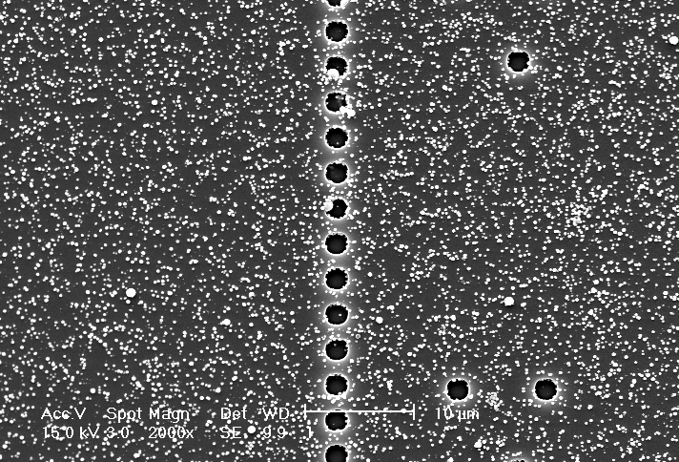

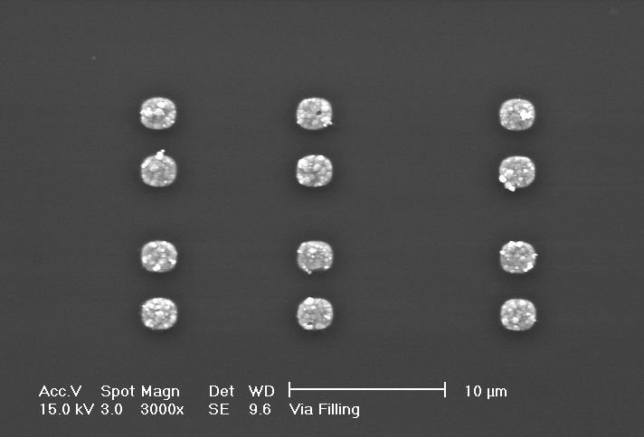

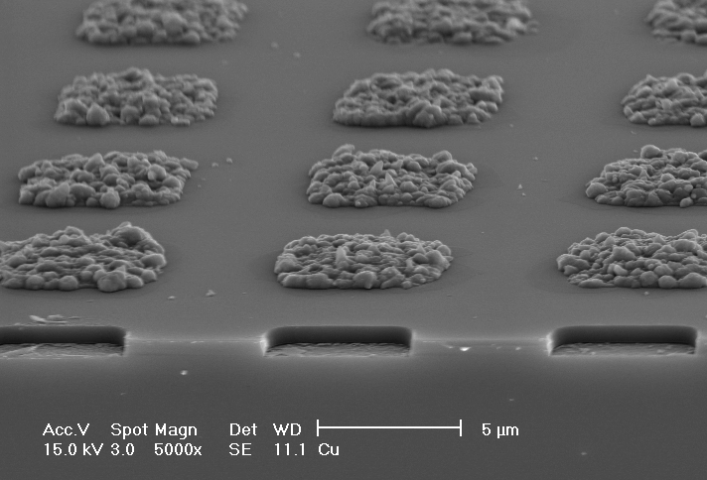

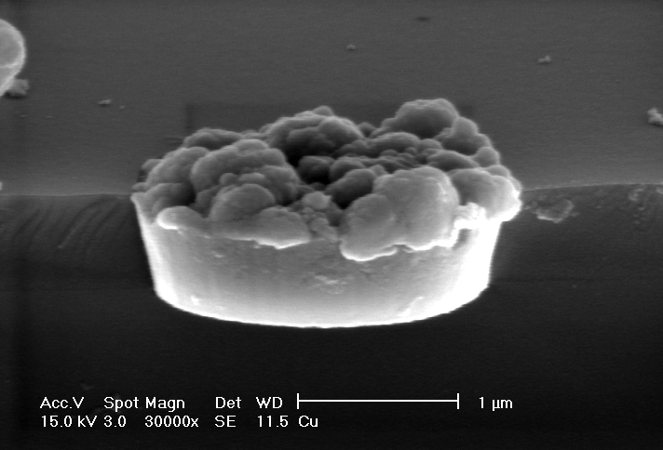

FIG 4. The selective copper fill-up in via holes by electroless plating after palladium activation at 50℃ and water rinse.
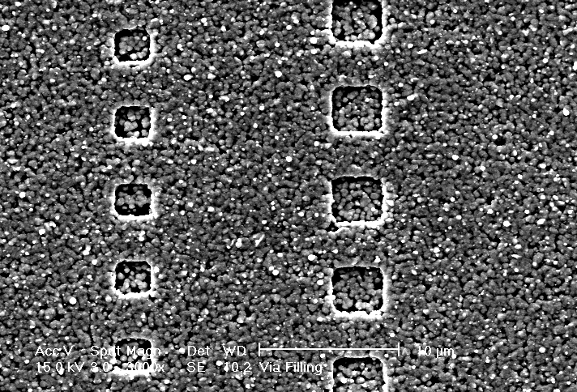
FIG 1. Deposited Copper film by electroless plating after palladium activation at room temperature without water rinse.

FIG 2. Deposited Copper particles by electroless plating after palladium activation at room temperature followed by water rinse.

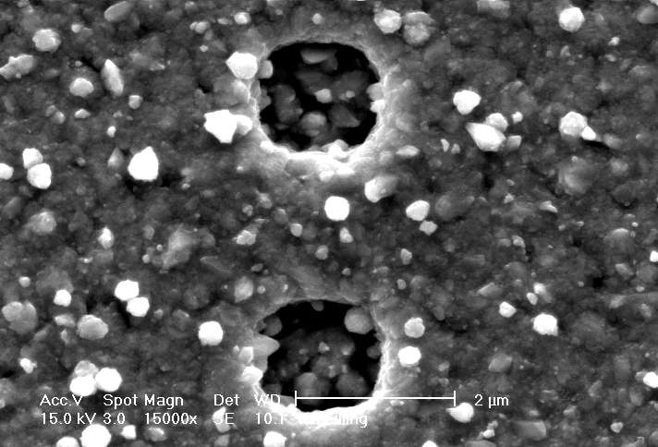

FIG 3. Deposited Copper film by electroless plating after palladium activation at 50℃ and no rinsing.

