다중루프 제어계의 DCLR을 위한 Sequential Loop Closing 방법의 적용

김창근, 전대웅, 이지태, 권순영*
경북대학교 화학공학과, ㈜서한섬유*

Sequential Loop Closing Method for Multiloop Control Systems with Desired Closed-loop Responses

Changgeun Kim, Daewoong Chun, Jietae Lee, Soon Young Kwon*
Department of Chemical Engineering
Kyungpook National University, Seohan Textile*

Introduction
Multiloop control systems which use multiple single-input single-output (SISO) controllers are still dominantly used in the chemical processes because of their simplicity and robustness. For multivariable processes with n inputs and n outputs, n SISO controllers are used to control n paired inputs and outputs in multiloop control systems, and hence responses of n paired loops can be designed to be what we want. Although responses other than the paired loops are not guaranteed, the overall responses are usually satisfactory compared with those of well-known design methods such as the biggest log-modulus tuning (BLT) method (Luyben, 1986) and the sequential autotuning (SAT) method (Loh et al., 1993; Shen and Yu, 1994). To design such multiloop control systems, Jung et al. (1999) proposed an iterative method based on the Newton-Raphson method. Their method works well for various processes when pairings are desirable. However, its derivation is rather complex and it was diverged for some processes. Here, a simple iterative method based on the concept of sequential loop closing method is proposed

Multiloop Control System with Desired Closed-loop Responses
Consider the multiloop control system where an nxn process, G(s)={g_{ij}(s)}, is controlled by a diagonal controller, C(s)=diag{c_{ii}(s)}. The closed-loop transfer functions between set points and outputs become
$Y(s)=H(s)R(s)$, $H(s)={\left(I+G(s)C(s)\right)}^{−1}G(s)C(s)$ (1)
Since C(s) has n elements, we may set n diagonal elements in H(s) as
$h_{\text{ii}}(s)={\tilde{h}}_{i}(s)≡\frac{g_{\text{ii}}^{+}(s)}{λ_{i}s+1}$, i=1,2,…,n (2)
where $g_{\text{ii}}^{+}(s)$ is the nonminimum-phase part of g_{ii}(s) with the steady-state gain of one. Multiloop controller satisfying Eq. 2 can be found by the Newton-Raphson iteration (Jung et al., 1999). The iterative scheme is rather complex and convergence is susceptible. Here the sequential loop closing method is applied to find C(s) satisfying Eq. 2. We design c_{i}(s) sequentially to satisfy Eq. 2. When loops except the i-th loop are closed, the transfer function for the i-th pair becomes (Figure 1)
$$\begin{aligned}{\hat{g}}_{\text{ii}}(s)=e_{i^{T}}{\left(I+G(s)Q_{i}(s))\right)}^{−1}G(s)P_{i}(s)e_{i} \\ Q_{i}(s)=\text{diag}\left\{c_{1}(s),⋯{\text{,c}}_{i−1}(s){\text{,0,c}}_{i+1}(s),⋯{\text{,c}}_{n}(s)\right\} \\ P_{i}(s)=\text{diag}\left\{c_{1}(s),⋯{\text{,c}}_{i−1}(s){\text{,1,c}}_{i+1}(s),⋯{\text{,c}}_{n}(s)\right\} \\ e_{i}=[\underset{i−1}{\underbrace{\text{0,}⋯\text{,0}}}\text{,1,}\underset{n−i}{\underbrace{\text{0,}⋯\text{,0}}}]^{T}\end{aligned}$$
We design c_{i}(s), for the above transfer function of ${\hat{g}}_{\text{ii}}(s)$, such that the closed-loop transfer function satisfies Eq. 2 approximately. Since ${\hat{g}}_{\text{ii}}(s)$ is dependent on other controllers, we should apply the design procedure iteratively until convergence. Design procedure is as follows.
Step 1) For i=1,2,…,n, set $c_{i}(jω)=0$, $ω∈Ω$ for a given frequency set $Ω$, and choose the design parameter, $λ_{i}$
Step 2) For i=1,2,…,n, calculate ${\hat{g}}_{\text{ii}}(\text{jω})$ and
$c_{i}(jω)=\frac{1}{{\hat{g}}_{\text{ii}}(jω)}\frac{{\tilde{h}}_{i}(jω)}{1−{\tilde{h}}_{i}(jω)}=\frac{1}{{\hat{g}}_{\text{ii}}(jω)}\frac{g_{\text{ii}}^{+}(jω)}{j(λ_{i}ω)+1−g_{\text{ii}}^{+}(jω)}$.
Step 3) Iterate the step 2 until convergence.
Step 4) Approximate the converged $c_{i}(jω)$, i=1,2,…,n, by the PID controller. For this, the least squares method (the routine of ‘invfreqs’ in Signal Processing Toolbox for MATLAB (1997)) can be used.

Example
Convergence of the proposed method is tested by applying it to problems in Luyben (1986). Table 1 shows the results. For Doukas and Luyben column, we can’t control with positive controllers like proposed controllers because RGA is negative. This means a bad fairing. Thus, we can simulate by exchanging the third row for the forth row. We can see that the proposed method has better convergence than the method in Jung et al. (1999).
The control performances designed by the proposed method and the method of Jung et al. (1999) are very similar. As an illustrative example, the Ogunnaike and Ray column (Luyben, 1986) is considered. All design parameters are those in Jung et al. (1999). Figure 2 shows responses of multiloop PI control systems. Slight differences are mainly due to the approximation methods for PI controllers.

Conclusion
A new iteration method based on the sequential loop closing method is proposed to design multiloop control system with desired closed-loop responses. This method is very simple and gives good responses as well.

Acknowledgment
Finantial support from KOSEF under grant # 2000-1-3700-006-1 is gratefully acknowledged.

Literature Cited
Jung, J., Choi, J. Y. and Lee, J., “One-Parameter Design Method for a Multiloop Control System Design”, Ind. Eng. Chem. Res., 38, 1580-1588 (1999).
Lyben, W. L., “Simple Method for Tuning SISO Controllers in Multivariable Systems”, Ind. Eng. Chem. Process Des. Dev., 25, 654-660 (1986).
Loh, A. P., Hang, C. C., Quek, C. K. and Vasnani, V. U., “Autotuning of Multivariable Proportional-Integral Controllers Using Relay Feedback”, Ind. Eng. Chem. Res., 32, 1002-1007 (1993).
Shen, S. H. and Yu, C. C., “Use of Relay-Feedback Test for Autotuning of Mutivariable Systems”, AIChE J., 40, 627-646 (1994).
Student Edition of MATLAB, Version 5, User’s Guide, Prentice-Hall, N. J., (1997).
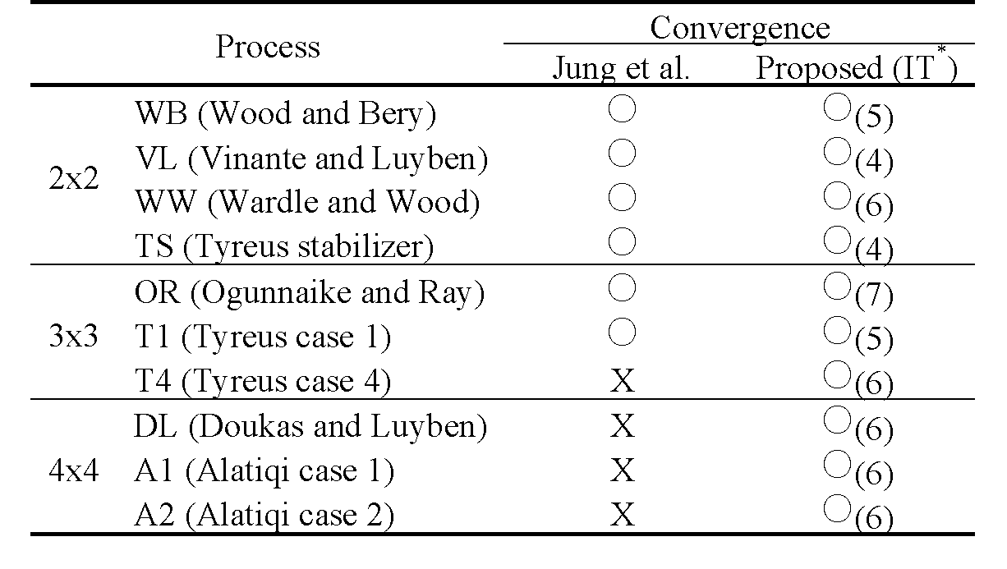
Table 1. Convergence of the proposed method and the method in Jung et al. (1999).
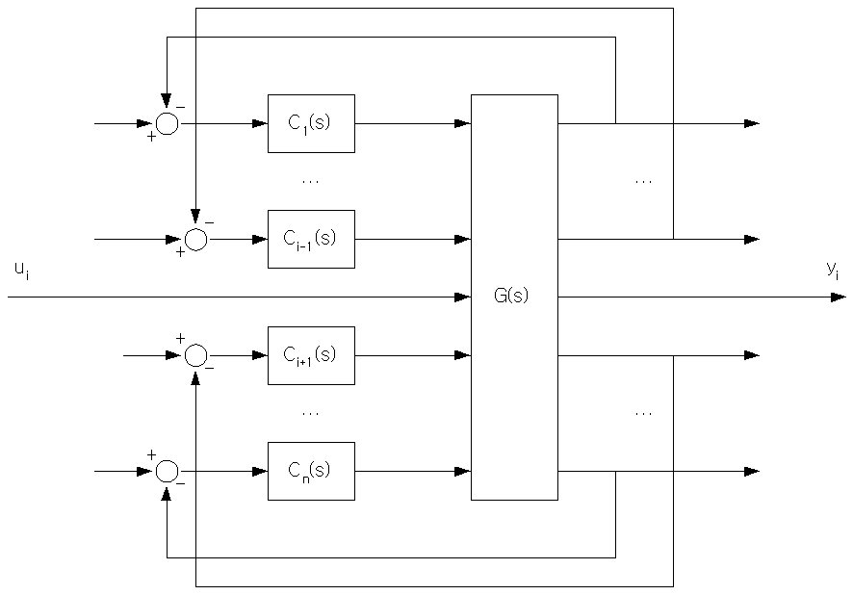
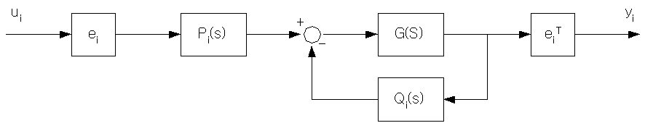
IT*: the number of iterations
(a) (b)
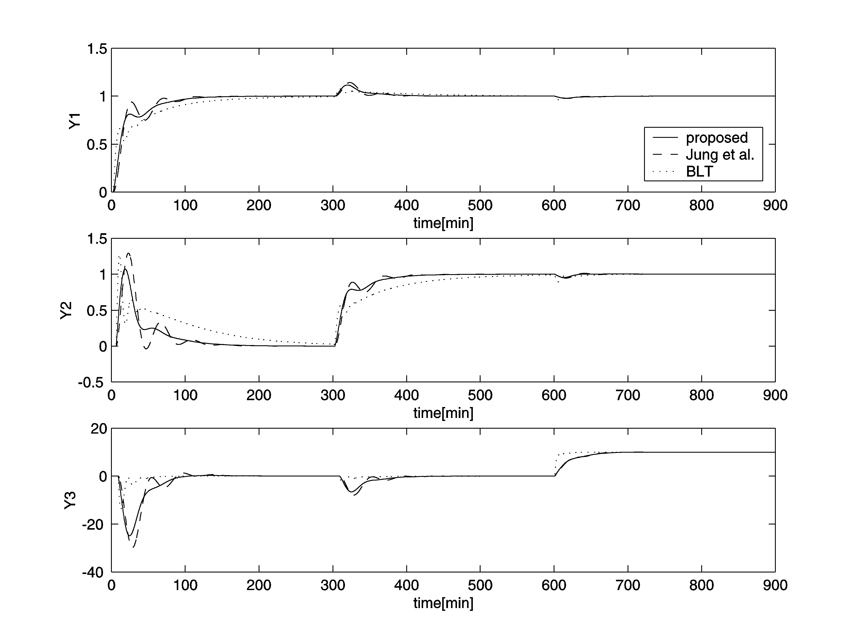
Figure 1. Multiloop control system where the i-th loop is open.
Figure 2. Control responses for the Ogunnaike and Ray column process.

