유변학적 방법과 순간 젤화에 의한Worm-like 마이셀
용액의 흐름장 구조 관찰

최대근, 김원종, 양승만
한국과학기술원 화학공학과

Shear-Induced Structure Observation of Worm-like Micellar Solution by in situ Gelation and Rheological Method

Dae-Geun Choi, Won-Jong Kim, Seung-Man Yang
Department of Chemical Engineering, KAIST

INTRODUCTION
Surfactants are industrially ubiquitous in both chemical and consumer domains and have provided a rapidly growing area of scientific research. They are used as detergents, cleaning agents, emulsifiers in food, pharmaceuticals, or cosmetics. Surfactant molecules in solution can self-assemble into aggregates (so-called micelles) in which their immiscible parts clump together. The shape and size of micelles depend on the molecular structure of the surfactant, nature of solvent and additives, and their molar composition. Specifically, the ionic surfactant molecules form spherical micelles when their concentration exceeds the critical micelle concentration (CMC). The presence of ionic or cosurfactant additives reduces the repulsions between micelle head groups and thereby affects the structural transitions. In addition, the micellar aggregates can grow anisotropically under appropriate conditions, changing their shapes from spheres to rods or highly flexible wormlike aggregates. Such evidence provided some analogies between giant flexible cylindrical micelles and conventional polymeric solutions (Israelachvili, 1985). Meanwhile, when immersed in a mean flow, surfactant micelles show various flow-induced microstructures, and flow properties of these systems are of interesting in technological processes. Several studies were performed on the effects of salts and organic additives on the micellar association in aqueous CPC solutions (Cates and Candau, 1990; Rehage and Hoffmann, 1988; Rehage and Hoffmann, 1991; Kabir-ud-Din et al., 1997; Berret et al., 1993). In the dilute regime, rodlike micelles are formed, and the solutions behave as a real sol with a rather low viscosity. As the shear flow applies, the wormlike micellar solution exhibits anomalous behavior, a dramatic increase in viscosity above a critical shear rate. At low shear rates, a solution of these micellar systems exhibits Newtonian behavior. As the shear rate increases, however, the rheological properties dramatically change. Above a well-defined threshold value of the velocity gradient, a supramolecular structure can be formed from the micellar aggregates. This shear-induced structure behaves like a gel and exhibits strong flow birefringence. It has been suggested that these phenomena are associated with the aggregation of micelles induced by the shear flow (Liu and Pine, 1996; Kim and Yang, 2000 ; Hu et al., 1998; Humbert and Decruppe, 1998). In the present work, we considered the rheological responses and flow-induced microstructure of dilute and semidilute wormlike micellar solutions by measuring flow birefringence under shear flow. In addition, we captured the flow-induced microstructure of wormlike CPC/NaSal micelles by in situ gelation through sol-gel reaction of an alkoxide. The SEM image of the captured microstructure was compared with rheological and rheo-optical results.

EXPERIMENT
CPC and NaSal were purchased from Aldrich. Highly deionized water was used as a solvent. The CPC concentration was in the range from 1 mM to 50 mM, and NaSal concentration was varied with the molar ratio, R = [NaSal]/[CPC], changing from 0.1 to 10.0. Before measurements were taken, samples were kept for at least three days to attain equilibrium.
To capture the flow-induced microstructure, tetramethylorthosilicate (TMOS: Aldrich) in hydrochloric acid was used as a silica precursor and ammonium hydroxide as a morphology catalyst. Samples were prepared in the annulus between two coaxial cylinders as used in the optical experiment. The samples were dried for 12 h and prepared for the scanning electron microscope.

RESULTS AND DISCUSSION
The formation of shear induced structure (SIS) of a micellar solution of cetylpyridinium chloride and sodium salicylate is studied by employing various techniques including a phase modulated flow birefringence, mechnical rheomtry and in situ gelation.
We observe the flow-induced microstructure change by in situ gelation of the micellar solution. In Fig. 1, SEM images of the captured microstructure of silica-micelles complex are reproduced for equimolar solutions of 5 mM CPC/NaSal at various shear rates. It can be noted from Fig. 1(a) that a small-scale zigzag structure is formed with no apparent flow-induced alignment at very low shear rate of 0.07 $s^{−1}$. It can be expected that the elongated micelles be aligned to the flow direction as the shear rate increases. Indeed, as shown in Fig. 1(b), well-aligned microstructure is developed in the flow direction at 5.27 $s^{−1}$. When the shear rate increases further and exceeds a certain critical value, the stretched wormlike micelles are fluctuated, and interlayer coagulation occurs by strong hydrodynamic interaction, as shown in Fig. 1(c). The critical shear rate for the occurrence of interlayer coagulation appears to be near the onset shear rate of shear thickening. These SEM images well explain the rheological behavior such as sudden viscosity buildup and shear thickening above the critical shear rate.
Rheological properties of the CPC solution in the presence of NaSal were investigated as a function of the molar ratio R of NaSal to CPC, and the result is reproduced in Fig. 2. The surfactant concentration is fixed at 5 mM, and the molar ratio R is changed from 0.1 to 10. The CPC molecules form wormlike micelles when the molar ratio R exceeds a certain threshold value. Below the threshold molar ratio, the micelles in dilute CPC solutions are spherical, and the solution exhibits Newton behavior. As the molar ratio increases above 0.5, the solution is transformed from a low-viscosity Newtonian liquid to a high-viscosity non-Newtonian solution. In this case, the CPC/NaSal solution displays a Newtonian-plateau viscosity at low shear rates. However, as the shear rate approaches a critical value, shear thickening appears. The onset of shear thickening depends weakly on the molar ratio. It can be also noted that as the shear rate increases further, viscosity shear thins.

REFERENCE
1. H.Rehage and H. Hoffmann, Mol. Physics, 74, 933 (1991)
2. P.Fischer and H.Rehage, Langmuir, 13, 7012 (1997)
3. W.J.Kim, Seung-Man Yang, and Myungsoo Kim, J. Colloid and Interface Science, 194,
108 (1997)
4. Kim, W.-J. and S.-M. Yang, Langmuir 16, 4761 (2000).
5 Liu, C. H. and D. J. Pine, Phys Rev Lett 77, 2121, (1996).
6. M E Cates and S J Candau, J. Phys: Condens. Matter2, 6869 (1990)
7. H. Rehage and H. Hoffmann, J. Phys. Chem, 92, 4712 (1988)

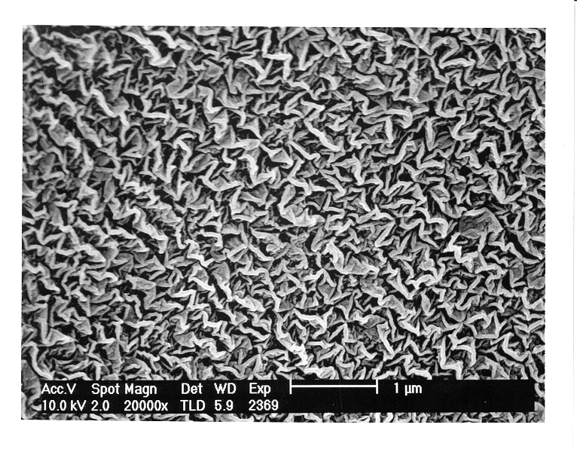
(a) (b) (c)
Fig. 1. SEM images of the captured microstructures: (a) at shear rate of 0.074 $s^{−1}$; (b) at shear rate of 5.27 $s^{−1}$; (c) at shear rate of 22.58 $s^{−1}$. The CPC concentration is 5 mM with the molar ratio fixed at unity.
Fig. 2. Effects of the molar ratio of NaSal to CPC on the shear viscosity for the 5 mM CPC solution. The molar ratio R of NaSal to CPC is varied from R = 0 to 10.

