전기화학적 물성에 미치는 다공성 전극의 미세구조의 영향

송현곤, 성주환, 이건홍
포항공과대학교 화학공학과 에너지/전자 재료 연구실

The Effects of Microstructure on Electrochemical Properties
of Porous Electrodes

Hyun-Kon Song, Joo Hwan Sung, Kun-Hong Lee
Frontier Energy and Electronic Materials Laboratory, Department of Chemical Engineering, Pohang University of Science and Technology

Introduction
Porous materials have been widely used in various scientific and industrial applications. They have attracted special concerns as electrodes used in electrochemical energy storage devices such as electrochemical capacitors, batteries and fuel cells. Understanding of the microstructure of a porous electrode is essential since the structure affects the electrochemical properties of the electrode and thus the performance of the device. Various techniques are available to analyze the microstructure of porous materials: gas adsorption, He pycnometry, mercury intrusion porosimetry, SEM, X-ray diffraction and so on. Previous methods, however, are non in situ techniques for the electrochemical applications, so that measured structures may not be identical to those accessible to electrolyte ions in real applications. Therefore, it has been extremely difficult to correlate the microstructure of porous electrodes with electrochemical behavior of energy storage devices.
The electrochemical impedance spectroscopy (EIS) is a unique tool to investigate frequency dispersion reflecting microstructure of porous electrodes. The frequency dispersion due to geometric factors can be divided into two classes; dispersions in a pore and by pore size distribution (PSD). In-a-pore dispersion occurs since penetration depth of ac signals into a pore decreases with frequency. Therefore, capacitance or equivalent series resistance changes with frequency even in the porous materials composed entirely of pores with equal dimension. In the other class, PSD causes frequency dispersion of the interfacial impedance. Penetration depth at a frequency becomes distributed by PSD since dimension of each pore determines its own penetration depth.
The in-a-pore dispersion of porous electrodes was first modeled by de Levie []. It was based on the findings that a transmission line equivalent circuit could simulate the frequency response in a pore. The assumptions of de Levie’s model (transmission line model, or TLM) include cylindrical pore shape and equal radius and length for all pores. It was shown that the impedance of a porous electrode follows a vertical line at low frequency in the Nyquist plot. Keiser et al. extended the TLM to a noncylindrical pore []. These models considered only in-a-pore dispersion and said in common that phase angle approaches to –90 degrees at low frequencies. But, many experimental data of impedance for porous materials show that phase angle is not –90 degrees even at very low frequencies, which is shown as an inclined line in the Nyquist plot.
We think that the inclined line of impedance at low frequencies comes from the by-PSD dispersion. Despite of the many researches mentioned above, there has been no attempt to consider the effect of PSD on the impedance of a porous electrode. In this work, we developed a model based on the transmission line, considering the effect of the PSD. We called it Transmission Line Model with PSD (TLM-PSD). In our new model, we use an analytical distribution function representing the pore size distribution of a porous material. The distribution function contains three parameters which are likely to have well-defined physical meanings. To prove the availability of TLM-PSD, we applied it to a broad spectrum of porous carbons from μm to Å pore dimensions.

Theory of TLM-PSD
The TLM-PSD combines both in-a-pore and by-PSD frequency dispersions in the absence of faradaic reactions or ionic adsorptions. Any model describing the in-a-pore dispersion can be used as the impedance of a pore only if the model simulates the electrochemical behavior of the pore. In this work, the de Levie’s model was used, assuming that the interfacial impedance of a pore is represented by a double layer capacitance. The de Levie’s equation is as follows.
$Z_{p}^{}=α\left[\frac{\text{sinh}(1/α)−\text{sin}(1/α)}{\text{cosh}(1/α)−\text{cos}(1/α)}−j\frac{\text{sinh}(1/α)+\text{sin}(1/α)}{\text{cosh}(1/α)−\text{cos}(1/α)}\right]$ (1)
with
$Z_{p}^{}=\frac{Z_{p}}{R_{o}}$, $R_{o}=\frac{1}{κ}\frac{l_{p}}{πr^{2}}$, $α=\frac{λ}{l_{p}}$, $λ=\frac{1}{2}\sqrt{\frac{κ\text{ r}}{C_{d}ω}}$ (2)
where Z_{p}, impedance of a pore; R_{o}, electrolyte resistance in a pore; α, penetrability that is defined as the ratio of the penetration depth of ac signal into pores (λ) to pore length (l_{p}); r, pore radius; κ, electrolyte conductivity; C_{d}, electric double layer capacitance; ω, angular frequency.
If a porous material have a PSD of f(x),
$\frac{1}{Z_{\text{tot}}(α:μ,σ^{2})}=\int_{−∞}^{∞}{\frac{1}{Z_{p}(α)}f(x:μ,σ^{2})\text{dx}}$ (3)
where f(x) dx is the number of pores between x and x+dx and x indicates a distribution variable. In this work, the PSD of a porous electrode takes a logarithmic distribution so that x = ln(r/r_{o}), r_{o} is an arbitrary characteristic length to adjust a length unit (=1cm, here) and μ and σ are the average and the standard deviation of the distribution variables x. Through further arrangements with a normalized distribution k(y:0,1) and a standardized deviate y=(x-μ)/σ, we obtain
$\frac{1}{Z_{\text{tot}}(ω\text{ : }α_{μo},σ,{\text{ Y}}_{p})}=Y_{p}\int_{−∞}^{∞}{\frac{1}{Z_{p}^{}(α)}\text{ k}(y\text{ : }0,1)\text{dy}}$ (4)
with
$α=α_{μ}\text{ exp}(σ\text{y/2})=α_{μo}\text{ exp}(σ\text{y/2})ω^{\text{-0}\text{.}5}$ (5)
The TLM-PSD has three fitting parameters (Y_{p}, α_{μ o} and σ) in the CNLS fitting procedure as shown in equation (4). Y_{p} means the total ionic conductance through pores: Y_{p} = κV_{p} / l_{p}². The representative penetrability coefficient α_{μ o} is assigned to the electrochemical pathway which an ensemble of charge carriers travels through:
α_{μ o} = 0.5 l_{p}⁻¹ [κ r_{μ}/ C_{d} ]^{0.5}. σ is the width of distribution of penetrability or PSD. The fitting parameters lead to the concrete geometric parameters (r_{μ}, σ, l_{p}) specifying the PSD, where r_{μ} , the mode radius at which a distribution function gives the maximal value; σ, distribution width of PSD; l_{p}, average pore length. The detailed derivation of TLM-PSD is available in our other publications [,].

Results and Discussion
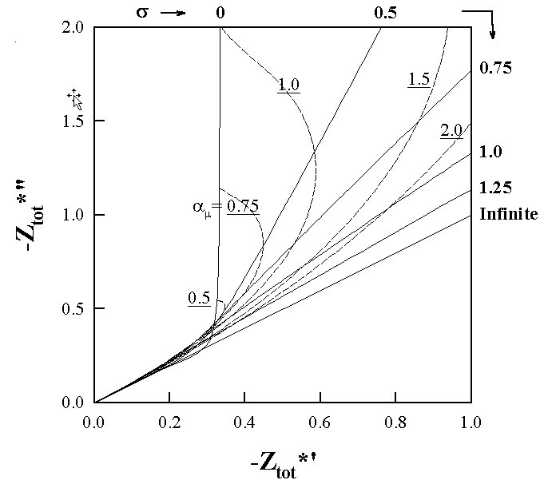
The equation (4) was numerically integrated by the trapezoidal method. The Lorentzian distribution was used as the distribution function of PSD. The results are drawn as the Nyquist plot in Fig.1. The impedance is a sole function of the representative penetrability α_{μ} with a fixed value of the standard deviation σ. The larger mode radius r_{μ} shifts the impedance at a frequency to the higher penetrability point on the Nyquist curve of impedance in Fig. 1 since α_{μ} is proportional to r_{μ}^{1/2}. For all σ, the absolute of the impedance decreases with decreasing α_{μ} and the phase angle approaches to –45 degrees. As σ becomes larger, the absolute of the impedance with an identical α_{μ} decreases and the phase angle goes to –45 degrees even at large α_{μ}. This last statement represents the characteristic of TLM-PSD in comparison with models considering only in-a-pore dispersion. In non-faradaic system, the deviation of phase angle from –90 degrees at low frequencies indicate σ, the width of PSD. Experimental data showing inclined curves at low frequencies in Nyquist plot can be fitted with TLM-PSD successfully and we can obtain PSD of the porous electrode by the fitting.
Fig. 1 Impedances of porous materials with various pore size distributions in Nyquist plot, simulated by TLM-PSD. Z_{tot}*’ and Z_{tot}*’’ are real and imaginary parts of reduced impedances, respectively. Dashed lines and solid lines indicate constant-α_{μ} and constant-σ curves, respectively.
To test availability of TLM-PSD, we fitted experimental impedance data of a wide spectrum of porous electrodes with our TLM-PSD but here we presented three kinds of porous carbon electrodes; macroporous carbon membrane, mesoporous carbon aerogel and microporous activated carbon fiber. Fig. 2 includes the experimental data (circular symbols), the fitting results from TLM-PSD (cross symbols) and de Levie equation (1) (solid line).
We can easily see that there is a fundamental difference between the experimental data and the fitting by de Levie equation at low frequency. Many experimental impedance data of porous electrodes show that the phase angle is not –90 degrees even at low frequency. However, models considering only the in-a-pore dispersion such as de Levie equation cannot express the inclined line at low frequency in Nyquist plot. On the other hand, the experimental data could be fitted successfully with TLM-PSD as shown in Fig. 2. This goodness of fit results from consideration of the by-PSD dispersion.
We obtained geometric parameters from fitting parameters. Fig. 3 compares the PSDs estimated from our TLM-PSD with the ones obtained from conventional nitrogen adsorption: the PSDs measured by both methods are in fairly good agreement for the carbon aerogel while our TLM-PSD emphasizes larger pores than nitrogen adsorption for the ACF. Underestimation of smaller pores is attributed to the difference in size of probes used in two methods: the statistical thickness of adsorbed nitrogen is 3.54 Å while the hydrated ionic diameter of a probe used in ECP (SO₄²⁻) is 7.58 Å []. Therefore, the micropores of several Å radius which exist dominantly in the ACF are inaccessible to the probe used in our method. On the other hand, the carbon aerogel consisting mainly of mesopores of tens to hundreds Å radius could be detected similarly by both methods. This is a kernel of our method: it measures the geometry which ions used in electrochemical systems actually feel.
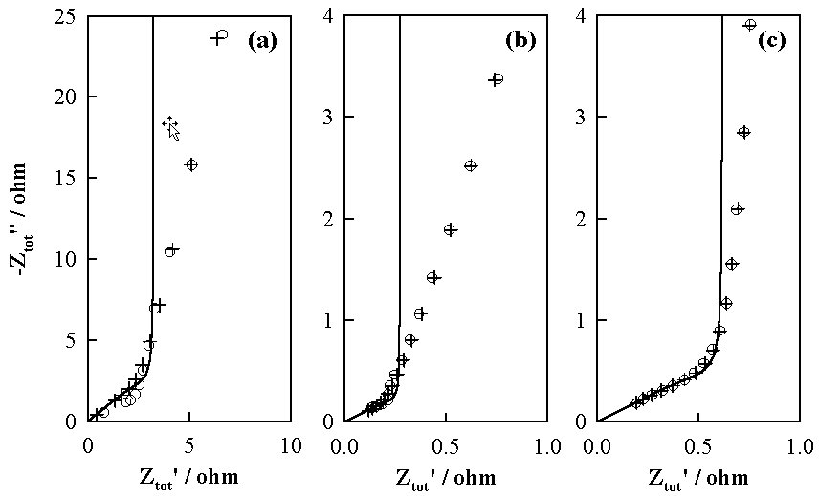
The TLM-PSD model can be a useful tool in two cases. First, with given PSD the model can predict impedances of porous materials in the absence of faradaic reactions. The PSD can be measured by various well-known techniques (nitrogen adsorption technique, mercury porosimetry and so on). The application as a prediction tool helps optimizing porous structure of electrodes used in electrochemical energy storage devices. Secondly, we can use this model as an analytical tool, i.e., electrochemical porosimetry. The PSD of a porous material can be obtained by fitting experimental impedance data with our model when the data are obtained in an electrochemically inert electrolyte with a known conductivity.
Fig. 2 Impedances of porous electrodes in Nyquist plot. Symbol O, experimental data; +, TLM-PSD; solid line, a previous model.
(a), carbon membrane;
(b), carbon aerogel;
(c), activated carbon fiber. 1M H₂SO₄ aqueous solution was used as an electrolyte.
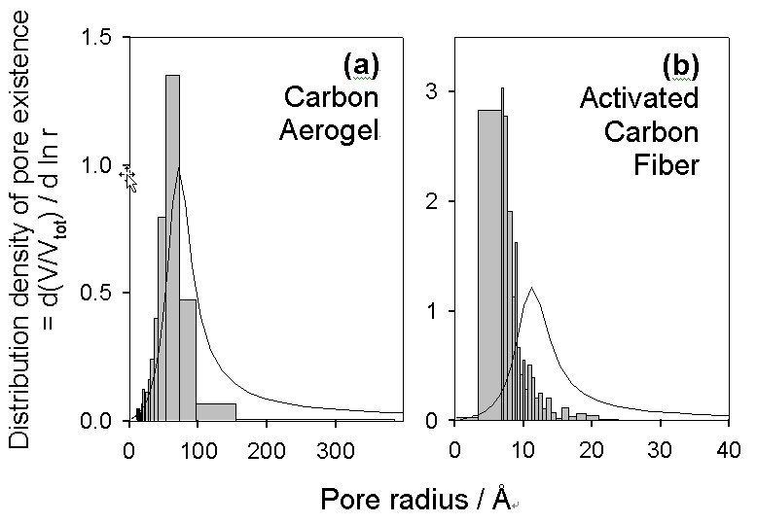
Fig. 3 Pore size distributions of (a) carbon aerogel and (b) activated carbon fiber estimated by conventional nitrogen adsorption (gray bars) and our TLM-PSD (solid lines). The latter was obtained from the TLM-PSD fitting shown in Figure 2b and c.

References

. de Levie, R.: in P. Delahay(Ed.), “Advances in Electrochemistry and Electrochemical Engineering”, Vol. VI, Interscience, New York, 329(1967).
. Keiser, H., Beccu, K. D. and Gutjahr, M. A.: Electrochim. Acta, 21, 539(1976).
. Song, H. –K., Jung, Y. –H., Lee, K. –H. and Dao, Le H.: Electrochim. Acta, 44, 3513 (1999).
. Song, H. –K., Hwang, H. –Y., Lee, K. –H. and Dao, Le H.: Electrochim. Acta, 45, 2241 (2000).
. Horvath, A. L. Handbook of Aqueous Electrolyte Solutions, 344 (Halsted Press, New York, 1985).

