Hot 필라멘트법에 의한 Si 기판상의 다이아몬드제조에 대한 연구

트란란안, 김정현, 츄반치엠, 신형식
전북대학교 화학공학부

A study in diamond synthesis on Si substrate
by HFCVD

Lan-Anh Tran, Jung-Hyun Kim, Van-Chiem Chu,
Hyung-Shik Shin

Introduction
The relationship of diamond film quality to growth rate is a critical issue for the chemical vapor deposition of diamond. Many applications for diamond are not feasible because current process growth diamond to slowly, of too poor quality that are too costly. Addressing and finding solutions to this issue will be critical if diamond is to find wide application in the market place.
The rate of the growth of heteroepitaxial diamond film is depend on the hetero-nucleation of diamond. On silicon substrate the intrinsic diamond nucleation density is only 10⁴ cm⁻² and special pretreatments are required to increase this density.
Many methods have been researched in order to enhance diamond nucleation such as scratching, biasing, various deposition conditions and so on. In this paper we try to use electric current to treat the substrate’s surface after chemical treatments. The electric current treatment allows us to affirm that the substrate’s surface is very clean and non-reconstructed. The nucleation density on Si (100) pretreated by electric current reaches a high value of 10¹⁰ cm⁻².

Experimental
Diamond films were deposited from the gaseous mixture of hydrogen and methane in a Hot-filament CVD apparatus. The substrates Si (100) were clean by ethanol, acetone, tricloroethane, nitric acid, HF, and de-ionized water before being put into the chamber. In chamber Electric current treated the substrate, which is used to grow diamond film. The filament temperature and the substrate temperature were controlled around at 2000⁰C and 900⁰C and were measured by optical parameter and themocouple, respectively. The processing pressure was maintained at 30 Torr. The nucleation and growth of diamond films carried out using 1 % methane concentration. Scanning electronic microscopy (SEM), Raman and X-ray photoelectron spectroscopy (XPS) were used to characterize the diamond film.

Results and discussions
Fig. 1 shows the XPS of Si substrate with and without electric current treatment. Without electric current treatment the XPS shows peak of oxygen 1S at 533 eV very clear but in the XPS of substrate that was treated by electric current there wasn’t peak at that position that means the substrate’s surface is very clean and non-recontructed.
Fig. 2 shows the SEM photograph of diamond nucleation for 20 min deposition time. From the SEM photograph we see the nucleation density is very high, approximately 10¹² cm⁻², that means high nucleation density can be gained on the substrate treated by electric current
.
The Raman spectrum of the growth of the diamond film after 1 h at 1% methane concentration is presented in Fig. 3. The diamond peak is located at 1332 cm⁻¹. However from XPS of the growth of the diamond film (not shows here) shows that diamond grows on Si substrate through silicon carbide.
Fig. 1 XPS of Si substrate with and without electric current treatment.

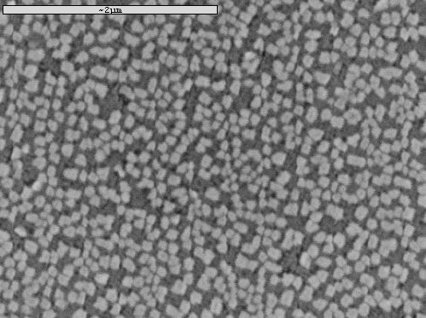
Fig. 2. Photograph of SEM of diamond nuclei on silicon for 20 min.
Fig. 3. Raman spectra of diamond film on silicon

Conclusion
The nucleation process of diamond film on silicon substrate in Hot-filament CVD has been studied. Compare with silicon substrate without electric current treating, the nucleation density of diamond is increased significantly on the silicon substrate with electric current treating.

References
[1] Jianwei Sun, Yafei Zhang, Deyan He, J.9 (2000) 1668-1672
[2] D.G. Goodwin, G.G. Gavillet, J. Appl. Phys. 68 (1990) 6393
[3] K.L. Meningen, C.J. Erichson, M.A. Childs, L.W. Anderson, J.E. Lawler, J. Mater. Res. 10 (1995) 1108
[4] X. Jiang and C.P. Klages. Phys. SI at. Sol. (a) 154, 175 (1996)
[5] B. R. Stoner and J. T. Glass, Appl. Phys. Letters 60, 698 (1992)
[6] L. Constant, C. Speisser, F. Le Normand, J. 387 (1997) 28-43
[7] Y. Liao, F. Ye, Q. Y. Shao, C. Chang, G. Z. Wang, R. C. Fang, J. 368 (2000) 211-215

