Avidin -Biotin 인지 작용을 이용한 제올라이트 결정의 섬유상 응집체 형성

엄 숭호*, 구 기갑*, 윤 경병**
서강대학교 화학공학과*, 서강대학교 화학과 제올라이트 초결정 연구단**, 서울 121-742

Formation of Fibrous Aggregates of Zeolite Crystals through Molecular Recognition of Avidin- Biotin

Soong Ho Um*, Kee-Kahb Koo*, Kyung Byung Yoon**
Department of Chemical Engineering*, Center for Microcrystal Assembly and Department of Chemistry, Sogang University**, Seoul 121-742, Korea

Introduction

In nature, the process of self-assembly, including the self-cloning of DNA molecule, the transcription of DNA to RNA, the translation of RNA to protein and the linking of cell-cell, has been grown up and elaborately designed for a long time. Human has made an endeavor to mimic that of nature during the livelong time. In the beginning time, it was very often investigated to form a self-assemble in the root of synthetic organic and inorganic materials, but in present, the materials impossible to manufacture is produced by the recognition of a biomolecule. Especially, the fact is noticeable that NT (nanotechnology) is interconnected with BT (biotechnology) through biomolecular linkers. Because of ability of a biomolecule to cognize with each other onto the surface of nano-materials, it opens the possibility to develop new materials and prepare a microchip.
In biological system, there are many materials capable to link each other in intimacy, for example, antigen-antibody, neurotransmitter-receptor, and protein-protein. The linkage of avidin and biotin is known to be one of the strongest in nature [1]. It is reported that this connection don’t easily break out in harsh condition of high pH and temperature [2]. Avidin is a protein in 66,000 D, it is composed of four subunits in 15,000 D. Each subunit has a site with which biotin is able to combine. Binding mechanism resembles the lock and key model of an antigen-antibody or a protein-ligand. Avidin is extracted from biological system such as an egg white. Biotin is an organic compound in 244 D. It is a kind of vitamin B, necessary for a birth and breeding of animals and plants. D-isomer of a biotin is a form to exist in nature, it is biologically active, and L-isomer is not. It is related to the metabolism of lipid and glucose. Also, it is useful for yeast and bacteria to get along. It is unusual to find the symptom of difficiency. However, when a biotin interact with the avidin in an egg white, it is possible to cause alopecia and a skin inflammation. Deoxybiotin is transposed of S to O of a biotin, desthiobiotin is the omission of S in a biotin moiety, exist in a yeast and a microbe. The part of a ring structure in a biotin is known to interact specifically with an avidin and the part of a chain to react with DNA, BSA, or so.
In the past, zeolitic materials have been used as simple inorganic catalysts, but, currently many efforts have been given to the improvement of physical and chemical performance through the cross-linking of zeolite particles in the diverse section of science and technology. In addition, the formation of layer-by-layer assembly of the zeolite on a substrate using ionic linkers has been reported [3]. The present study further demonstrates the possibility of three dimensional self-assembly of zeolite crystals through the specificity and selectivity of biomolecules. When the zeolite film was formed with the molecular recognition of biomolecules, it was found that the fibrous aggregates of zeolite crystals were produced. The observed phenomenon is very similar to the previously observed fibrillation from β-glucosidase and D-glucose coupled with zeolite microcrystals, despite that the two complex-forming protein-substrate systems are entirely different in nature. These results suggest that self-assembly of complex-forming proteins and the corresponding substrates coupled with inorganic microcrystals into structured aggregates may be a ubiquitous phenomenon in nature [4]. Here we report the experimental results on the formation of fibrous aggregates of zeolite crystals through molecular recognition of avidin-biotin.

Experiments

Avidin (lot number 38H7834), D-biotin (lot number 129H0974), and phosphate buffered saline (PBS, pH = 7.4) were purchased from Sigma co. and they were used as received. Zeolite-A (Na⁺ form) was synthesized using tetramethylammonium (TMA⁺) as the template [5]. The average size of the resulting zeolite-A was about 300 nm. TMA⁺ was removed from the zeolite by calcining it at 550 °C for 12 h prior to biotin tethering on their external surfaces. To induce fibrillation with avidin, a PBS buffer solution (20 ml)[6] dispersed with Biotin-Z (10 mg) was introduced into a flat-bottomed cylindrical reaction vessel in which a teflon slab with four supporting legs was placed. Avidin (2 mg, 3 µmol) was subsequently introduced into the solution and the heterogeneous mixture was stirred with the aid of an underlying small magnetic stirrer at room temperature. The turbid solution slowly turned transparent with time and after elapse of 1 day the presence of fibrils on top of the teflon slab became visually apparent. The fibrils were then finally dispersed into 10 mL of fresh water and the solution was freeze-dried. The amount of avidin was also varied to 1, 4, 8, and 10 mg, respectively, to test the effect of the weight ratio of avidin to zeolite (A/Z) on the morphology of the resulting avidin-biotin-zeolite composite.

Results and Discussion

Controlled experiments reveal that complexation between avidin and the zeolite-bound biotin is essential for fibrillation to occur. It was observed that avidin and nanometer-sized zeolite crystals (~300 nm) coupled with D-biotin readily self-assembled into thin (2-20 μm) and very long (> 1 cm) fibrous aggregates in a buffer solution of pH = 7.4 when A/Z was equal to or higher than 0.2. As shown in Figure 1(A), at A/Z = 0.2, the exteriors of the produced fibrils are covered with zeolite-A crystals. At A/Z = 0.4, the zeolite crystals are completely buried within the fibrils covered with thick layers of avidin (Figure 1(B)). At A/Z = 0.8 ~ 1.0, the morphology of the fibrils become smooth and flat due to the thick surface-lining avidin layers (Figure 1(C)). Interestingly, discrete clusters of zeolite crystals with sizes of 5-10 μm are produced when the A/Z ratio is reduced to 0.1 as can be seen from Figure 2.

Acknowledgment

We thank the Creative Research Initiatives (CRI) program of the Ministry of Science and Technology (MOST) for financial support. K.-K. K. and S. H. U. also thank Advanced Backbone IT Technology Development Project (IMT-2000-133-2) of the ministry of Information and Communication of Korea. We extend our thanks to Dr. K. S. Yun at LG Electronics Institute of Technology for helpful discussions.

References

1. Hiller, Y., Gershoni, J. M., Bayer, E. A., Wilchek, M., “Biotin binding to avidin,” Biochem, J., 248, 167-171 (1987)
2. Wilchek, M., Bayer, E. A., “Avidin-Biotin Technology,” Academic Press, London, Chap 2 (1990)
3. Lee, G. S., Lee, Y.-J., Yoon, K. B., “Layer-by-Layer Assembly of Zeolite Crystals on Glass with Polyelectrolytes as Ionic Linkers,” J. Am. Chem. Soc., 123, 9769-9779 (2001)
4. Lee, G. S., Lee, Y.-J., Choi, S. Y., Park, Y. S., Yoon, K. B., “Self-Assembly of β-Glucosidase and D-Glucose-Tethering Zeolite Crystals into Fibrous Aggregates,” J. Am. Chem. Soc., 122, 12151-12157 (2000)
5. Zhu, G., Qui, S., Yu, J., Sakamoto, Y., Xiao, F., Xu, R., Terasaki, O., “Synthesis and Characterization of High-Quality Zeolite LTA and FAU Single Nanocrystals,” Chem. Mater., 10, 1483-1486 (1998)
6. Nelson, K. E., Gamble, L., Jung, L. S., Boeckl, M. S., Naeemi, E., Golledge, S. L., Sasaki, T., Castner, D. G., Campbell, C. T., Stayton, P. S., “Surface Characterization of Mixed Self-Assembled Monolayer Designed for Streptavidin Immobilization,” Langmuir, 17, 2807-2816 (2001)

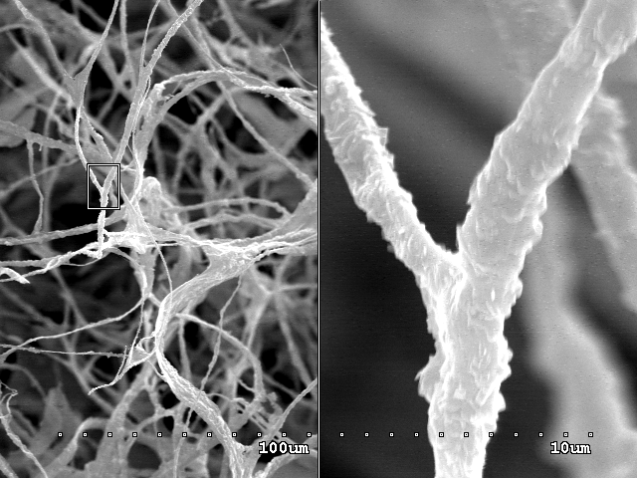
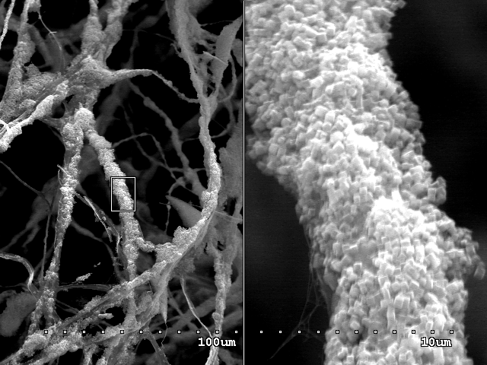
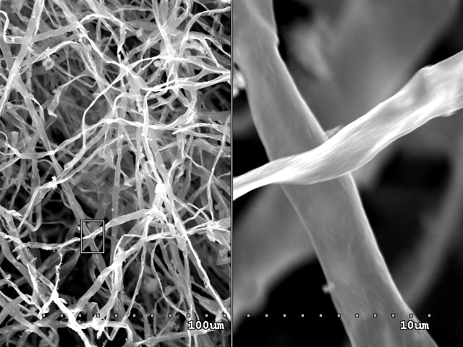
A
20μm
B
20μm
2μm
C
2μm
2μm
20μm

Figure 1. SEM images showing the A/Z ratio-dependent morphology change of the fibrils: (A) 0.2, (B) 0.4, and (C) 1.0. The right part of each panel is the 10-times magnified image of the rectangular section marked on the left part.

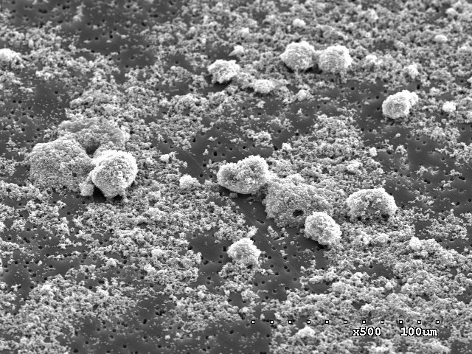
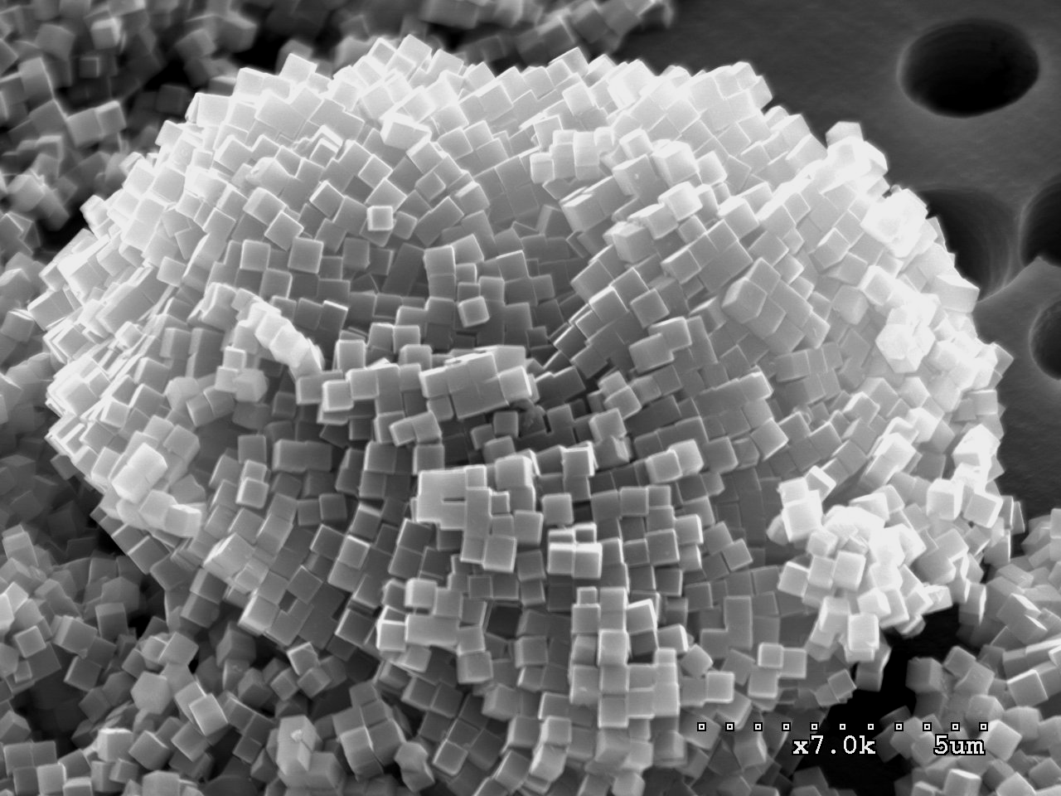
A
30μm
1μm
B

Figure 2. SEM images showing the discrete clusters of Biotin-Z produced at A/Z ratio of 0.1: (A) lower and (B) higher magnifications.

