n-Heptane 분해반응을 위한 니켈이 담지된 탄소 나노튜브의 합성 및 적용

Ai Min Zhangª, Dong Cheng Hanª, 이정우^{b}, 이현구^{b*}
ª난징대학교 화학과
^{b}서울대학교 응용화학부·화학공정신기술연구소

Synthesis and Catalytic Application of Ni-Supported Carbon Nanotubes
for n-Heptane Cracking

Ai Min Zhangª, Dong Cheng Hanª, Jung-Woo Lee^{b}, Hyun-Ku Rhee^{b*}
ªDepartment of Chemistry, Nanjing University, Nanjing, P.R. China
E-mail: zhangaamm@yahoo.com.cn
^{b}School of Chemical Engineering and Institute of Chemical Processes,
Seoul National University, Seoul 151-742, Korea
E-mail: hkrhee@snu.ac.kr

INTRODUCTION
Smalley and co-workers [1] developed the chemistry of fullerenes in the mid 1980s. These cage-like forms of carbon have been known to exhibit exceptional material properties. Since the first discovery of carbon nanotubes with fullerenes structure a decade ago [2], many researchers have reported their mechanical properties that exceed those of any previously existing materials. Theoretical and experimental results have shown extremely high elastic modulus and also strengths 10-100 times higher than the steel. They also possess superior thermal and electric properties. These exceptional properties of carbon nanotubes have been corroborated for devices such as field-emission displays, scanning probe microscopy tips and micro-electronic devices [3,4]. With the large-scale synthesis of carbon nanotubes, attention is now being directed to their potential application in various fields of materials.
Catalysis is a nanoscale phenomenon that has been the subject of research and development for many decades, but only recently become a nanoscale science of materials and chemistry involving more investigations on the molecular level. In the field of heterogeneous catalysis, various carbon materials have been used to disperse and stabilize metallic particles [5]. However, the carbon nanotubes, different from general carbon materials, exhibit exceptional properties such as uniform pore diameter, high length-diameter ratio, ability of very high H₂ uptake [6] and large specific surface area, and the hydrophobic or hydrophilic character of the surface can be controlled by chemical treatment or modification [7]. These properties suggest enormous potential applications of carbon nanotubes as novel materials for the catalyst carrier.
For large-scale synthesis of carbon nanotubes, the as-prepared carbon nanotubes usually contain a large amount of impurities such as metal particles, amorphous carbon and multi-shell carbon nanocapsules. These impurities bring about a serious impediment to the detailed characterization of carbon nanotubes, so it is very important to purify the carbon nanotubes in order to prepare good catalysts.
In this study, we synthesized carbon nanotubes by chemical vapor deposition, purified them by different methods, characterized their properties by TEM, XRD, BET, and TG/DTA, and examined the catalytic activity of carbon nanotubes in n-heptane cracking.

EXPERIMENTAL

Preparation of carbon nanotubes and Ni-supported carbon catalyst
The multi-walled carbon nanotubes were obtained by chemical vapor deposition of acetylene over Co-La catalyst at 973K following the procedure reported previously [8]. The main impurities coexistent with multi-walled carbon nanotubes were metal particles and amorphous carbon. In order to remove these impurities, the as-synthesized carbon nanotubes were first suspended in concentrated HNO₃ solution with stirring and refluxing at 333K for 2 h. After filtering, washing and drying, the treatment with nitric acid was repeated twice for surface oxidation of carbon nanotubes. Subsequently, the dried oxidized carbon nanotubes were impregnated with NiNO₃·6H₂O dissolved in alcohol with stirring for 5 h, dried at 323K for 15 h and heated in vacuum at 409K for 2 h. Finally, the samples were oxidized and reduced. Other samples supported on different materials were obtained by the same method.

Characterization
The morphometrics of carbon nanotubes were observed with the JEM-200 CX transmission electronic microscope (TEM). The specimens for TEM were first mulled in agate bowl, then dispersed in aqueous solution containing 50% alcohol by ultrasonic treatment and dropped onto holey grids. The specific surface area was measured by the method of nitrogen physisorption at liquid nitrogen temperature using a Micrometritics ASAP 2000 apparatus. XRD patterns were taken with a D/MAX X-ray diffraction instrument by using CuKα in the voltage of 40 kV and current of 50 mA.

Activity for n-heptane cracking
Catalytic reaction of n-heptane cracking was carried out using a tubular 4 mm ID flow micro-reactor at 723K. 0.1g of the sample with the particle size of 20/40 mesh was put into the U-shape quartz tube. Before reaction, the catalyst was pretreated by heating in nitrogen flow at a constant rate of 10 Kmin⁻¹ to 773K and held at this temperature for 2 h. After activation, the reactor was cooled down to 723K and held at this temperature. Then, the mixture of H₂ saturated with n-heptane at 298K was passed through the reactor at a constant flow rate of 15 ml/min. Reactants and cracking products were analyzed by on-line gas chromatograph GC-1102 with FID detector and Proparak QS column.

RESULTS AND DISCUSSION
Purification and properties of carbon nanotube
The TEM image of the as-synthesized carbon nanotubes is shown in Fig. 1. They are multi-walled carbon nanotubes and have outer diameter of about 30 nm, inner diameter of about 5 nm and length of several tens of μm. From Fig. 1, we notice that there are many dark metal agglomerates around carbon nanotubes. The purified carbon nanotubes after treatment with acid are shown in Fig. 2. Those dark metal agglomerates have been removed and the walls of carbon nanotube become thinner than before. This is due to the occurrence of oxidation on the surface of carbon nanotubes at the same time of removing the impurities with acid. The oxidized carbon nanotubes were favored to support active metals. The specific surface areas of as-prepared nanotubes were about 100 m²/g but the value was increased to about 120 m²/ g after treatment with acid. This indicates that part of the nanotubes was opened. The XRD pattern shows only one sharp peak at 2θ= 26.06, indicating that the carbon nanotubes have a uniform pore size and graphited-well structure and there are no impurities.
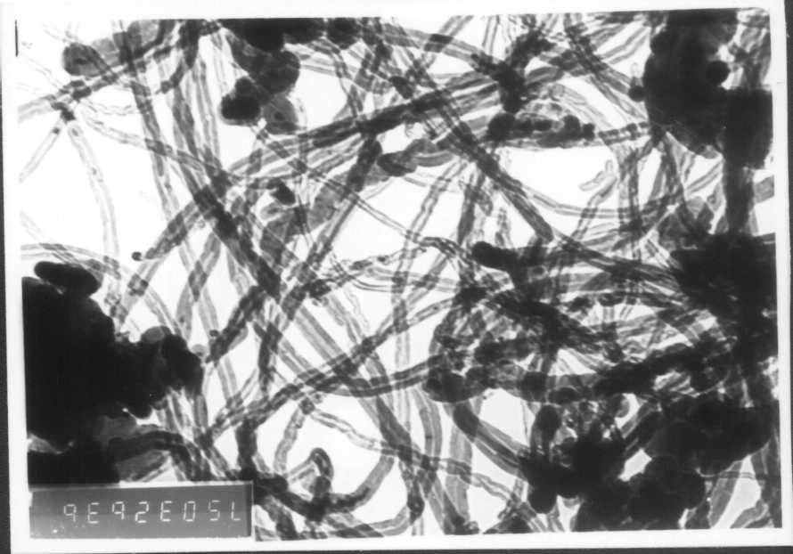
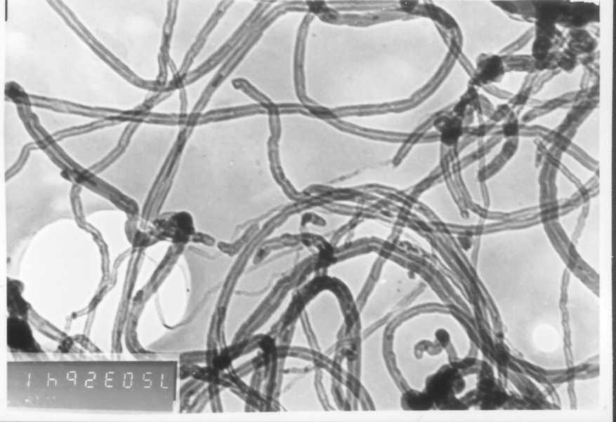
Fig.1. TEM image of the as-synthesized carbon nanotubes Fig.2.TEM image of the purified carbon nanotubes

Activity of Ni-supported carbon nanotubes for n-heptane cracking
In Fig. 3, catalytic activities are compared among the Ni-supported carbon nanotubes (Ni/CNTs), the unsupported carbon nanotubes (CNTs) and the nickel catalyst for the cracking of n-heptane. It is observed that the carbon nanotubes have no catalytic activity and nickel alone does not exhibit any catalytic activity, either. Once the nickel was supported on carbon nanotubes, however, the catalyst, Ni/CNTs, showed a very high conversion of n-heptane. Obviously, the carbon nanotube as carrier plays a crucial role in the reaction. This is mainly due to the high dispersion of nickel onto the carbon nanotubes having a uniform pore size and the increase of acid sites on the surface during refluxing carbon nanotubes with nitric acid.
The effect of the amount of nickel loading on the activity of Ni/CNTs was examined as described in Table 1. The optimum amount of Ni loading in carbon nanotubes is about 5.2 mmol/g. This catalyst can maintain the high conversion of 99% for 15 h. If the amount of nickel loading is further increased, the cracking activity is decreased and the deactivation time is also deceased.

Fig. 3. Catalytic activities of three different materials for the cracking of n-heptane
Table 1 Effect of the amount of nickel loading on the activity activity and decline time
Samples Ni-loading (mmol/g) Conversion of n-heptane (%) Decline time (h)
1 1.718 3 0
2 3.436 80 0
3 5.155 99 15
4 6.873 99 11
5 13.746 99 7

Role of carbon nanotubes in cracking reaction
The activity of the Ni-supported carbon nanotubes is compared with those of Ni-supported on different materials as shown in Fig. 4. The Ni/CNTs catalyst maintains the high activity for more than 8 h and still shows no tendency of deactivation. The cracking product consists mainly of methane. Does the carbon in carbon nanotubes take parts in the cracking reaction in the presence of activated metal? This is a bewildering question at all time. In order to understand the role of carbon nanotubes in the cracking reaction, we conducted some blank reactions in the presence of hydrogen only (in the absence of n-heptane) over Ni, Ni/CNTs and Ni/USY, respectively. The results rarely showed cracking products over these catalysts. This indicates that the analytic cracking products are formed by the cracking of n-heptane rather than by the decomposition of carbon nanotubes.
Fig. 4. Comparison of activities of Ni catalysts supported on different carriers in n-heptane cracking

CONCLUSIONS
Nickel-supported multi-walled carbon nanotubes exhibited a very high activity for the cracking of n-heptane. This indicates that the carbon nanotubes can be used as a good carrier for catalysts. Since the cracking products consist mainly of small hydrocarbons, this would foreshow that Ni-supported carbon nanotubes may possess a remarkable ability for the cracking of hydrocarbons.

REFERENCES
[1] Kroto, H.W., Heath, J.R., O’Brien, S.C., and Smalley, R.E., Nature, 318, 162 (1985).
[2] Iijima, S., Nature, 354, 56 (1991).
[3] Treacy, M.M.J., Ebbesen, T.W., and Gibson, J.M., Nature, 382, 678 (1996).
[4] Iijima, S., Brabec, C., Maiti, A., and Bernholc, J.J., Chem. Phys., 104, 2089 (1996).
[5] Tans,S.J., Devoert, M.H., Dai, H., Thess, A., Smalley, R.E., Geerligs, L.J., and Dekker, C., Nature, 386, 474 (1997).
[6] Dillon, A.C., Jones, K.M., Bekkedahl, T.A., Kiang, C.H., Bethune, D.S., and Heben, M.J., Nature, 386, 377 (1997).
[7] Fan, S., Chapline, M.G., Franklin, N.R., Tombler, T.W., Cassell, A.M., and Dai, H., Science, 283, 512 (1999).
[8] Zhang, Y., Zhang, H.B., Lin, G.D., Appl. Catal. A, 187, 213 (1999).
[9] Zhang, A.M., Xie, D., Bao, S., and Xu, Q., ACTA CHIMICA SINICA, 58(7), 876 (2000).

