Model Predictive Control Using Wiener Model Identified by a Modified Method

Ro-Ji Oh, In-Hyoup Song and Hyun-Ku Rhee*

School of Chemical Engineering and Institute of Chemical Processes,

Seoul National University
Tel. +82-2-880-7405, Fax. +82-2-888-7295, E-mail: hkrhee@snu.ac.kr

변형된 방법으로 식별된 Wiener Model을 이용한 모델 예측 제어

오로지, 송인협, 이현구*
서울대학교 응용화학부, 화학공정 신기술 연구소

Introduction

A Wiener system is given by the cascade interconnection of a linear time invariant dynamic system with a static nonlinearity at the output [1,2]. This model corresponds to a process with linear dynamics and can adequately represent many of the nonlinearities encountered in industrial processes. The Wiener model may be incorporated into the model predictive control (MPC) schemes in a unique way that removes the nonlinear property from the control problem, preserving many of the favorable properties of a linear MPC. The Wiener model, however, may suffer from the superposition of a linear part and a nonlinear part. In this study, we identify the Wiener model by using a modified structure. For the linear part identification, the linear input/output data-based prediction form is used. In the case of the static nonlinear part, the inverse of the nonlinear function is directly identified using Tchebychev polynomials. With the proposed model, we have designed a Wiener type input/output data-based predictive controller and applied it to a continuous methyl methacrylate (MMA) polymerization reactor.

Identification of Wiener model

Consider a process described by combination of a linear time-invariant (LTI) state space model and the static nonlinear model

$x_{k+1}={\text{Ax}}_{k}+{\text{Bu}}_{k}+ω_{k}, y_{k} ={\text{Cx}}_{k}+{\text{Du}}_{k}+ν_{k}$ and $z_{k}=f(y_{k})$ (1)

where $x_{k}∈R^{n}$ is the state variable, $u_{k}∈R^{m}$ is the input vector, and $y_{k}∈R^{l}$ is the output vector of the linear part. The Wiener model is composed of an LTI state space part and a static nonlinear part [1]. To identify this model, three steps are devised as follows:

Step 1: Identification of linear time-invariant part

The linear time invariant part can be identified as a linear input/output data-based prediction model [3,4]

$Y_{f}=Γ_{N_{p}}X_{f}+H_{N_{p}}U_{f}+H_{N_{p}}^{s}Z_{f}+V_{f}L_{w}W_{p}+L_{u}U_{f}$ (2)

From the eq. (2) we notice that the optimal predicted output sequence can be expressed as

${\hat{y}}_{f}=L_{w}w_{p}+L_{u}u_{f}$ (3)

in which $w_{p}$ is defined as $(y_{p}^{T} u_{p}^{T})$ with the M last known values of inputs $u_{n}∈R^{\text{Mm}}$ and the outputs$y_{p}∈R^{\text{Ml}}$, where

$y_{p}={\left(\begin{matrix}y_{t−M+1}^{T} & ⋯ & y_{t−1}^{T} & y_{t}^{T}\end{matrix}\right)}^{T}$ and $u_{p}={\left(\begin{matrix}u_{t−M+1}^{T} & ⋯ & u_{t−1}^{T} & u_{t}^{T}\end{matrix}\right)}^{T}$ (4)

Step 2: Identification of the inverse of the static nonlinear part

At the interface between the LTI and nonlinear block, we can write down the following equation

${\hat{y}}_{k}=f^{−1}(z_{k})=Ψ(z_{k})θ$ (5)

We parameterize $f^{−1}$ by using the linear in parameter basis function; i.e., Tchebychev polynomial. All the basis functions are collected in the matrix $Ψ(z_{k})$ and the parameters in the vector $θ$. By using the polynomial, the inverse of the static nonlinear function is directly obtained.

Step 3: Iteration

The consistent estimate of $f^{−1}$ obtained in Step 2 enables us to compute a consistent estimate of the signal $y_{k}$. With the signals $u_{k}$ and $y_{k}$, the LTI part is again identified as a linear input/output data-based prediction model. Steps 1 and 2 are repeated until the variance accounted for (VAF) value reaches the specified desirable point. These three steps complete the whole procedure of identification effectively.

Wiener type I/O data-based predictive control


Figure 1. Block diagram of the Wiener type input/output data-based predictive control.
I/O PC
Plant
Figure 1 shows the block diagram of the proposed control scheme. In the predictive control algorithm, we use the input/output data-based prediction model. Here, the gain matrices, $L_{w}$ and $L_{u}$, were obtained by using the past data during the identification procedure. The objective function is given by the equation

$\underset{u_{f}}{\text{min}}J(u_{f})=(L_{u}u_{f}+L_{w}w_{p}−r_{f})^{T}Q(L_{u}u_{f}+L_{w}w_{f}−r_{f})+u_{f}^{T}{\text{Ru}}_{f}$ (6)

where Q and R are the output and input weighting matrices, respectively, and $r_{f}$ denotes the set point trajectory. Continuous changes of $w_{p}$ and $r_{f}$ innovate the objective function at every sampling time. The objective function is solved by using the QP method to determine the control input $u_{f}$. It should be noted that there is no need to explicitly calculate the state estimate or the state space model.

Application to polymer quality control in a continuous MMA polymerization reactor

Identification results

For application, the first principles model of a continuous methyl methacrylate (MMA) polymerization reactor is taken as the plant. For the details, one may refer to the article by Jeong et al. [5]. The 4-level pseudo random input sequences of $T_{j,\text{in}}$and $q_{f}$ (jacket inlet temperature and feed flow rate) are used for the generation of corresponding outputs (conversion and weight average molecular weight (Mw)). As the iteration algorithm is continued, the separation of two elements becomes more pronounced. The VAF indexes for conversion and Mw reach the levels of 99.3% and 98.7%, respectively within 5 iterations. This improvement may bring about an enhancement of the control performance. The results of Wiener model identification are compared with the plant data in Figure 2.
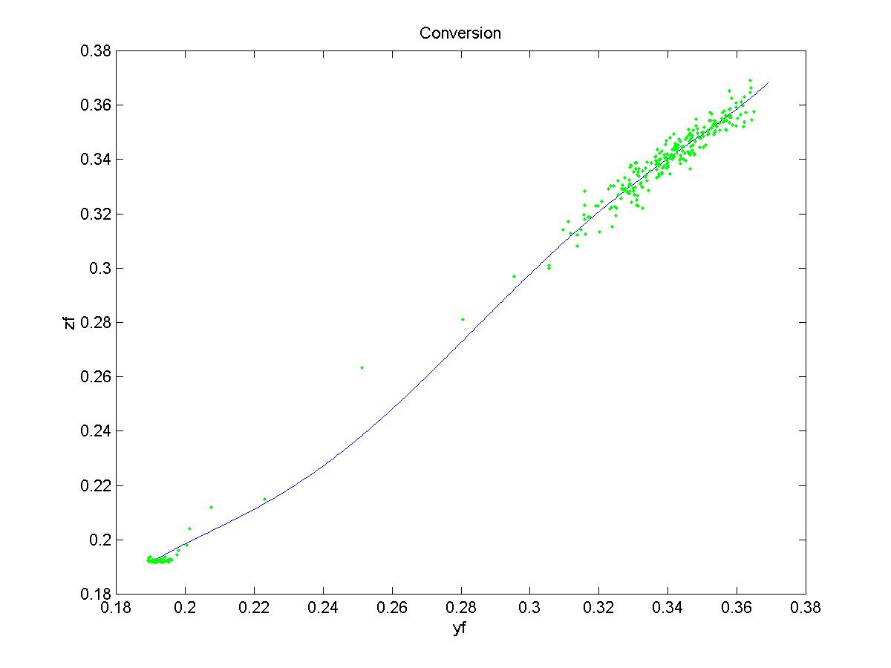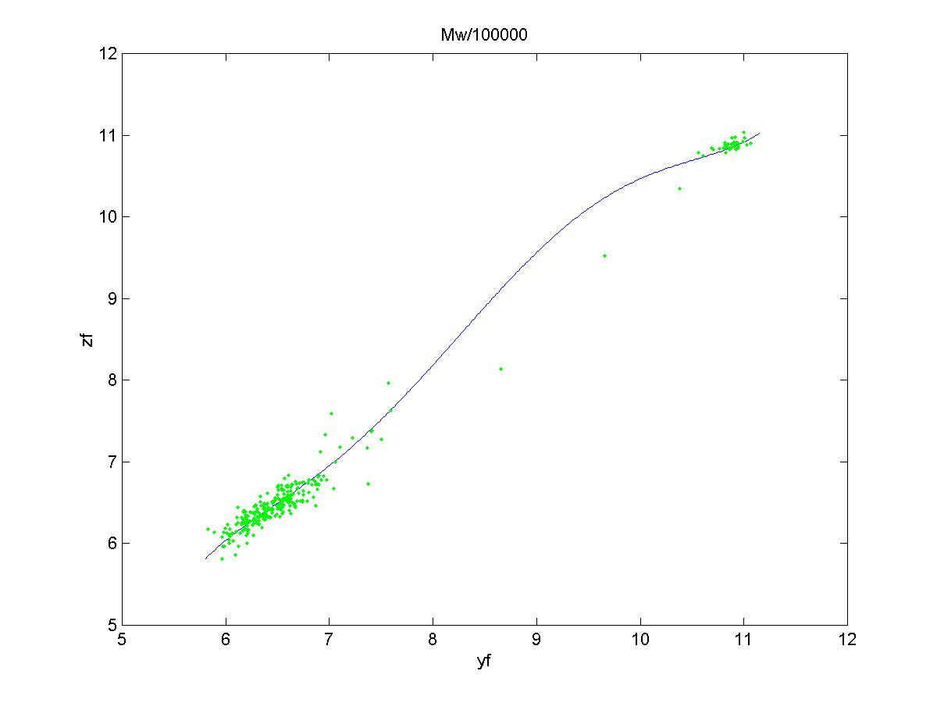
Figure 2. Comparison between the plant data (•) and the prediction (-) by the inverse of the static nonlinear part in the identified Wiener model.

Control results

For the control purpose, we set the sampling time as 1 min and the prediction and control horizons are selected to be 10 and 3, respectively. Both the input and output constraints are
taken into account in the calculation of the predictive control input. After the process reaches the steady state at 300 min, the controller starts to work to maintain the steady state. Set point changes are introduced in Mw at 600 min and in conversion at 750 min, respectively. The simulation result presented in Figure 3 clearly demonstrates a satisfactory performance of the proposed control algorithm.

Conclusions

Here we propose a modified method for the identification of Wiener model. For the linear part identification, the linear input/output data-based prediction form is used and the Tchebychev polynomial is employed in the identification of the inverse static nonlinearity. The iteration algorithm of identification enhances the accuracy of the identified model. We apply this method to identify a MIMO Wiener model describing the relationship between the manipulated variables (e.g., jacket inlet temperature and feed flow rate) and the important qualities (e.g., conversion and Mw) in a continuous MMA polymerization reactor. With this model, the input/output data-based predictive controller is designed and applied to the system. The simulation result shows a satisfactory performance of the controller for the polymer quality control with input/output constraints. Experimental work for the on-line digital control is being undertaken with on-line densitometer and viscometer installed. It is expected that the proposed identification method and control scheme may be successfully applied to nonlinear chemical processes.

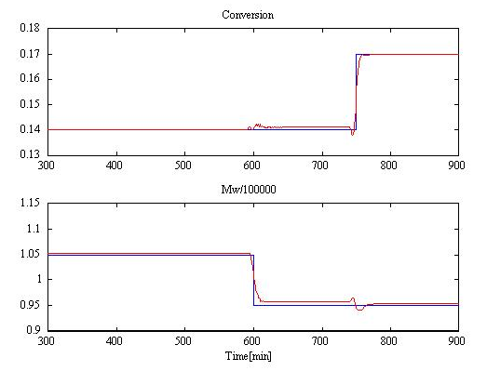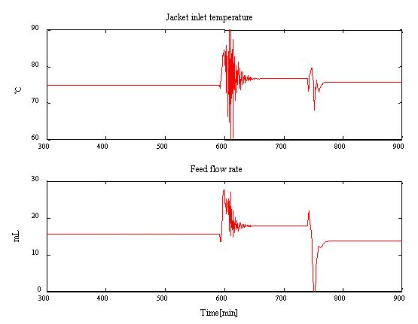
Figure 3. Simulation result of the polymer quality control in a continuous MMA polymerization reactor.

Acknowledgment

The financial aid from the Brain Korea 21 Program supported by the Ministry of Education is greatly appreciated.

References

- Verhaegen, M. and Dewilde, P., “Subspace model identification: Part 1. The output-error state-space model identification class of algorithms,” Int. J. Control, 5, 1187-1210 (1992).
- Norquay, S. J., Palazoglu, A. and Romagnoli, J. A., “Model Predictive Control Based on Wiener models,” Chem. Eng. Sci., 53(1), 75-84 (1998).
- Viberg, M., “Subspace-based Methods for the Identification of Linear Time-invariant Systems,” Automatica, 31(12), 1835-1851 (1995).
- Song, I.-H., Yoo, K.-Y. and Rhee, H.-K., "Analysis and Design of a Linear Input/Output Data-Based Predictive Control," Ind. Eng. Chem. Res., 40(20), 4292-4301 (2001).
- Jeong, B.-G., Yoo, K.-Y. and Rhee, H.-K., "Nonlinear Model Predictive Control Using a Wiener Model of a Continuous MMA Polymerization Reactor," Ind. Eng. Chem. Res., 40(25), 5968-5977 (2001).

