고분자용액의 열역학

배 영 찬
한양대학교 응용화학공학부 분자열역학연구실
(e-mail : ycbae@email.hanyang.ac.kr)

Molecular Thermodynamics of Polymer Solutions
Young Chan Bae
Division of Chemical Engineering and Molecular Thermodynamics Lab.

Hanyang University, Seoul 133-791, Korea

Chapter I.
Liquid - Liquid Equilibria of Linear Polymer/Solvent Systems

Model Development
•Internal and Helmholtz energies of mixing
$\frac{Δ_{\text{mix}}U}{N_{r}ε}=\frac{1}{2}\frac{N_{\text{12}}}{N_{r}}$$ε=2ε_{\text{12}}−ε_{\text{11}}−ε_{\text{22}}$The internal energy of mixing

$\frac{Δ_{\text{mix}}A}{N_{r}\text{kT}}=\left(\frac{Δ_{\text{mix}}A}{N_{r}\text{kT}}\right)_{1\tilde{T}=0}+\int{\frac{Δ_{\text{mix}}U}{N_{r}ε}}d\left(\frac{1}{\tilde{T}}\right)$The Helmholtz energy of mixing
$\left(\frac{Δ_{\text{mix}}A}{N_{r}\text{kT}}\right)_{1\tilde{T}=0}=\frac{φ_{1}}{r_{1}}\text{ln}φ_{1}+\frac{φ_{2}}{r_{2}}\text{ln}φ_{2}+\frac{z}{2}\left[φ_{1}\frac{q_{1}}{r_{1}}\text{ln}\frac{θ_{1}}{φ_{1}}+φ_{2}\frac{q_{2}}{r_{2}}\text{ln}\frac{θ_{2}}{φ_{2}}\right]$The Guggenheim's athermal entropy of mixing

$\frac{2Δ_{\text{mix}}U}{N_{r}ε}=φ_{1}φ_{2}\left[\frac{B^{'}}{1−A^{'}(φ_{2}−φ_{1})}\right]$Correlation with Monte-Carlo simulation data
$A^{'}=a_{0}+a_{1}\left[\text{exp}\left(1\tilde{T}\right)−1\right]$$B^{'}=b_{0}+b_{1}\left[\text{exp}\left(1\tilde{T}\right)−1\right]$where
$\begin{aligned}\frac{Δ_{\text{mix}}A}{N_{r}\text{kT}}={\left(\frac{Δ_{\text{mix}}A}{N_{r}\text{kT}}\right)}_{1\tilde{T}=0} \\ +\frac{1}{2}φ_{1}φ_{2}\left[B\frac{1}{\tilde{T}}−\frac{A}{a_{1}(2φ_{2}−1)}\text{ln}\left\{1−\frac{a_{1}(2φ_{2}−1)}{1−a_{0}(2φ_{2}−1)}\left\{\text{exp}(1/\tilde{T})−1\right\}\right\}\right]\end{aligned}$•Chain length(r2) dependence term

$\frac{{ΔA}_{\text{sec,}\text{ij}}}{N_{\text{ij}}\text{kT}}=\frac{2}{z}\left[η\text{ln}η+\left(1−η\right)\text{ln}\left(1−η\right)+\frac{{\text{zC}}_{α}δ{\tilde{ε}}_{\text{ij}}\left(1−η\right)η}{1+C_{α}δ{\tilde{ε}}_{\text{ij}}\left(1−η\right)η}\right]$•Specific interaction term

Results and Discussion
PEG (Mw=8000)/water

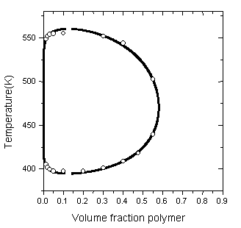
= 248.85
= 1514.281K
= -1367.725K
= -0.000614

PS (Mw=233000,100000)/t-butyl acetate
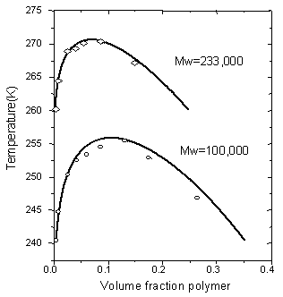

Mw=233000
r₂=767.85
ε/k=70.15K
Mw=100000
r₂=291.52 ε/k=68.68K

SUMMARY
Our proposed model predicts and describes remarkably well phase behavior for polymer solution systems

A secondary lattice concept to take into account the specific interaction is reasonable
The temperature dependence of energy parameter by specific interaction is well introduced

Chapter II. Vapor - Liquid Equilibria of Dendritic Polymer/Solvent Systems

Model Development
$Q=Q_{\text{LCT}}Q_{S}$•Canonical Partition function
The intermolecular force into physical (van der Waals force)
$A=A^{\text{LCT}}+A^{S}$The chemical (hydrogen bonding force) forces
ALCT : Physical contributions to the Helmholtz free energy
AS : Chemical contributions to the Helmholtz free energy
Assumption : We consider specific interactionas nearest neighbor site interaction

Lattice Cluster Theory

•By Cluster Expansion with respect to 1/z, e/kT
$Ω_{H}=\prod_{i=1}^{k}{\frac{(N_{i}d_{i})!}{(N_{i}d_{i}−\sum_{m=1}^{k}{M_{\text{im}}})!}}\prod_{j=1}^{k}{\frac{(N_{j}a_{j})!}{(N_{j}a_{j}−\sum_{n=1}^{k}{M_{\text{nj}}})!}}\prod_{i=1}^{k}{\prod_{j=1}^{k}{\frac{p_{\text{ij}}^{M_{\text{ij}}}}{(M_{\text{ij}})!}}}$• Truncation - 2nd Order for 1/z & 4th order for e/kT
Mij : the number of (i,j) pair H-bond formation

Pij : The mean field probability that a specific acceptor j will be proximate to a given donor i

Molecular Simulation

•Simulation Package: Cerius2 BLENDS, Molecular Simulations Inc.
•Method:
Structure Parameterization in Open Force Field Environment : Dreiding II (2.21)
Monte Carlo Atomistic Simulations with Excluded-Volume Constraints
- A modified Blanco’s molecular silverware algorithm
- The Pairs method
- Boltzmann Averaging Sampling Method
•Energy Terms calculated : van der Waals force, Coulombic force, Hydrogen bonding force

Simulation Results
Innergroup /toluene
Vapor Liquid Equilibria of ARg4/Toluene system (J. Chem. Eng. Data 1998, 43, 541)
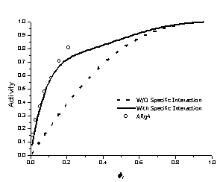
Summary
Atomistic Simulation give useful tools to predict the phase equilibria of structured polymer solution
Theoretical Prediction shows slight deviation in higher generation, it is due to the steric effects from crowded endgroups of dendritic polymers
Specific Interaction plays an important role in phase behavior of structured polymer

Conclusion

The Molecular Thermodynamic Approach
plays a powerful roles in the phase equilibria of Linear and structured polymer system

The Key to Develop Molecular Thermodynamic Approach
is the good mathematical models and simulation methods

