결정 코팅을 통한 인슐린의 안정성 증가

권재현, 최성희, 김성태, 김찬화
고려대학교 생명공학원

STABILITY ENHANCEMENT OF PLGA-COATED INSULIN MICROCRYSTAL

Jai-Hyun Kwon, Sung Hee Choi, Sung Tae Kim, Chan-Wha Kim
Graduate School of Biotechnology, Korea University

INTRODUCTION

Peptide or protein drugs that produced through genetic engineering and complex purification processes are characterized by their high cost and instability. Therefore their stability is critical considerations in their purification and formulation processes. During the encapsulation process, peptides are exposed to heat, shear stress [Oliva et al., 1996], pH extremes, organic solvent, freezing and drying. Often, these physical and chemical stresses induce protein aggregation and denaturation [Brange et al., 1997].
The crystallization of protein is an intensively researched field, both in respect of structural analysis and in respect of pharmaceutical applications. Crystallization of proteins is a formation of the lattice structure with protein molecules. Direct interactions between protein molecules are relatively tenuous in most protein crystals, thus minimize the loss of biological activities.
To demonstrate the feasibility of using protein crystals in PLGA coating process, insulin microcrystal was used as a model protein. The encapsulation efficiency, drug content, and stability of microcrystal-loaded microparticles were investigated.

EXPERIMENT

Preparation of PLGA microcapsules
PLGA microcapsules were prepared using the double-emulsification solvent evaporation procedure [Edwards et al., 1997]. In briefly, 0.3 ml of concentrated crystal suspension was added into 4.0 ml of PLGA polymer solution in DCM (200 mg of polymer) and emulsified on ice by homogenizer (Biospec. products, Inc.). The first emulsion was poured into 50 ml of 1% aqueous PVA solution and homogenized to form the double emulsion. The microcapsules were continuously stirred for 3 hours to allow hardening, collected by centrifugation, washed several times with double-distilled water, and freeze-dried into a freely flowing powder. Insulin solution was also encapsulated using the same method.

Particle size determination
The particle size and its distribution were determined by a laser light diffractometry (CILAS 1064, France), and expressed as volume-mean diameter.

Drug content and encapsulation efficiency
A known weight of microcapsules was dissolved in 500 μl of DCM and extracted twice with 1 ml of 0.1 N acetic acid. The insulin concentration of the extracted solution was determined spectrophotometrically at 595 nm by the Bradford method. Encapsulation efficiency was calculated from the ratio of the insulin content of the microcapsules and the amount of insulin used for preparation of the microcapsules.

Stability of microencapsulated insulin
Ten milligram of microcapsules was suspended in 0.4 ml of phosphate-buffered saline (PBS) and kept to stand at 37oC without agitation. The denatured insulin during release was measured spectrophotometrically at 280 nm by means of a high-performance liquid chromatography (HPLC) method (reversed-phase C18 column). The flow rate was 1.0 ml/min. Size exclusion chromatography (Supelco, TSK-GEL G2000SW, 7.5 mm ID60 cm) was performed to detect the aggregated insulin impurities. The flow rate was 0.5 ml/min and also detected at 280 nm.

In vitro release test
Sample equivalent to 500 mg of insulin of each dosage form was suspended in 0.4 ml PBS buffer. The samples were placed in an incubator for a scheduled period of times at 37℃ and collected by centrifugation. The release medium was removed and equal volume of fresh PBS was added. The release medium was analyzed by Bradford method.

Scanning electron microscopy
Morphology of microcapsules was analyzed by scanning electron microscopy (SEM) (HITACHI S-450, Japan). Freeze-dried microcapsules were mounted onto metal stubs using double-sided adhesive tape, vacuum-coated with gold and directly analyzed under SEM

RESULTS AND DISCUSSTION

In light microscopy, both of the solution/PLGA and crystal/PLGA showed uniform particle size distributions. The particle size was also measured by laser light diffractometry. Both microparticles showed uniform and narrow size distribution. Crystal/PLGA had smaller diameter, 5.09±0.92 ㎛, than solution/PLGA, 6.58±0.42 ㎛.
In electron microscopy, solution/PLGA usually showed multi-nuclei structures. . In the case of crystal/PLGA, the polymer shell showed uniform thickness and only few populations showed porous structure (Fig.1).
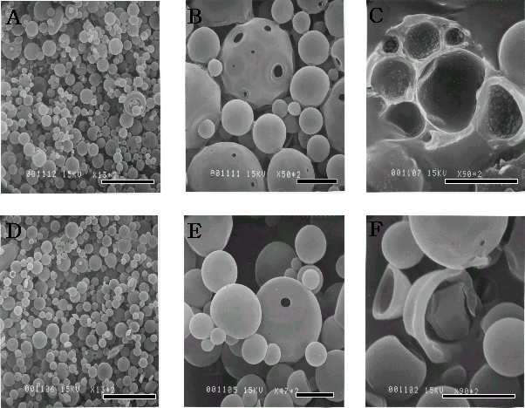
Fig. 1. Scanning electron microscopic analysis of solution/PLGA and crystal/PLGA, non fractured (A, B, C, D), fractured (E, F).

At the low insulin loading (10 mg/ml), there was no difference in drug content of solution/PLGA microcapsules (1.11±0.15%) and crystal/PLGA microcapsules (1.06±0.52%). However, the difference became larger with increases in the insulin loading. At 50 mg/ml loading, the drug content of solution/PLGA microcapsules was 3.31±0.67%, while that of crystal/PLGA microcapsules was 5.84±0.74%. As the pH decreases, the more insulin could be dissolved up to 50 mg/ml. But low pH may cause instablilty of insulin, so maximum insulin drug content in solution/PLGA is about 3%.
Table 1. Insulin stability in the PBS after 7 day
 |  | Insulin (%) | Desamido  Insulin (%)
Non  freeze-dried | Solution / PLGA | 93.17±0.64 | 6.83±0.64
Non  freeze-dried | Crystal / PLGA | 98.74±0.20 | 1.26±0.20
Freeze-dried | Solution / PLGA | 93.52±3.12 | 6.48±3.12
Freeze-dried | Crystal / PLGA | 97.80±0.47 | 2.01±0.47

In RP-HPLC analysis, both microparticles showed desamido insulin peak [Rosa et al., 2000]. The fraction of desamido insulin peak was 6.83±0.64% in solution/PLGA and 1.26±0.20% in crystal/PLGA (Table 1).

CONCLUSIONS

This study has shown that the use of insulin crystals can improve the stability of loaded protein, increase drug contents, and encapsulation efficiency. During the release, insulin turned into desamido-insulin. Insulin crystal improved stability three fold by reducing the contact area with hydrophobic surfaces, organic, solvent, heat, and absorption to polymer barriers. Therefore, crystal formulation of protein in conventional emulsification solvent evaporation technique improved peptide stability.

REFERENCES

Brange, J., Andersen, L., Laursen, E. D., Myen, G., Rasmussen, E., “Toward understanding insulin fibrillation”, Journal of Pharmaceutical Science, 86, 517 (1997).
Edwards, D. A., Hanes, J., Caponetti, G., Hrkach, J., Ben-Jebria, A., Eskew, M. L., Mintzes, J., Deaver, D., Lotan, N., Langer, R., “Large porous particles for pulmonary drug delivery”, Science, 276, 1868 (1997).
Oliva, A., Fari, J. B., Labr, M., “Influence of temperature and shaking on stability of insulin preparation: degradation kinetics”, International Journal of Pharmaceutics, 143, 163 (1996).
Rosa, G. D., Iommelli, R., Quaglia, F., “Influence of the co-encapsulation of different non-ionic surfactants on the properties of PLGA insulin-loaded microspheres”, Journal of Controlled Release, 69, 283 (2000).

