Tri-Sodium Citrate(TSC) 수용액상에서
Ammonium Peroxo di-Sulfate(APS)로 환원시킨
은 나노입자의 제조

남동헌, 신승일, 오성근
한양대학교 화학공학과

Preparation of Colloidal Silver Nanoparticles
Using Ammonium Peroxo di-Sulfate (APS) as Reducing Agent
in Aqueous Tri-sodium Citrate (TSC) Solutions

Dong- Hun Nam, Seung-Il Shin, Seong-Geun Oh
Department of Chemical Engineering, Hanyang University

Introduction
Many efforts have been reported in a lot of scientific journals and devoted to the synthesis and characterization of stable colloidal nanoparticles. In many of them, a variety of methods can be used for the formation of nanoparticles. For example, reduction by radiation^{1, 2, 3, 4}, ultrasonic^{5, 6}, thermal reduction in aqueous or organic solvents^{7, 8, 9, 10}, chemical reduction^{11, 12, 13, 14, 15, 16}, photo-reduction (UV)^{17, 18} in protic or aprotic solvents, etc.
For the chemical methods in the preparation of silver nanoparticles, the choice of the reducing agent is the major factor in determining the size and size distribution of particles. All methods involve the reduction of silver ions in the presence of suitable protecting agent, which is necessary in controlling the growth of silver colloids through agglomeration.
As one of protecting agents, sodium citrate has been used as both the reducing agent and stabilizer of the particles in the classical “Turkevich” preparation of silver colloids. One can hardly distinguish between these two actions of citrate, since the variation in its concentration may cause both a change in the reduction rate and in the nucleation-to-growth ratio. Moreover, the oxidation/decarboxylation products of citrate, such as acetone dicarbonic and itaconic acids, may be chemisorbed and affect the particle growth. Henglein and Giersig reported that citrate can actively involve in the reduction mechanism of silver ions or can be solely a spectator to the redox process depending upon the reaction conditions.¹ However, it plays an important role as stabilizer.
In this study, silver nanoparticles were prepared by reducing the silver ions with ammonium peroxydisulfate (APS) in aqueous trisodium citrate solution to find out the key factor of Redox reaction in APS-TSC system. APS has been widely used as an initiator in the polymerization due to its radical formation of monomers.^{19, 20} The structure analysis by XRD, surface plasmon effect by UV and morphology by SEM of silver nanoparticles were performed with the variation in the concentrations and pH of solutions. Also the effects of ammonium ions, sulfate ions, ammonium sulfate and persulfate on the formation of silver particles were studied.

Experimental
Materials: Tri-sodium citrate di-hydrate (99% solid state), silver nitrate (99.9995% crystalline solid state) were purchased from Aldrich. Ammonium peroxo di-sulfate (ammonium persulfate: 98% solid state) was bought from Kanto chemical. All colloidal solutions were prepared in de-ionized and doubly distillated water (Milli-Q, Millipore, France, electrical resistivity 18.2㏁). This water was also used in all washing process.
Preparation of silver nanoparticle: The silver colloids are prepared as follows. The 10ml of 0.01M AgNO₃ solution was added for a few seconds after an each solution of 10ml of APS and 10ml of TSC were mixed together by vortex mixer (CHANG SHIN SCIENTIFIC CO., C-VT mixer). The APS, TSC and AgNO₃ mixture was getting more and more change from colorless to yellowish-brown colored solution.
For measuring XRD and SEM & EDX, the solution was centrifuged by centrifugal machine (Hanil science industrial, UNION 32R), washed by de-ionized and doubly distillated water and dried in incubator (JICICO, J-100M) after the end of reaction. At that time, a centrifuge (2000 RPM, 10℃, 15min) and drying (40℃) process were carried out to obtain the silver powder.
We will show that the effect of pH was controlled with H₂SO₄ and NaOH solution at pH 3, 5, 7 and 9 and the effect of APS concentration was varied at 0.5M, 0.01M, and 0.05M.
Characterization: X-ray diffraction (XRD) patterns and SEM (Scanning Electron Microscopy) images of nano-powders were obtained by X-ray diffractometer (Rigaku D/MAX RINT 2500) and Field Emission Scanning Electron Microscopy (FE-SEM, JEOL model JSM-6340F). And nanoparticle in aqueous solution was studied by Transmission Electron Microscopy (TEM, JEOL/ EM-2000EX2) and UV-visible spectrophotometer (SCONCO S-2150). As TEM grids, copper grids (400 mesh) were covered with a carbon film.

Results & Discussion
Colloidal silver nanoparticles were synthesized by APS as reducing agent in aqueous TSC. Tri-sodium citrate can be not only as the character of stabilizer but also as assisting agent in APS-TSC system. And APS couldn’t be sololy used as reducing agent without aqueous TSC. These results have a reminded that APS and TSC were playing an important role at the Redox (reduction-oxidation) reaction mechanism as the result of our experiment.
Physico-chemical analysis of silver nanoparticles
After nanoparticle was made in APS-TSC system, the solution itself and powder were measured by several instrumental techniques (XRD: for certificating of crystallinity, EDX: for proving of pure silver nanoparticle, UV-vis spectrum: for confirmation of surface plasmon of silver). We could be verified throughout the results of the data in several instruments.
As a result of considering from analysis (XRD, SEM & EDX, UV) of solid-state silver nanoparticle, silver particles were not formed in AgNO₃-APS and AgNO₃-TSC mixed solutions at room temperature. The silver nanoparticles were formed only in the mixed solution of AgNO₃-APS-TSC.
The controlling effect of pH and APS concentration
In this part, the controlling effect of pH and TCS-APS concentrations were studied. First of all, it was investigated whether APS molecules were activated or not in the acid-base situation of solution. As appearing in the reference, actually, APS were activated in aqueous basic solution.²¹ And it has already been reported that the chelate formation was directly affected by the pH of a solution.²² So the pre-experiments on pH effect were carried out as experiment. To study the effect of concentration on the particle formation, only the concentration of APS was varied because TSC concentration was already exceeded. That’s the reason why if the TSC concentration were lacked in the reaction, un-known silver sulfate salt might be produced by TSC lacked reaction. So, the APS concentrations in the reaction were controlled at 0.5M, 0.01M, 0.05M, respectively.
The silver nanoparticles could be formed in the presence of both APS and TSC in the solution by the reduction of AgNO₃. The nanoparticles were purely silver confirmed by XRD. The silver nanoparticles were not formed if only either APS or TSC was added into AgNO₃ solution. It seemed that TSC formed the complex with silver ions and prevented the formation of silver sulfates salt. Also the TSC behaved as the stabilizer of nanoparticles and hindered the growth of particles by capping action. In the absence of TSC, the silver sulfate salts were formed by the reaction between AgNO₃ and APS. The formation of silver nanoparticles was stopped or delayed at acidic conditions. But silver nanoparticles were easily formed at neutral and alkaline solution. The size of silver particles formed in alkaline solution was larger than that of particles formed in acidic condition. The size of particles was decreased as the concentration of APS was decreased due to the slow reduction rate, and the reducing yield of Ag+ into silver particles was also decreased as the concentration of APS was decreased.

References
(1) Henglein, A.; Giersig, M. J. Phys. Chem. B, 1999, 103, 9533-9.
(2) Henglein, A. Parl Muluaney, P.; Linnert, T. Faraday Discuss, 1991, 92, 31-44.
(3) Li, Y.; Duan, X.; Qian, Y.; Yang, L.; Liao, H. J Colloid Interface Sci. 1999, 209, 347-9.
(4) Henglein, A. J. Phys. Chem. 1993, 97, 9457-5471.
(5) Zhu, Z.; Liu, S.; Palchik, O.; Koltypin, Y.; Gedanken, A. Langmuir 2000, 16, 6396-6399
(6) Li, B.; Xie, Y.; Huang, J.; Qian, Y. Ultrasonic Sonochem. 1999, 6, 217-220
(7) Shiraishi, Y.; Toshima.N. J. Mol. Cata. 1999, 141, 187-192
(8) Silvert, P. Y.; Herrera-Urbina, R.; Duvauchellen, N.; Vijayakrishnan, V.; Elhsissen, K. T. J. Mater. Chem. 1996, 6(4), 573-7
(9) Silvert, P. Y.; Herrera-Urbina, R.; Elhsissen, K. T. J. Mater. Chem. 1997, 7(2), 293-299
(10) Mayer, A.B.R.; Mark, J.E. Polymer 2000, 41, 1627-1631
(11) Van Hyning, D. L.; Zukoski, C. F. Langmuir 1998, 14, 7034-7046
(12) Chou, K. S.; Ren, C. Y. Mater. Chem. Phys. 2000, 64, 241-246.
(13) Pavlyukhina, L. A.; Zaikova, T. O.; Odegova, G. V.; Savintseva, S. A.; Boldyrev, V. V. Inorg. Chem. 1998, 34(2), 159-164
(14) Pastoriza-Santos, I.; Liz-Marzan, L. M. Langmuir 1999, 15, 948-951.
(15) Burshtain, D.; Zeiri, L.; Efrima, S. Langmuir 1999, 15, 3050-3055.
(16) Henglein, A. Chem. Mater. 1998, 10, 444-450.
(17) Huang, H. H.; Ni, X. P.; Loy, G. L.; Chew; C. H.; Tan, K. L.; Loh, F. C.; Deng, J. F.; Xu, G. Q. Langmuir 1996, 12, 909-912.
(18) Esumi, K.; Wakabayashi, M.; Torigoe, K. Colloid surface A.1996, 109, 55-62.
(19) Sandler, S. R.; Karo, W.; Bonesteel, J. A.; Pearce, E. M. Polymer synthesis and Characterization: A Laboratort manual. Academic Press, U.S.A ,1998, p28~29
(20) Chanda, M. Advanced Polymer Chemistry. Marcel Dekker Inc, U.S.A. 2000, p458~460
(21) Patai, S. The chemistry of Peroxides; John Wiley & Sons, New York, 1993, p757-758
(22) Martell, A. E.; Calvin, M. Chemistry of the metal chelate compounds. PRENTICE HALL, U. S. A. 1956, p78

Figure 1 TEM image of silver nanoparticles throughout controlling of the pH prepared in water: (a) pH 5, (b) pH 7, (c) pH 9.

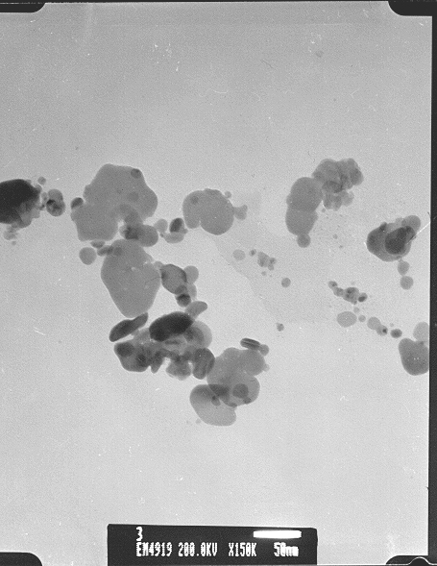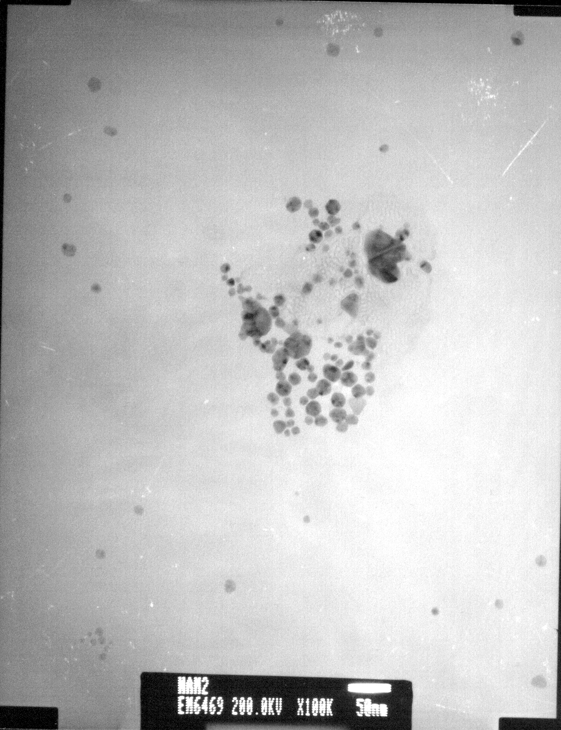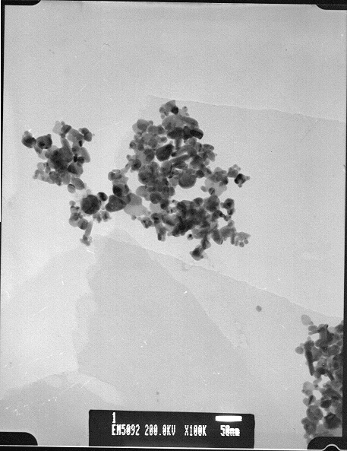
(a) (b) (c)
Figure 2 Transmission Electron Micrograph image of silver nanoparticles throughout controlling of the APS concentrations prepared in water: (a) 0.5M, (b) 0.1M, (c) 0.01M.

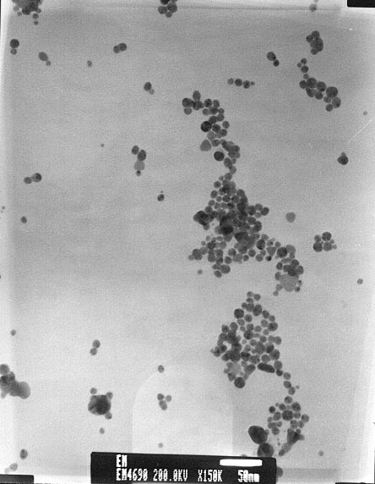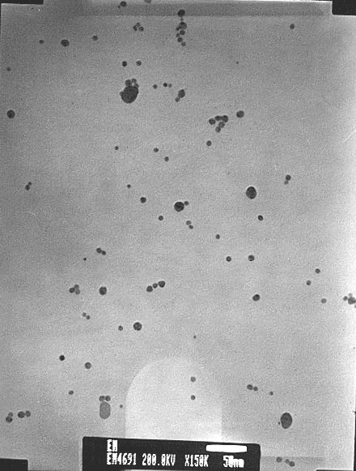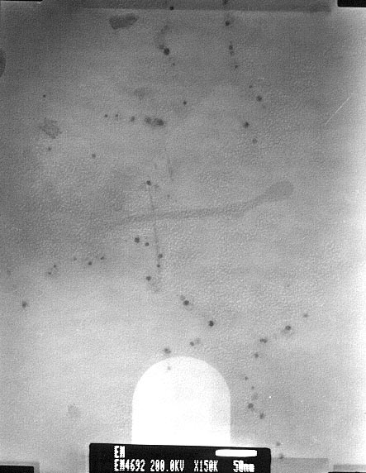
(a) (b) (c)

