Type of presentation : POSTER
Name of presentation author : Eung Jin Ahn

The Effect of Thiourea on Ag Electroplating
for ULSI Interconnection Material

Eung Jin Ahn, Joon Mo Seo and Jae Jeong Kim*
School of Chemical Engineering,
Seoul National University, San 56-1, Shillim-dong, Kwanak-gu, Seoul, 151-742, Korea

The effects of thiourea (TU) on Ag electroplating for ultra large-scale integrated (ULSI) circuits interconnection were experimented. To remove silver sulfide and the other contaminations, the diluted nitric acid was used in the pretreatment process. For successfully deposition on the patterned wafer, the rms roughness was momentous issue. As a result of addition of small amount of TU, the rms surface roughness of electroplated Ag film was decreased about 40 %. Also the deposition rate was decreased. To reduce the resistivity and enhance the adhesion of Ag electroplated film, we performed annealing process at 350℃ in a nitrogen atmosphere. Finally, Ag film was successfully electroplated on the patterned wafer which has aspect ratio from 0.93 to 2.1.

Keywords : silver, electrodeposition, electroplating, additive, thiourea

The structure of substrate was TiN (100Å)/Ti (150Å)/Si. The Ti and TiN layers were deposited by ionized metal plasma (IMP) PVD and MOCVD, respectively. Ag thin film as a seed layer were also deposited in 500Å using PVD.
The electrolyte was composed of KAg(CN)₂, KCN, deionized (DI) water and TU. TU concentration is varied from 0 to 5 g/l. Ag electroplating carried out –800 mV controlled by EG & G scanning potentiostat (model 362) at room temperature. Annealing process was performed at 350℃ for 30 min in a N₂ atmosphere at 20 torr in a quartz tube.

As shown in Fig 1, With TU addition, from additive-free to 0.5 g/l, deposition rate was increased. But over 2 g/l of TU, the film thickness was decreased. And over 2 g/l TU had more smooth surface morphologies than without TU in the electrolyte (Fig. 2). Annealing process was conducted to observe adhesion and resistivity of deposited Ag film. After annealing, the surface more rough than before annealing in the case of deposition film in additive-free electrolyte but the surface roughness , with TU-including electrolyte, was more smooth than as-deposition. For Ag interconnection material in ultra large scale integration (ULSI), electroplating method is experimented in the cyanide based electrolyte. TU was used as a additive which has smooth effect and suppressor. On the other hand, when TU was added into electrolyte, the resistivity increased due to reduction in grain size and co-adsorbed S species on the surface but annealing process would make up for the resistivity that reduced to 1.67. Gap-filling of Ag electroplated film that includes TU in electrolyte shows good filling profile (Fig. 3).

Fig. 1. Ag film thickness according to concentration of thiourea.

Fig. 2. Rms roughness of deposited Ag film according to concentration of thiourea.

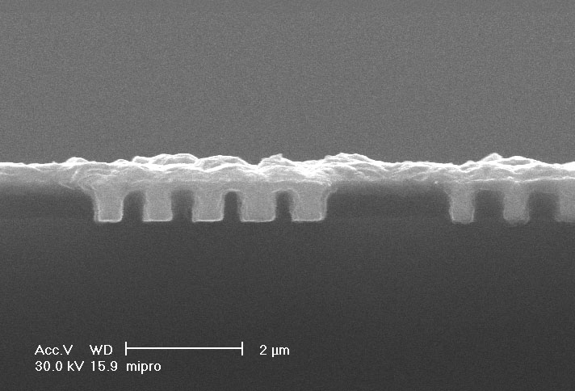
2

Fig. 3 FESEM image of gap-filling with thiourea.

* Tel : +82-2-880-8863 Fax : +82-2-888-1604
Electronic mail : jjkimm@snu.ac.kr

